TABLE OF CONTENTS
UNITS AND DIMENSIONS 3
module 1
Oscillations & Waves 4
shock waves 23
module 2
Elastic properties of materials 36
module 3
optical fibers 63
module 4
quantum mechanics 79
lasers 94
module 5
material science 114
viva questions & answers 156

UNITS AND DIMENSIONS

Sl. No | Particular | Symbol | SI Unit
1 | Resistance | R | $Ω$(Ohm)
2 | Capacitance | C | F (Farad)
3 | Inductance | L | H(Henry)
4 | Frequency | f | Hz(Hetrz)
5 | Power | P | W(Watt)
6 | Energy | E | J(Joule)
7 | Force | F | N(Newton)
8 | Charge | q or Q | C(Coloumb)
8 | Voltage | V | V(Volt)
9 | Density | $$ρ$$ | Kg/m³
10 | Wavelength | $$λ$$ | m(Meter)
11 | Intensity | I | w/m³
12 | Current | I | A(Ampere)
13 | Magnetic field strength | B | Weber/m³
14 | Stefan constant | $$σ$$ | Wm⁻²K⁻⁴
15 | Boltzmann constant | K | J/K  $$(1.38×{10}^{-23})$$
16 | Plank’s constant | h | Js  $$(6.625×{10}^{-34})$$
17 | Permittivity of free space | $$ϵ_{0}$$ | F/m  $$(8.854×{10}^{-12})$$
18 | Mass of electron | m_{e} | Kg  $$(9.1×{10}^{-31})$$
19 | Mass of neutron and proton | m_{p} | Kg  $$(1.67×{10}^{-27})$$
20 | Reduced planck’s constant or Dirac’s constant | $$ħ$$ | Js  $$(ħ=\frac{h}{2π}=1.05×{10}^{-34})$$

MODULE 1

OSCILLATIONS AND WAVES

Oscillations and waves
Oscillations and Waves
Free Oscillations: Definition of SHM, derivation of equation for SHM, Mechanical simple harmonic oscillators (mass suspended to spring oscillator), complex notation and phasor representation of simple harmonic motion. Equation of motion for free oscillations, Natural frequency of oscillations.
Damped and forced oscillations: Theory of damped oscillations: over damping, critical & under damping. Theory of forced oscillations and resonance, Sharpness of resonance. One example for mechanical resonance.
Shock waves: Mach number, Properties of Shock waves, control volume. Laws of conservation of mass, energy and momentum. Construction and working of Reddy shock tube, applications of shock waves.
Numerical problems
Free Oscillations
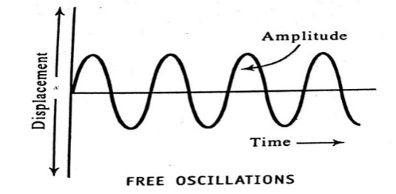
Introduction:

Displacement ($x$) : The shortest distance of the particle measured along the path of the motion from its mean position, at a given instant $t$ is called displacement.
$$x=A\sin{(ωt)}$$Where, $x$ is displacement
A is amplitude of motion
$ω$ is angular velocity
Velocity ($v$): It is defined as distance travelled per unit time.
$$v= \frac{dx}{dt}=ωA\cos{(ωt)}$$
The above equation varies periodically between +$ωA$ & - $ωA$.
Acceleration ($a$):
$$a=\frac{dv}{dt}=\frac{d^{2}x}{dt^{2}}= - ω^{2} A\sin{ (ωt)}$$Acceleration various periodically between the values +$ω^{2}A$ and -$ω^{2}A$.
$∴$ $a=- ω^{2} x$
Time period ($T$): Time taken for one complete oscillation is called period.
$$T= \frac{2π}{ω}=2π \sqrt{\frac{Displacement}{Acceleration}}$$
Frequency ($f$): The number of vibrations made by the body in one second is known as frequency & it is denoted by $ν$.
$$f= \frac{1}{T}$$
Angular frequency ($ω$): It is the angle covered in unit time by a representative point moving on a circle whose motion is correlated to the motion of the vibrating body.
The SI unit is radian per second.
Restoring Force:
$$F ∝ -x$$
$$F= -kx$$Where, k is force constant.
Thus the force constant is defined as,
“It is the magnitude of the applied force that produces unit extension (or compression) in the spring while it is loaded within the elastic limit”.
Physical significance of force constant:
- It is a measure of stiffness
- In case of springs, it represents how much force it takes to stretch a spring over unit length
- Springs with larger value of force constant will be stiffer
Definition of Simple Harmonic Motion (SHM):
“A SHM is defined as a motion in which the acceleration of the body is directly proportional to its displacement from a fixed point and is always directed towards the fixed point.”
Characteristics of SHM:
- It is a particular type of periodic motion.
- The oscillation system must have inertia which in turn means mass
- There is a constant restoring force continuously acting on the body
- The restoring force should be directly proportional to the displacement of the body from its mean position.
Examples of SHM:
- A mass suspended to a spring
- A pendulum set for oscillation
- Excited tuning fork
- A plucked string in a guitar
- A shock absorber after being bumped
- Electrical oscillations in LC circuit
Differential Equation of motion for SHM
Consider a particle of mass$'m'$, executing SHM. If the displacement of the particle at any instant $'t'$be $'x',$ then its acceleration will be, $=\frac{d^{2}x}{dt^{2}}$ . From definition of SHM and Hooke’s law,
$Restoring force$ $∝Dispalcement$
$$F ∝ -x$$ $F = -kx$ ----- (1)
Where, $k$ is proportionality constant or Force constant
But, $F =ma = m\frac{d^{2}x}{dt^{2}}$ ----- (2)
From Eq. (1) and Eq. (2) we have,
$m\frac{d^{2}x}{dt^{2}}= -kx$ ----- (3)
Here the negative side indicates that the force is oppositely directed.
Eq. (3) can be written as,
$\frac{d^{2}x}{dt^{2}}$ $+ \frac{k}{m}x=0$
If we put, $ω^{2}= \frac{k}{m}$ in the above Eq. i.e., angular frequency of the particle,
Then, $\frac{d^{2}x}{dt^{2}}$ $+ ω^{2}x=0$ ----- (4)
Eq. (4) is called the differential equation of motion for a SHM.
The general solution for differential equation for SHM is given by,
$$x=A\sin{(ωt)}$$Where, $x$ is displacement
A is amplitude of motion
$ω$ is angular velocity

Mechanical Simple harmonic oscillator:
Mass Suspended to spring (vertical oscillations)
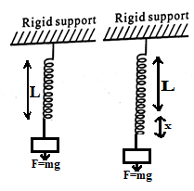
Let us consider a spring loaded at one end and fixed at the other end as shown in the fig. If oscillations are given, it exhibits simple harmonic oscillation.
Due to the mass, the spring will elongate and the weight $mg$ of the mass and tension in the spring $τ$ will keep the system in equilibrium.
We can write, $τ = mg = kl$---- (1)
where, $k$ is spring constant
$l$is elongation of the spring due to mass m
$$∴k= \frac{mg}{l}$$
If we apply force to stretch the spring through a small distance
‘$x$’ and if the force is removed, the mass ‘$m$’ starts to
move up and down & becomes harmonic in nature.
$i.e. τ’ = k (l + x)$ ---- (2)
When $x$ is small, the applied force is given by,
$$F =τ-τ^{'}=kl-k \left(l+x\right)$$
$F = -kx$ ---- (3)
But we have,$F =$ $m\frac{d^{2}x}{dt^{2}}$ and $k= \frac{mg}{l}$
Eq. (3) becomes, $m\frac{d^{2}x}{dt^{2}}= -\frac{mg}{l}x$
Or, $\frac{d^{2}x}{dt^{2}}+ \frac{g}{l}x=0$
Or, $\frac{d^{2}x}{dt^{2}}$ $+ ω^{2}x=0$
Where, $ω^{2}= \frac{g}{l}= \frac{k}{m}$
The time period of the oscillation is given by,
$T = \frac{2π}{ω}$ or T = $2π \sqrt{\frac{l}{g}}$
Equivalent force constant for springs in series combination ($k_{s}$)
Consider two idealized springs${ S}_{1}$ and ${ S}_{2}$ with spring constants ${ k}_{1}$ and ${ k}_{2}$ respectively. Let ${ x}_{1}$ and ${ x}_{2}$ be the extension in ${ S}_{1}$ and ${ S}_{2}$ when a mass $m$ is attached at lower end.
From Hooke’s law we have, $F = -kx$ & $F=mg$
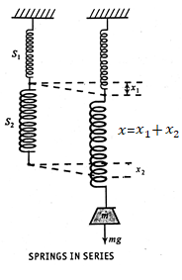
$$∴mg= -kx$$
$$or, x= -\frac{mg}{k}$$
Using the above relation we can write Eq. for ${ x}_{1}$ and ${ x}_{2}$
$${ x}_{1}= -\frac{mg}{{ k}_{1}} ---(1)$$
$$\& { x}_{2}= -\frac{mg}{{ k}_{2}} ---(2)$$
Now, let ${ S}_{1}$ and ${ S}_{2}$ be suspended in series as shown in fig. Let the load $m$ be suspended at bottom of series combination. Thus the mass $m$ comes down showing total extension,
$x= { x}_{1}$ $+ { x}_{2}$
Let the force constant for this series combination be $k_{s}$
$∴$ We can write, $mg= -k_{s}x= -k_{s} \left({ x}_{1} + { x}_{2}\right)$
Or, ${ x}_{1} + { x}_{2}=- \frac{mg}{k_{s}}$ ------ (3)
Using Eq. (1) & (2), Eq. (3) can be written as,
$$-\frac{mg}{{ k}_{1}}-\frac{mg}{{ k}_{2}} =- \frac{mg}{k_{s}}$$
Removing the common factor –mg and rearranging, we have,
$$\frac{1}{k_{s}}= \frac{1}{{ k}_{1}}+\frac{1}{{ k}_{2}}$$
Or, $k_{s}= \frac{{ k}_{1}{ k}_{2}}{{{ k}_{1}+k}_{2}}$

If there are n number of springs in series then,
$$\frac{1}{k_{s}}= \sum_{i=1}^{n}{ \frac{1}{k_{i}}}$$
If a mass m is attached at bottom and set for oscillations then time period will be,
T = $2π \sqrt{\frac{m}{k_{s}}}$
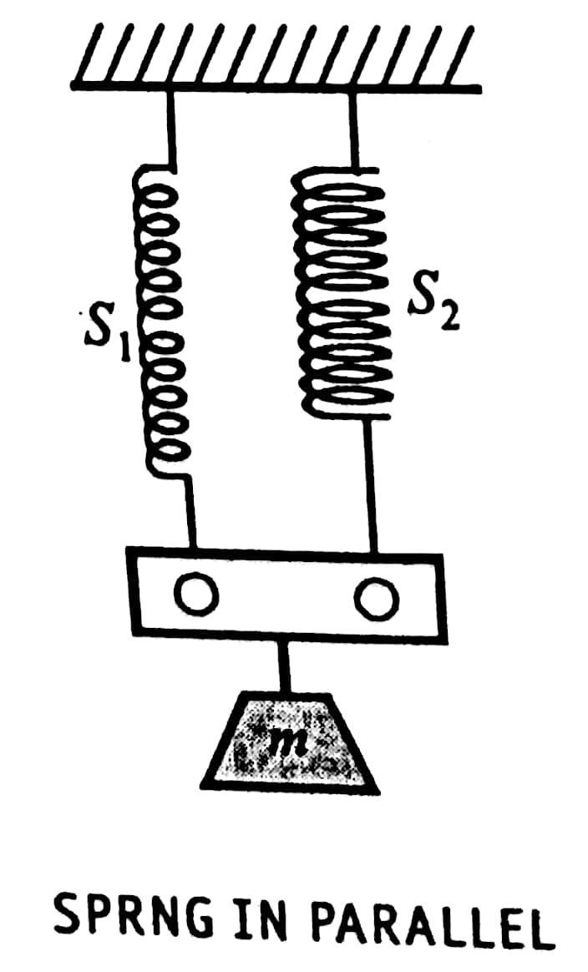
Equivalent force constant for springs in parallel combination ($k_{p}$)
Let the two springs be suspended from a rigid support parallel to each other as shown in fig. The free support descends a distance $x$ due to the mass $m$. Let the restoring force be $F_{p}$ and the force constant for this combination be $k_{p}$.
$∴$ $F_{p}= - k_{p} x$ ----- (1)
The restoring force $F_{p}$ is actually shared by the two springs. Let the restoring force in${ S}_{1}$ be $F_{1}$ & that in $S_{2}$ be $F_{2}$.
$∴$ $F_{p}= F_{1}+ F_{2}= -k_{1}{ x}_{1} -k_{2}{ x}_{2}$
But, since both springs undergo same extension $x$, ${ x}_{1}= { x}_{2}=x$.
$∴$ $F_{p}= -k_{1}x-k_{2}x$
Or, $F_{p}= -\left(k_{1}+k_{2}\right)x$ ------ (2)
Comparing Eq. (1) & Eq. (2), we have,
$$k_{p}= k_{1}+k_{2}$$
If there are $n$ number of springs connected in parallel, then,
$$k_{p}= k_{1}+k_{2}+ ……+ k_{n}$$
For this combination of mass-spring system, the period of oscillation will be,
T = $2π \sqrt{\frac{m}{k_{p}}}$
Complex Notation:
In general a complex number ‘$z$’ in Cartesian form is given by
$$z = x + iy$$Where, $i= \sqrt{-1}$ is a imaginary number.
The complex number in coordinate form is represented by Argand diagram as shown in fig.
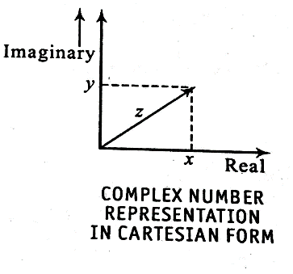
In polar coordinates,
$$z=r e^{iθ}----(1)$$Where, $e^{iθ}=\cos{θ+i\sin{θ}}$
$r$ is magnitude of $z$
Complex notation for SHM can be represented using Eq. (1) by replacing $θ by ωt$
$$z=r e^{iωt}$$
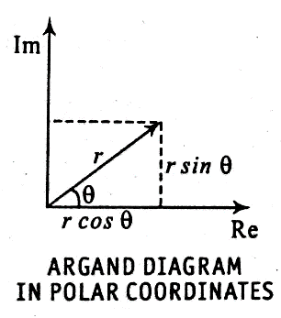
At, $t=0$ , if $z$is already making an angle $ϕ$ then ,
$$z=r e^{i(ωt+ϕ)}$$
This is the Complex notation for SHM.
Phasor Representation:
A phasor is a complex number representing a sinusoidal function whose amplitude (A), angular frequency ($ω$) and initial phase ($θ$) are time variant.
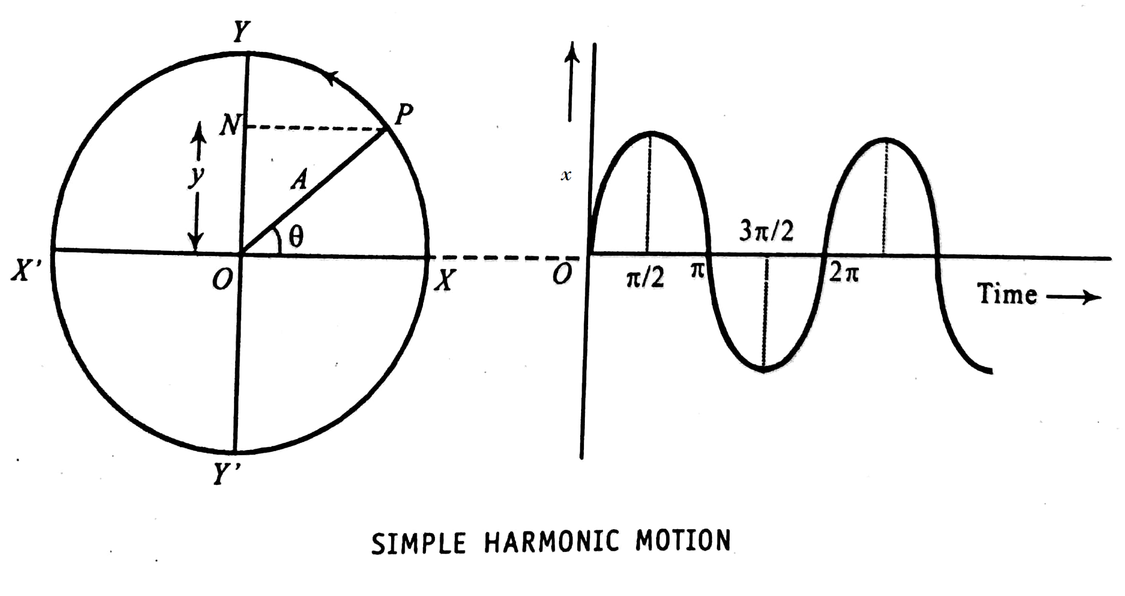

For SHM the complex notation is given by
$$z=r e^{i(ωt+ϕ)}$$From the Argand diagram for polar representation, the rotating angle $z$ is the phasor.
It is represented as,
$r ∠ϕ=r (cosϕ+i sinϕ)$
In electrical engineering the phasor representation is given by
$\overline{I}= I ∠ϕ=I (cosϕ+j sinϕ)$
And $\overline{V}= V ∠ϕ=V (cosϕ+j sinϕ)$
Where, $\overline{I} and \overline{V}$ are the current and voltage phasor in an electrical circuit.
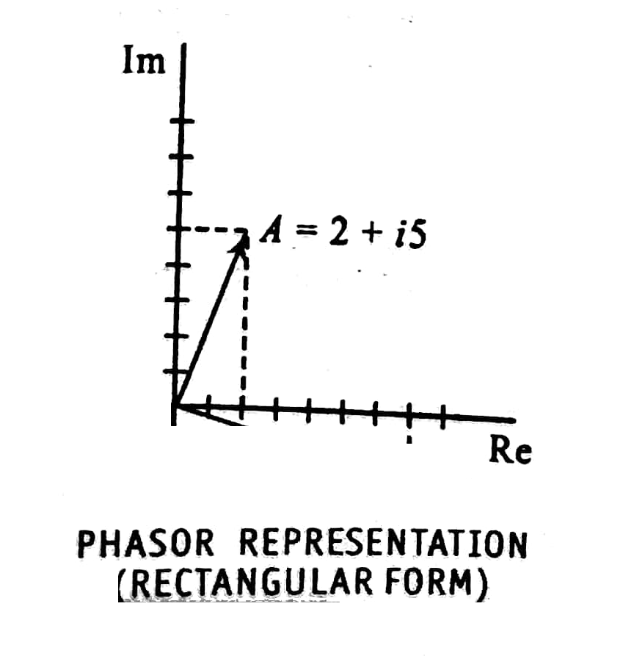
Example of Phasor: $A = 2 + i5$

Free Oscillation:
Definition of Free Oscillation:
“When a body oscillates with its own characteristics frequency, then the oscillations are called free oscillations. The frequency of the free oscillation is called natural frequency.”
Example for Free oscillation:
- The oscillation of mass suspended by a spring
- Oscillation of a simple pendulum
- LC oscillations
- Air column oscillates in a test tube
Equation of motion for free oscillation:
The general differential equation of motion of SHM itself represents the equation of motion for Free Oscillations.
$\frac{d^{2}x}{dt^{2}}$ $+ \frac{k}{m}x=0$
Where, $m$ is mass of the oscillating body
$k$ is force constant
$x$ is displacement
$t$ is instant time
Natural Frequency (Qualitative)
The frequency of free oscillation is called natural frequency.
Natural frequency depends on,
- Dimension of a oscillating body
- Elasticity of the body
- Inertial property of the oscillating system

Damped Oscillations
Definition of Damped Oscillations:
“The oscillation in which amplitude goes on decreasing with time is called Damped oscillation”.
Example for damped oscillation:
- Mechanical oscillation of simple pendulum
- Electrical oscillation in LC circuit
- A swing left free to oscillate after being pushed once
Expression for the decay of the amplitude in damped oscillations:
Let us consider a simple harmonic oscillator system damped by viscous damping forces. The damping force is proportional to the velocity of the system. Thus the damped force is given by,
$$F_{d}= -b\frac{dx}{dt}----(1)$$Where, b is a constant depends on shape of the body.
Thus the equation of damped simple harmonic oscillator could be obtained by adding damping force term to the Hooke’s law.
$$m \frac{d^{2}x}{dt^{2}}= -kx-b\frac{dx}{dt}---(2)$$
$$m \frac{d^{2}x}{dt^{2}}+ b\frac{dx}{dt}+kx = 0$$
The above equation could be written as,
$$\frac{d^{2}x}{dt^{2}}+ \frac{b}{m}\frac{dx}{dt}+\frac{k}{m}x = 0---(3)$$
Or,
$$\frac{d^{2}x}{dt^{2}}+ γ \frac{dx}{dt}+ω^{2} x = 0----(4)$$
Where, $γ= \frac{b}{m}$ is called damping coefficient
$ω= \sqrt{\frac{k}{m}}$ is called natural frequency of the system
The auxiliary equation for Eq. (3) could be written as
$$\left(D^{2}+ \frac{b}{m} D+ \frac{k}{m}\right) x=0---(5)$$
The roots for the above equation could be written as,
$D_{1}= \frac{-b}{2m}+\frac{1}{2m} \sqrt{b^{2}- 4mk}$ ------ (6) & $D_{2}= \frac{-b}{2m}- \frac{1}{2m} \sqrt{b^{2}- 4mk}$ ----- (7)
The general solution for Eq. (3) could be written as,
$$x \left(t\right)=M e^{\left(\frac{-b}{2m}+\frac{1}{2m} \sqrt{b^{2}- 4mk}\right) t}+ N e^{\left(\frac{-b}{2m} - \frac{1}{2m} \sqrt{b^{2}- 4mk}\right) t} ----(8)$$
For small damping, the above equation could be reduced to,
$$x \left(t\right)=A e^{ \frac{-b}{ 2m} t }cos \left(ωt+ϕ\right)----(9)$$
The frequency of damped oscillation is given by,
$$p= \sqrt{ω^{2}- {\left(\frac{b}{2m}\right)}^{2}}$$
The amplitude of Damped oscillation is given by $A e^{ \frac{-b}{ 2m} t }$which decreases with increase in time.
The frequency of damped oscillation is less than the natural frequency.
The damping is classified into three types as shown below:
Under Damping:
Oscillations are said to be under damped or weakly damped if the retarding force is weaker than the restoring force. The amplitude of oscillations decreases with respect to time. The condition for under damped oscillation is given by$b^{2}< 4mk$.
Over Damping:
Oscillations are said to be over damped when the system attains equilibrium state quickly without making any oscillations. The condition for over damping is given by $b^{2}> 4mk$.
Critical Damping:
When the system approaches equilibrium sate quickly without making any oscillations is called Critical Damping. The condition for critical damping is given by $b^{2}= 4mk$.
The damping conditions are shown in the graph.
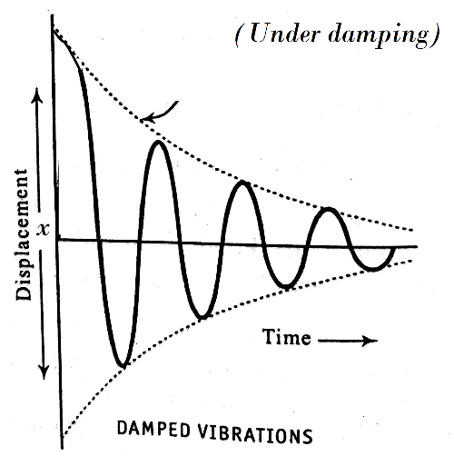
$$A e^{ \frac{-b}{ 2m} t }$$
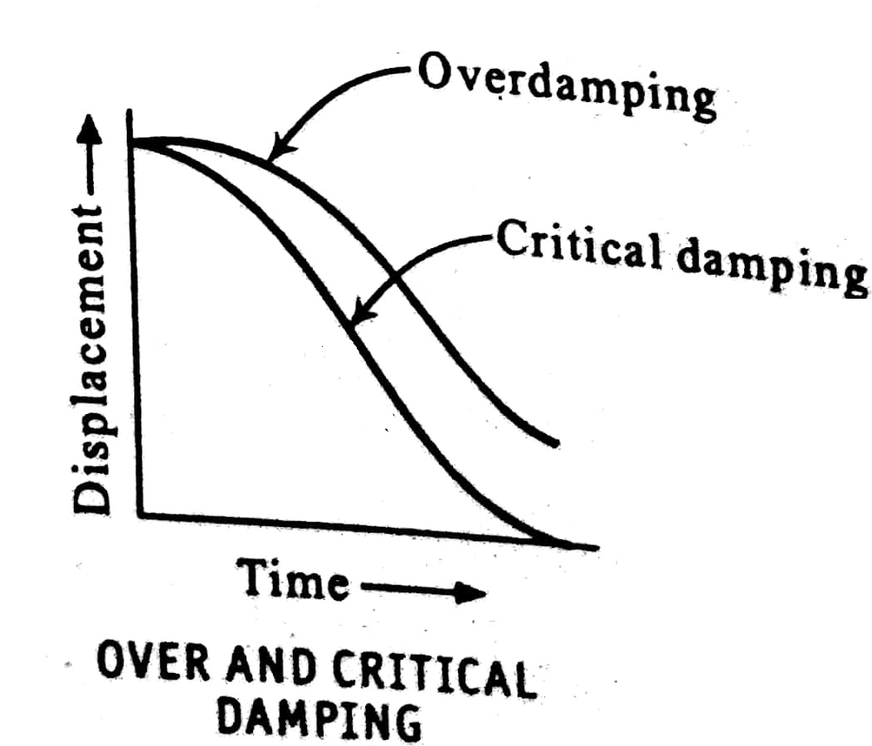

Quality factor and its Significance
Definition:
“The quality factor is defined as 2$π$ times the ratio of energy store in the oscillator to the energy lost per time period.”
The energy loss rate of a weakly damped oscillator is represented using a parameter $Q$ called Quality factor.
$$Q=2π \frac{E}{PT}= \frac{ω}{γ} (for low damping)$$
Where, $P$ is power dissipated
$T$ is time period
$γ= \frac{b}{m}$ is called damping coefficient
The basic differential equation for damped oscillation in terms of Q is given by
$$\frac{d^{2}x}{dt^{2}}+ \frac{ω}{Q} \frac{dx}{dt}+ω^{2} x = 0$$
Significance:
- If the oscillator is weakly damped, then Q is much large than unity.
- Q describes how much under damped is the oscillatory system

Forced Oscillation:
Definition:
When a force is applied to the body, it oscillates not with its natural frequency but oscillates with frequency of the applied force such oscillations are called Forced Oscillations.
The resultant frequency is known as forced frequency ($p$)
Example of Forced Oscillation:
- Resonance air column
- Sonometer wire set to oscillations using tuning fork.
Expression for amplitude and phase in forced oscillations
The force acting on the system during forced oscillations are,
- Restoring force: $m \frac{d^{2}x}{dt^{2}}= -kx$
- Damping force: $F_{d}= -b\frac{dx}{dt}$
- External periodic force: $F_{ext}=Fe^{ipt}$
Therefore, the equation for oscillations in differential form could be,
$$m \frac{d^{2}x}{dt^{2}}= -kx -b\frac{dx}{dt}+Fe^{ipt}$$
Or, $m \frac{d^{2}x}{dt^{2}}+ b\frac{dx}{dt}+ kx= Fe^{ipt}---(1)$
Eq. (1) can be written as,
$$\frac{d^{2}x}{dt^{2}}+ \frac{b}{m}\frac{dx}{dt}+ \frac{k}{m } x= \frac{F}{m}e^{ipt}$$
$$or, \frac{d^{2}x}{dt^{2}}+ γ\frac{dx}{dt}+ ω^{2} x= \frac{F}{m}e^{ipt}-----(2)$$
Where, $γ= \frac{b}{m}$ is called damping coefficient
$ω= \sqrt{\frac{k}{m}}$ is called natural frequency of the system
$\frac{F}{m}e^{ipt}$ is the applied periodic force
$p$ is the frequency of the applied periodic force
The general solution for Eq. (2) is given by,
$$x=A \left[\cos\left(\left(pt- ϕ\right) \right)+i\sin{(\left(pt- ϕ\right))}\right]$$
$$or, x=A e^{i\left(pt- ϕ\right)}---(3)$$
Where, A is amplitude of forced oscillation
ϕ is phase of forced oscillation
Substituting Eq. (3) in Eq. (2) we get
$$\frac{d^{2}\left(A e^{i\left(pt- ϕ\right)}\right)}{dt^{2}}+ γ\frac{d\left(A e^{i\left(pt- ϕ\right)}\right)}{dt}+ ω^{2} \left(A e^{i\left(pt- ϕ\right)}\right)= \frac{F}{m}e^{ipt}$$
$$\left(-p^{2}A+iγpA+ ω^{2}A\right) e^{i\left(pt- ϕ\right)}= \frac{F}{m} e^{ipt}$$
$$\left(ω^{2}- p^{2}\right)A+iγpA= \frac{F}{m} e^{iϕ} ---(4)$$
Eq. (4) can be written as,
$$\left(ω^{2}- p^{2}\right)A+iγpA= \frac{F}{m} \left(\cos{ϕ+i \sin{ϕ}}\right)---(5)$$

Equating real and imaginary parts of LHS and RHS of Eq. (5)
$$\left(ω^{2}- p^{2}\right)A= \frac{F}{m} cos ϕ ---(6)$$
$$γpA= \frac{F}{m} sin ϕ ---(7)$$
Amplitude (A):
Squaring and adding Eq. (6) and Eq. (7)
$${\left(ω^{2}- p^{2}\right)}^{2} A^{2}+ {\left(γpA\right)}^{2}= {\left(\frac{F}{m}\right)}^{2} \left(\cos^{2} ϕ+ \sin^{2} ϕ\right)$$
$$A^{2}= \frac{{\left(\frac{F}{m}\right)}^{2}}{{\left(ω^{2}- p^{2}\right)}^{2} + {\left(γp\right)}^{2}}$$
$$A= \frac{\left(\frac{F}{m}\right)}{\sqrt{{\left(ω^{2}- p^{2}\right)}^{2} + {\left(γp\right)}^{2}}}---(8)$$
Eq. (8) represents the amplitude of forced oscillations.
Phase (ϕ):
Now dividing Eq. (7) by Eq. (6) we get,
$$\frac{\left(ω^{2}- p^{2}\right)A}{γpA}= \frac{\frac{F}{m} cos ϕ}{\frac{F}{m} sin ϕ }$$
$$\tan{ϕ= }\frac{γp}{\left(ω^{2}- p^{2}\right)}$$
$$ϕ= \tan^{-1}{\frac{γp}{\left(ω^{2}- p^{2}\right)}}---(9)$$
Eq. (9) represents the phase of forced oscillations.

Different conditions of forced oscillations:
Case (i) If $p≪ ω$:
Then Eq. (8) becomes
$$A= \frac{F}{m ω^{2}}---(10)$$
From Eq. (10), the system oscillates with frequency $ω$ and its amplitude is independent of $p$
And Eq. (9) becomes,
$$\tan{ϕ= }\frac{γp}{\left(ω^{2}\right)} ≈0---(11)$$
From Eq.(11), the displacement and phase will be approximately in phase.
Case (ii) If $p= ω$:
Then Eq. (8) becomes
$$A= \frac{F}{m γω}---(12)$$
From Eq. (12), the amplitude of the oscillations is maximum. This condition is called resonance.
And Eq. (9) becomes,
$$\tan{ϕ= }\frac{γp}{0} =∞$$
$$ϕ= \frac{π}{2} ---(13)$$
From Eq. (13), the phase angle between displacement and the applied periodic force is $\frac{π}{2}$.
Case (iii) If $p≫ ω$:
This case is significant only when damping forces are very small.
Then Eq. (8) becomes (for small $γ$)
$$A= \frac{F}{m p^{2}} ---(14)$$
And Eq. (9) becomes,
$$\tan{ϕ= }- \frac{γ}{p}$$
For small $γ$,
$$\tan{ϕ= }0 ---(15)$$
From Eq. (15), the phase angle between displacement and the applied periodic force is $- π$.

Resonance
Definition:
When frequency of the external force ($p$) is same as the natural frequency of oscillating body ($ω$), the amplitude of forced oscillation may become very large this phenomenon is known as resonance.
Examples of Resonance:
- Helmholtz resonator
- Resonance in LCR circuits
- The absorption of energy by electrons in atoms
- Resonance air column
Condition for resonance & expression for maximum amplitude:
The condition for resonance is $p= ω$.
Amplitude of forced oscillation is given by, $A= \frac{\left(\frac{F}{m}\right)}{\sqrt{{\left(ω^{2}- p^{2}\right)}^{2} + {\left(γp\right)}^{2}}}$
At resonance the system will keep the same phase as applied periodic force at all times. This is also evident by applying the condition $p= ω$ in above equation we get,
$$A= \frac{F}{m γω} ---(1)$$
From Eq. (1), the amplitude of the oscillations is maximum. This condition is called resonance.

Sharpness of Resonance
Definition:
The sharpness of resonance is the rate of change of amplitude with respect to a small change in frequency of the applied external periodic force, at resonance.
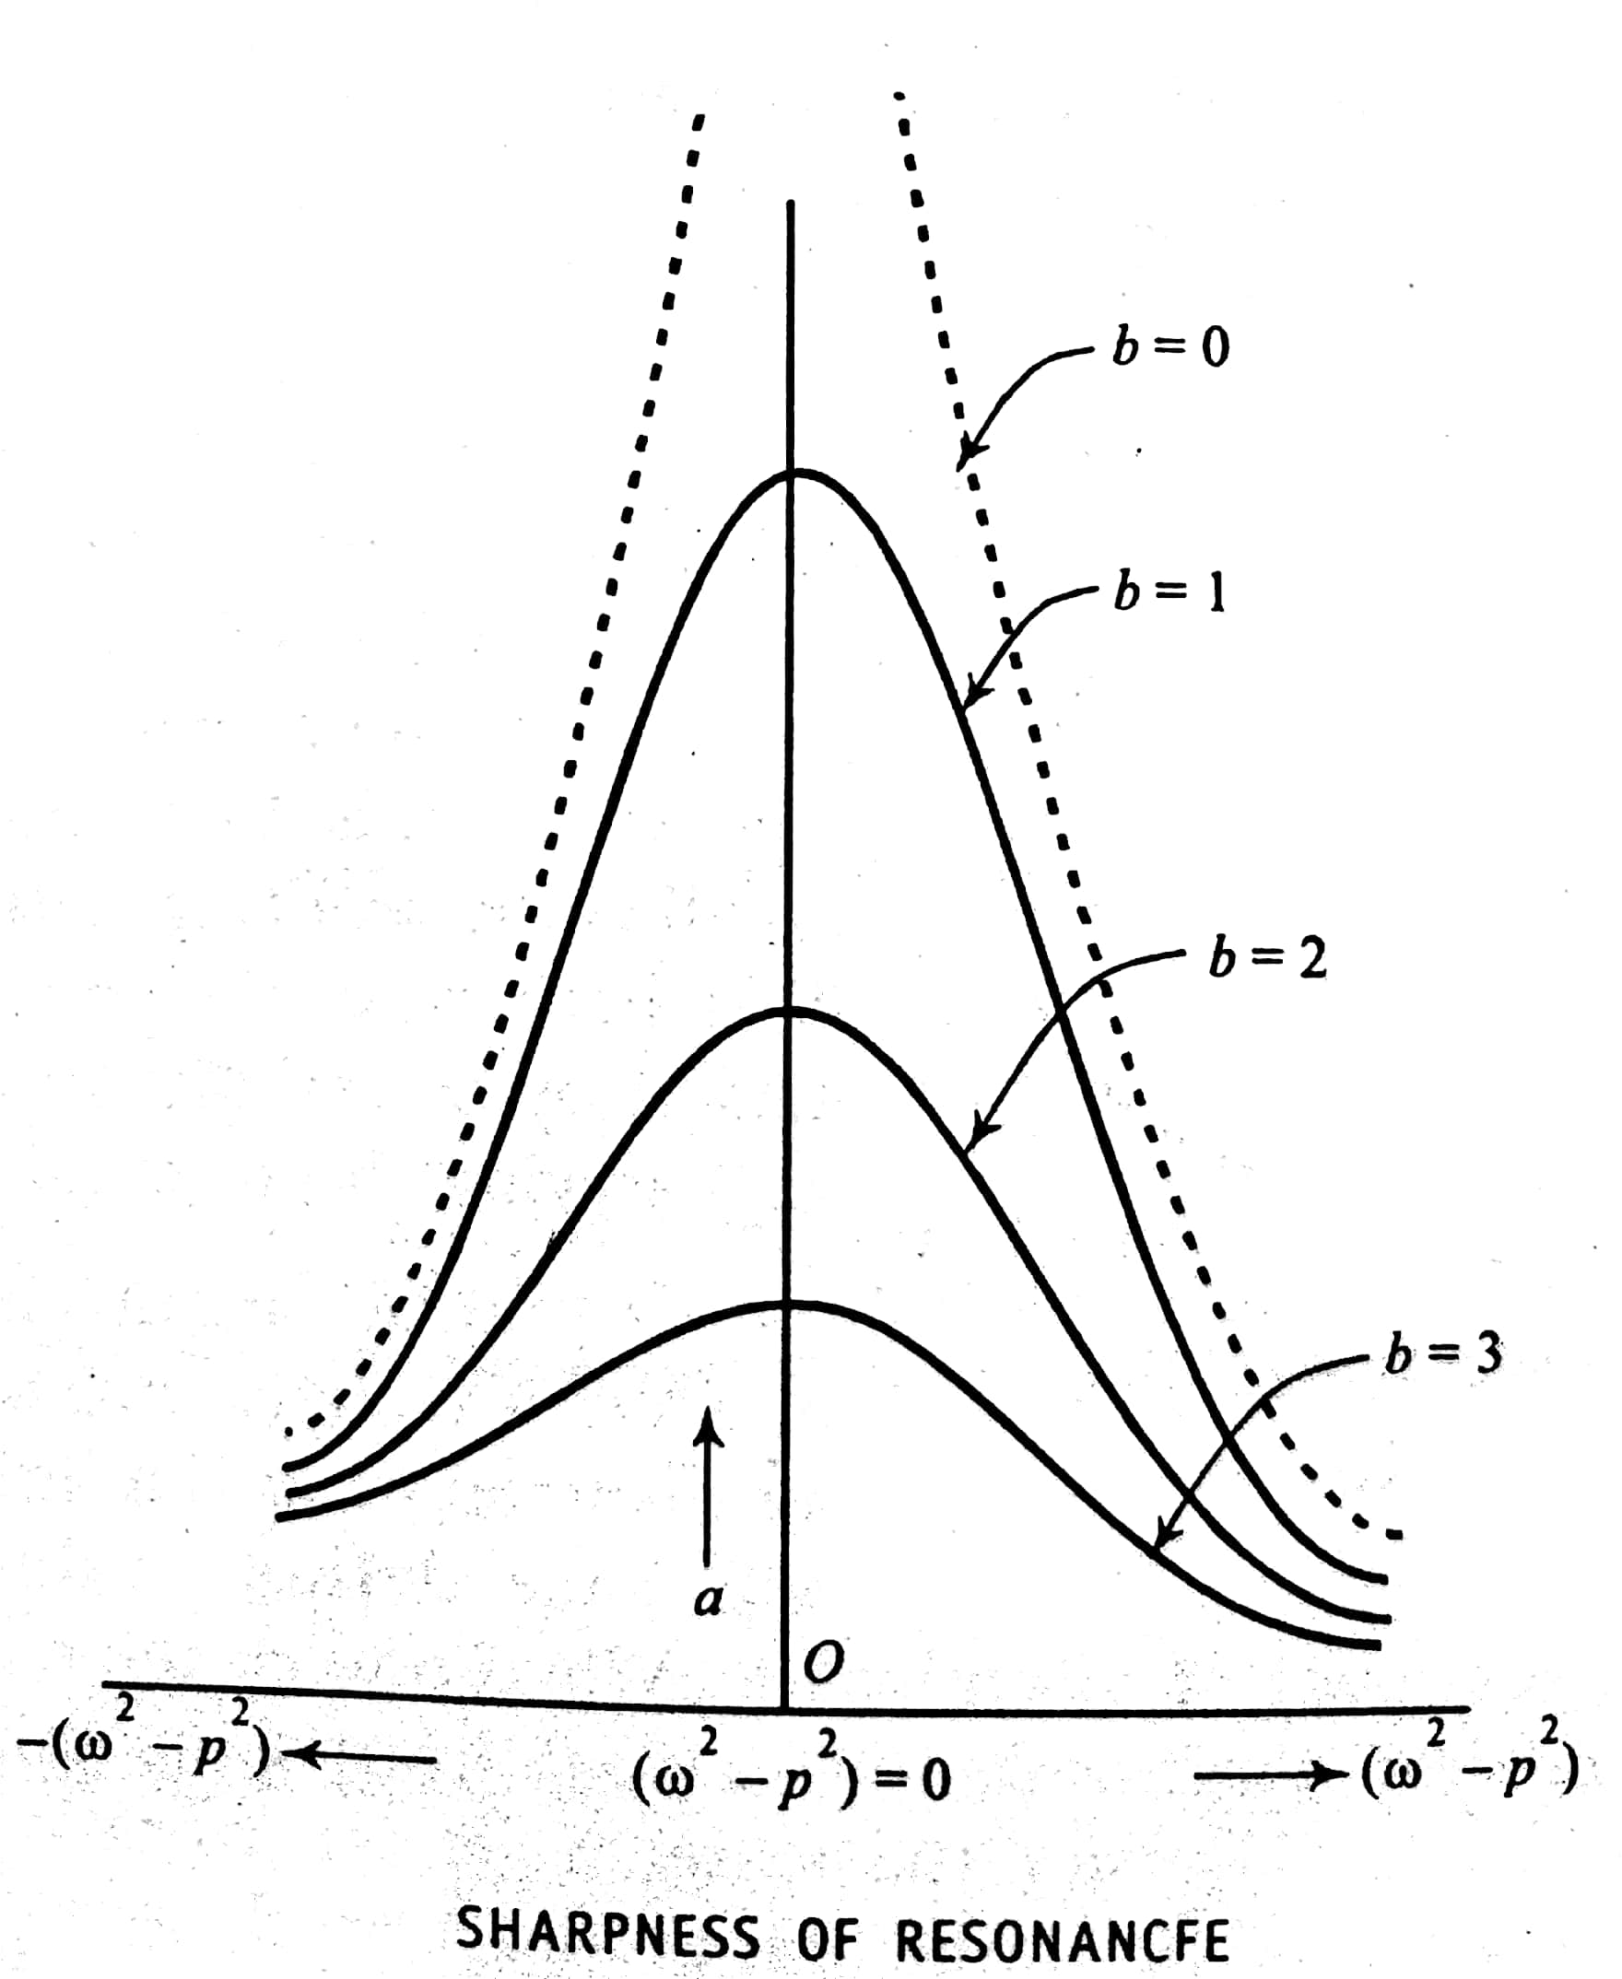
$$sharpness of resonance= \frac{∆ A}{∆ p}$$
Here, $∆ A$ is change in amplitude
with respect to $∆ p$ the change in frequency at resonance.
$$∴ sharpness of resonance= \frac{F}{m γ ω p}$$

Significance of sharpness of resonance:
- The amplitude of oscillations of an oscillating body rises to a maximum when the frequency of external force matches the natural frequency of the oscillating system.
- However, the rise of the amplitude will be very sharp when the damping is very small.
Effect of damping on the sharpness of resonance:
The graph representing the variation of amplitude of forced oscillations with respect to damping is as shown in the below fig.
$$sharpness of resonance= \frac{F}{m γ ω p}$$
As per above equation,
- The maximum amplitude at resonance is a function of damping
- Higher the damping lower will be the amplitude at resonance
- Thus, the sharpness will be higher at lower damping and vice-versa is the significance
Example of Mechanical oscillator
Helmholtz resonator
Description:
- It is named after German physicist Hermann Von Helmholtz.
- It is made of a hallow sphere with a short and small diameter neck.
- It has a single isolated frequency and no other resonances below about 10 times that frequency
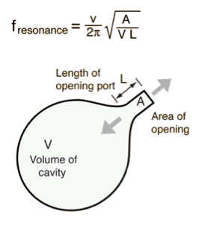
- The resonant frequency ($f$) of Helmholtz resonator is determined by its Volume ($V$), length ($L$) and area (A) of its neck

Working:
- The isolated resonance of a Helmholtz resonator made it useful for the study of musical toned in the mid-19th century.
- When resonator is held near the source of a sound, the air in it will begin to resonate, if the tone being analyzed has a spectral component at the frequency of the resonator
- By listening tone of a musical instrument with such a resonator, it is possible to identify the spectral components of a complex sound wave such as those generated by musical instruments
The expression for resonant frequency in Helmholtz resonator is given by,
$$f= \left(\frac{ν}{2π}\right)\sqrt{\frac{A}{LV}}$$
Where, $ν$ is frequency of source sound
$A$ is area of neck
$L$ is length of neck
$V$ is volume of neck
Shock waves
Shock waves: Mach number, Properties of Shock waves, control volume. Laws of conservation of mass, energy and momentum. Construction and working of Reddy shock tube, applications of shock waves.

Mach number:
In Aerodynamics, the speeds of bodies moving in a fluid medium are classified in to different categories on the basis of a parameter called Mach number.
It is defined as “The ratio of the speed of the object to the speed of the sound in the given medium”
i.e., Mach Number (M) = $\frac{v}{a}$
Where $v$ is speed of an object and $a$ is the speed of sound in that medium.

Speed of sound: (a)
The speed of sound in air or any gas medium at a temperature T (in kelvin) is given by, $a=\sqrt{γRT}$ where $γ$ is the ratio of specific heats and R is the specific gas constant.

Distinction between acoustic, ultrasonic, subsonic and supersonic waves:

Acoustic waves:
- An acoustic wave is simply a sound wave. it moves with the speed 333 m/sec in air at STP.
- Sound waves have frequencies between 20 Hz to 20,000 Hz and the Amplitude of acoustic wave is very small.

Ultrasonic waves:
- Ultrasonic waves are pressure waves having frequencies beyond 20.000 Hz. but they travel with the same speed as that of sound.
- Amplitude of the ultrasonic wave is also small.

Subsonic waves:
- If the speed of the mechanical wave or body moving in the fluid is lesser than that of sound then such a speed is referred to as subsonic and the wave is a subsonic wave.
- All subsonic waves have Mach number < 1.
- The speeds of almost all the vehicles such as motor cars or trains that we see moving on the road fall in the subsonic category.

Note: Subsonic flight
For a body moving with subsonic speed, the sound emitted by it manages to move ahead & away from the body since it is faster than the body

Supersonic waves:
- Supersonic waves are mechanical waves which travels with speeds greater than that of sound, i,e with speeds for which, Mach number >1.

Mach angle:
A number of common tangents drawn to expanding sound waves emitted from a body at supersonic speed formulate a cone called Mach cone. The angle made by tangent with the axis of the cone (half angle of the cone) is called Mach angle µ.
$μ=\sin^{-1}\left(\frac{1}{M}\right)$
In supersonic waves, we have a special class of waves called hypersonic waves. They travel with speeds for which Mach number≥ 5.
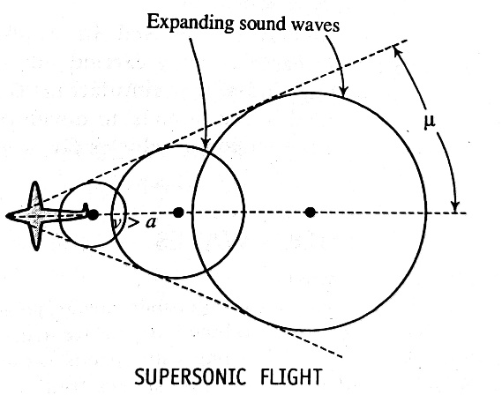

Transonic waves:
- There is a speed range which overlaps on the subsonic & supersonic ranges. This is actually in the domain in which, there is a change of phase from subsonic to supersonic.
- Transonic range is from $0.8<M<1.2$

Description of a shock wave:
- Any fluid that propagates at supersonic speeds, gives rise to a shock wave.
- Shockwaves can be produced by sudden dissipation of mechanical energy in medium enclosed in small space.

Laws of conservation:
We know that conservation means the maintenance of certain quantities unchanged with physical process. Conservation laws apply to the isolated system.

- Law of conservation of mass:
“The total mass of any isolated system remains unchanged or constant and is independent of any chemical and physical changes that could occur within the system”
$ρ_{1}u_{1}=ρ_{2}u_{2}$
$ρ_{1},ρ_{2}$are the density of state $u_{1} and u_{2}$ are the velocities.
- Law of conservation of momentum:
In a closed or isolated system, the total momentum remains constant or when two bodies collide in an isolated system, the total momentum of objects before collision equal to the after collision.
$$p_{1}+{ρ_{1}u_{1}}^{2}=p_{2}+{ρ_{2}u_{2}}^{2}$$
Where $p_{1}$, $p_{2}$ are the momentum of particle 1 and 2 and $ρ_{1},ρ_{2}$are the density of state.

- Law of conservation of energy:
The total energy of the isolated system or closed system is constant and it is independent of any changes occurring within the system.
$$h_{1}+\frac{{u_{1}}^{2}}{2}=h_{2}+\frac{{u_{2}}^{2}}{2}$$
Where $h_{1}$ and $h_{2}$ are the enthalpy and $u_{1}$ and $u_{2}$ are the velocity.

Reddy Tube (Reddy shock Tube):
- It is hand operated shock tube capable of producing shock waves using human energy.
- It has two sections separated by diaphragm. One end is fitted with piston and the other is closed or open to the surroundings.
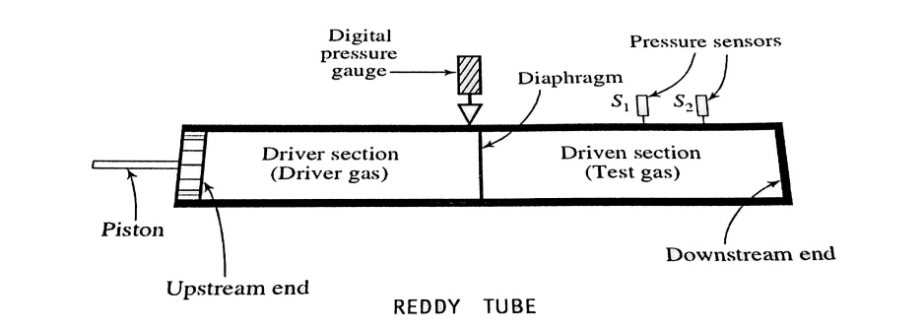

Construction:
- Reddy tube consists of a cylindrical stainless steel tube of 30mm diameter and 1m length, which is divided into two sections driver tube and driven tube these two are separated by a 0.1mm thick paper diaphragm.
- Digital pressure gauge is mounted in the driver section next to the diaphragm.
- Two piezoelectric sensors s₁ and s₂ are mounted 70mm apart towards the closed end of the shock tube. A port is provided at the closed end of the driven section for the filling the test gas to the required pressure.
- The driver section is filled with a driver gas, which is held at relatively high pressure due to compressing action of the piston, the gas at the driven section is termed as driven gas.
Working:
- The driver gas is compressed by pushing the piston hard into driver tube until diaphragm ruptures. Then driver gas rushes into the driven section and pushes driven gas towards the far downstream end so the temperature and pressure of shock wave increases.
- The reflected shock waves from the downstream end undergo further compression, leads to further increase of T and P.
- This high value of temperature and pressure sustained at the downstream end until an expansion wave reflected from the upstream end.
- These expansion waves are created at the instant the diaphragm is ruptured and they travel in the direction of shock waves.
- Actual creation of shock waves are depends on the properties of driver and test gases and dimension of the shock tube, increase of pressure is sensed by sensors S₁ and S₂, and they are recorded in CRO.
- From the recording the CRO, shock wave arrival time, Mach number, Pressure and temperature can be calculated.
Characteristics of Reddy tube:
- The Reddy tube operates on the principle of free piston driven shock tube(FPST).
- It is a hand operated shock producing device.
- It is capable of producing Mach number exceeding 1.5.
- The rupture pressure is a function of the thickness of the diaphragm.
- By using helium as a driver gas and argon as driven gas, temperature exceeding 900K can be produced. This Temperature is useful for chemical reaction.

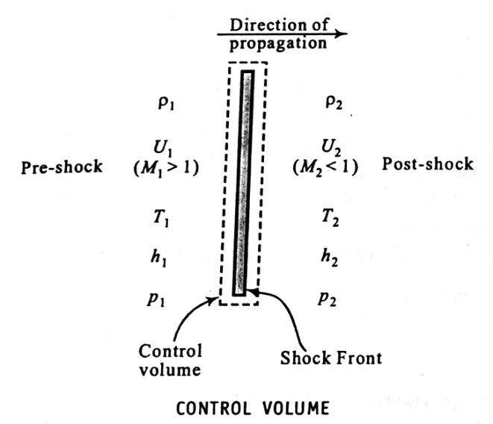
Control Volume:

- Control volume is a model on the basis of which the shock waves are analyzed. It is an imaginary thin envelope that surrounds the shock front within which, there is a sharp increase in the pressure, temperature and density in the compressed medium.
- Let $ρ_{1},U_{1},T_{1},h_{1} and P_{1}$ be the density, Internal energy, Temperature, Enthalpy and Pressure on the pre-shock tube. And at the post-shock side they are respectively $ρ_{2},U_{2},T_{2},h_{2} and P_{2}$
- Within this volume the energy is constant and its transfer is adiabatic.
Problems on Module 1
- A man weighing 600 N steps on a spring scale machine. The spring in the machine is compressed by 1 cm. Find the force constant of the spring.
Given, W = 600 N
Compression, $x=$0.01 m
Force constant, $k= ?$
Solution: we have, $F= -kx$
$k=- \frac{F}{x}= - \frac{W}{x}$ = $\frac{- 600}{- 0.01}= 6×{10}^{4}$ N/m

- A mass of 5 Kg is suspended from the free end of a spring. When set for vertical oscillations, the system executes 40 oscillations in 100 seconds. Calculate the force constant of the spring.
Given, mass, m = 5 Kg
Period, $T=\frac{100}{40}=2.5 seconds$
Force constant, $k= ?$
Solution: we have, $T=2π \sqrt{\frac{m}{k}}$
Squaring & simplifying we have,
$k=4 π^{2}\frac{m}{T^{2}}$
$k=4 π^{2}\frac{5}{{2.5}^{2}}=31.5$N/m

- A mass 0.5 Kg causes an extension 0.03 m in a spring & the system is set for oscillations. Calculate spring constant, angular frequency and time period.
Given, Mass, m = 0.5 Kg
Extension, $x=$0.03 m
Spring constant, $k= ?$
Angular frequency, $ω= ?$
Time period, $=$ ?
Solution: We have, Force acting F = mg = 0.5 X 9.8 = 4.9 N
$k=- \frac{F}{x}=$ $\frac{- 4.9}{- 0.03}= 163.3$ N/m
$ω= \sqrt{\frac{k}{m}}$ = $\sqrt{\frac{163.3}{0.5}}$ = 18.1 rad/s
$T=2π \sqrt{\frac{m}{k}}$ = $2 ×3.14 × \sqrt{\frac{0.5}{163.3}}$ = 0.35 s
- An electric motor weighing 50 Kg is mounted on 4 springs each of which has a spring constant 2 $× {10}^{3}$ N/m. The motor moves only in vertical direction. Find frequency of the system.
Given, Mass, m = 50 Kg on 4 springs
Spring constant, $k= 2× {10}^{3} N/m$
Frequency, $f= ?$
Solution: We have, $ω=2πf$ & $ω= \sqrt{\frac{k}{m}}$
$∴$ $f= \frac{1}{2π} \sqrt{\frac{k}{m}}$ = $\frac{1}{2π} \sqrt{\frac{2× {10}^{3}}{50}}$ = 2 Hz

- In the two mass-spring systems shown in the figures, $k_{1 }=2000$ N/m , $k_{2 }=1500$ N/m , $k_{3 }=3000$ N/m , $k_{4}=k_{5}=500$ N/m. Find m such that the system has a natural frequency of 10 Hz in each of the cases.
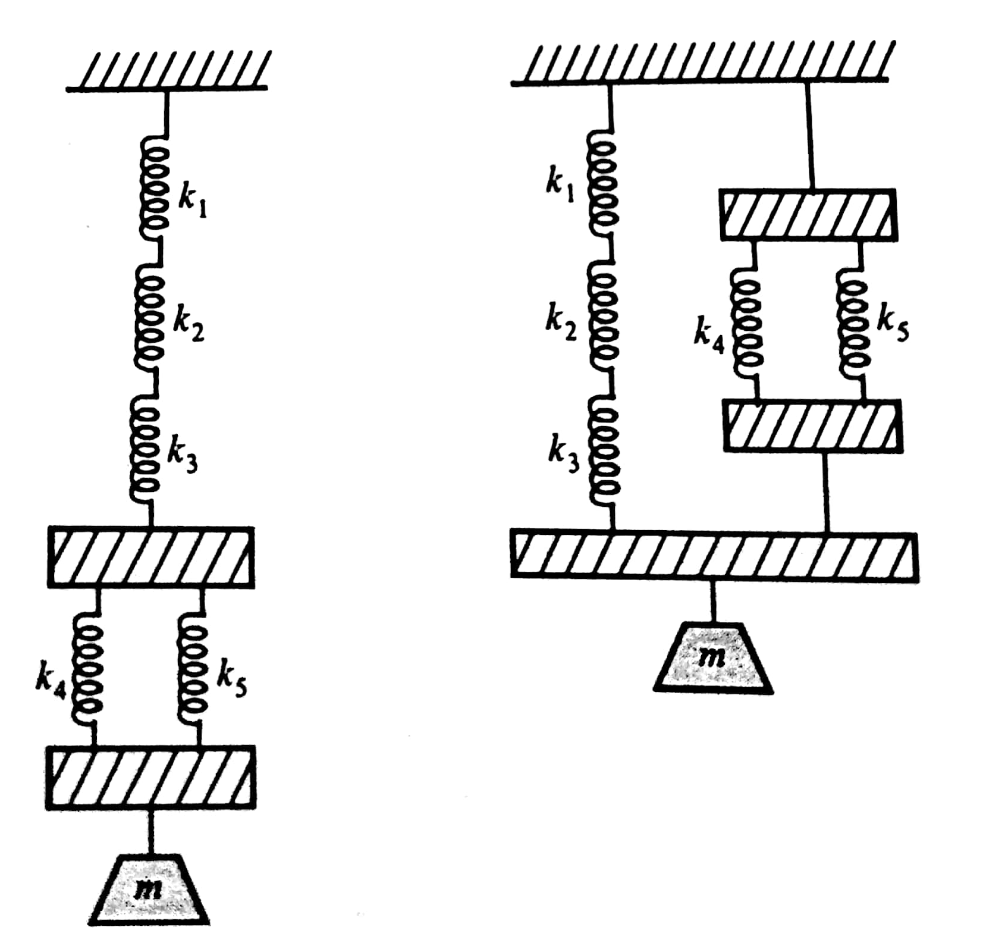

Given, $k_{1 }=2000$ N/m , $k_{2 }=1500$ N/m , $k_{3 }=3000$ N/m , $k_{4}=k_{5}=500$ N/m
$f=10 Hz$
m = ?
Solution: In figure 1, for top three springs,
$$\frac{1}{k_{s}}= \frac{1}{{ k}_{1}}+\frac{1}{{ k}_{2}} +\frac{1}{{ k}_{3}}= \frac{1}{2000}+\frac{1}{1500} +\frac{1}{3000}=1.5 ×{10}^{-3}$$
$$∴ k_{s}=667 N/m$$
For the parallel pair of springs,
$$k_{p}= k_{1}+k_{2}=500+500=1000 N/m$$
Let $k_{eq}$ be the equivalent force constant for the set up in figure 1
$$\frac{1}{k_{eq}}= \frac{1}{{ k}_{s}}+\frac{1}{{ k}_{p}}= \frac{1}{667}+\frac{1}{1000}$$
$$k_{eq}=400 N/m$$
We have frequency, $f= \frac{1}{2π} \sqrt{\frac{k}{m}}$
$or, m= \frac{1}{{4π}^{2}} \left(\frac{k}{f^{2}}\right)= \frac{1}{{4π}^{2}} \left(\frac{400}{{10}^{2}}\right) =0.1$Kg
Let $k_{eq}$ be the equivalent force constant for the set up in figure 2
$$k_{eq}= k_{s}+k_{p}=677+1000=1667 N/m$$
$m= \frac{1}{{4π}^{2}} \left(\frac{k}{f^{2}}\right)= \frac{1}{{4π}^{2}} \left(\frac{1667}{{10}^{2}}\right)=0.422$Kg

- A free particle is executing SHM in a straight line. The maximum velocity it attains during any oscillation is 62.8 m/s. Find the frequency of oscillation, if its amplitude is 0.5m.
Given, Maximum velocity, $v_{max }=62.8 m/s$
Amplitude, A = 0.5 m
Frequency of oscillation, $f= ?$
Solution: We have equation for vibration,
$x=A\sin{ωt}$
Velocity is given by, $v=\frac{dx}{dt}=A ω\cos{ωt}$
= $A ω \sqrt{1- \sin^{2}ωt}$
= $ω \sqrt{A^{2}-A^{2} \sin^{2}ωt}$
= $ω \sqrt{A^{2}-x^{2}}$
Particle attains maximum velocity at $x=0$
$∴ v_{max }= ω \sqrt{A^{2}-0}$ = $A ω$
$$∴ ω= \frac{v_{max }}{A }= \frac{62.8}{0.5}=125.6 rad/s$$
$$∴ Frequency of oscillation, f= \frac{ω}{2π}= \frac{125.6}{2π}=20 Hz$$

- A spring undergoes an extension of 5 cm for a load of 50 gm. Find its frequency of oscillation, if it is set for vertical oscillations with a load of 200 gm, attached to its bottom. Ignore the mass of the spring.
Given, Extension of the spring, $x=5 ×{10}^{-2}m$
Load acting during extension, M = 50 $× {10}^{-3}$Kg
Load attached to bottom, m = 200 $× {10}^{-3}$Kg
Frequency of oscillation, $f= ?$
Solution: We have,
Force constant, $k= \frac{F}{x}= \frac{mg}{x}= \frac{50 × {10}^{-3} ×9.8}{5 ×{10}^{-2}}=9.8 N/m$
Angular frequency of the spring, $ω= \sqrt{\frac{k}{m}}= \sqrt{\frac{9.8 }{200 × {10}^{-3}}}$ = 7 rad/s
$$∴ Frequency of oscillation, f= \frac{ω}{2π}= \frac{7}{2π}=1.11 Hz$$

- A body of mass 500 gm is attached to a spring and the system is driven by an external periodic force of amplitude 15 N, and frequency 0.796 Hz. The spring extends by a length of 88 mm under the given load. Calculate the amplitude of oscillation if the resistance coefficient of the medium is 5.05 Kg/s. Ignore the mass of the spring.
Given, Mass of the body, m = 500 gm = 0.5 Kg
External periodic force, F = 15 N
Frequency of applied force, $f=0.796 Hz$
Extension, $x=88 mm=88 × {10}^{-3} m$
Resistance coefficient, b = 5.05 Kg/s
Amplitude of oscillation, A = ?
Solution: We have, $A= \frac{\left(\frac{F}{m}\right)}{\sqrt{{\left(ω^{2}- p^{2}\right)}^{2} + {\left(γp\right)}^{2}}}$
And $γ=\frac{b}{m}=$ $\frac{5.05}{0.5}$ = 10.1 /s
Angular frequency of applied force, $p=2πf=2×3.14 ×0.796=5 rad/s$
Force constant of the spring, $k= \frac{F}{x}= \frac{mg}{x}= \frac{0.5 ×9.8}{88 × {10}^{-3}}=55.68 N/m$
Natural frequency of the body , $ω= \sqrt{\frac{k}{m}}= \sqrt{\frac{55.68 }{0.5}}$ = 10.55 rad/s
$$∴ A= \frac{\left(\frac{F}{m}\right)}{\sqrt{{\left(ω^{2}- p^{2}\right)}^{2} + {\left(γp\right)}^{2}}}$$
$$A= \frac{\left(\frac{15}{0.5}\right)}{\sqrt{{\left({10.55}^{2}- 5^{2}\right)}^{2} + {\left(10.1 ×5\right)}^{2}}}$$
$$A=0.3 m$$
- A mass of 3 Kg is attached to a spring and set for oscillations. The equation of motion of the system is given by $2\frac{d^{2}x}{dt^{2}}+0.013 \frac{dx}{dt}+ 1.2 x=0.$ Assuming the damping to be small calculate the angular frequency of oscillation for the system, and the time taken for the amplitude of oscillations to decay to 1/e of its starting value.
Given, Equation of motion, $2\frac{d^{2}x}{dt^{2}}+0.013 \frac{dx}{dt}+ 1.2 x=0$
i.e, Mass, m = 2 Kg
Resistance coefficient, b = 0.013
Force constant, $k= 1.2 N/m$
Angular frequency, $ω= ?$
Time taken for the amplitude to decay to 1/e of the starting value, $t^{'}$ = ?
Solution: We have the amplitude of damped vibrations,
$Amplitude=A e^{ \frac{-b}{ 2m} t }$
At , $t=0 ,$ $Amplitude=A$
Let $t^{'}$ be the time taken for the amplitude to decay from the value A to the value (1/e) A.
$$\frac{1}{e}A=A e^{ \frac{-b}{ 2m} t^{'} }$$
$$e^{-1}= e^{ \frac{-b}{ 2m} t^{'} }$$
Since the bases are same, the powers could be equated,
$$-1= - \frac{b}{2m} t^{'}$$
$$t^{'}= \frac{2m}{b}= \frac{2×2}{0.013}=307.7 seconds.$$
For small damping, the system oscillates with its natural frequency,
$ω= \sqrt{\frac{k}{m}}= \sqrt{\frac{1.2}{2}}$ = 0.775 rad/s

- A mass of 2 Kg suspended by a spring of force constant 51.26 N/m is executing damped simple harmonic oscillations with a damping of 5 Kg/s. Identify whether it is the case of under damping or of over damping. Also estimate the value of damping required for the oscillations to be critically damped.

Given, Mass, m = 2 Kg
Force constant, $k= 51.26 N/m$
Resistance coefficient, b = 5 Kg/s
To identify whether it is the case of under damping or over damping
Value of b, required for critical damping =?
Solution: Condition of under damping, $b^{2} <4mk$
Condition of over damping, $b^{2}>4mk$
Condition of critical damping, $b^{2}=4mk$
$∴ b^{2}=5^{2}=25$----- (1)
$\& 4 mk=4×2××51.26=410.1---(2)$
$$from \left(1\right)\& (2)$$
$b^{2} <4mk$, Hence it is the case of under damping
For Critical damping,
$$b^{2}=4mk$$
$b =\sqrt{(4×2×51.26)}=$20.25 Kg/s

Problems on Shock waves
- The distance between the two pressure sensors in a shock tube is 150 mm. the time taken by a shock wave to travel this distance is 0.3 ms. If the velocity of sound under the same condition is 340 m/s. find the Mach number and Mach angle of the shock wave.
Given. d=150 × 10⁻³ m
t=0.3 × 10⁻³ s
Velocity of sound a=340 m/s
Mach Number (M)=?
Mach angle $μ=?$
Solution : $M=\frac{v}{a}=\frac{d}{ta}=1.47$
$$μ=\sin^{-1}\left(\frac{1}{M}\right)={42.86}^{0}$$

2. Evaluate the speed of sound in He gas at 350 K. Given $γ$ for He is 1.667 and R=2008 J/Kg/K.
Solution:
$$Speed of sound a=\sqrt{γRT}=1082 m/s$$

Module 1: Oscillations and Waves

Q. No. | Question Bank
01 | Define Simple harmonic motion. Derive the equation of motion for SHW and mention its solution. (Dec/Jan 2019)
02 | Describe the force constant for a mass suspended to a spring. Mention the physical significance of it.
03 | Derive the expression for equivalent force constant for two springs in series. Mention the expression for period of its oscillation.
04 | Derive the expression for equivalent force constant for two springs in parallel. Mention the expression for period of its oscillation.
05 | Explain how the complex notation is expressed.
06 | Explain phasor representation and mention three examples.
07 | Define natural frequency of vibration and free oscillations
08 | Distinguish between free, damped and forced vibrations giving suitable examples.
09 | Derive the general solution of damped vibrations. (Dec/Jan 2019)
10 | Give the general solution of damped vibrations and Discuss the three cases in detail.
11 | Derive an expression for amplitude and phase of vibration of a body undergoing forced vibration.
12 | Explain the dependence of amplitude and phase of vibration of a body on frequency of applied force.
13 | Write a note on (i) sharpness of resonance, (ii) Resonance condition and significance and (iii) Quality factor.
14 | Write a note on Helmholtz resonator.
15 | Problems on Free, damped and forced oscillations.
16 | Define Mach Number and Mach angle.
17 | Explain the subsonic, transonic, supersonic and hypersonic waves based on Mach number.
18 | Mention the properties of Shock waves. (Dec/Jan 2019)
19 | Explain constant volume.
20 | State the law of conservation of mass, momentum and energy along with the equation.
21 | Explain the construction and working of Reddy shock tube. (Dec/Jan 2019)
22 | Mention the characteristics of Reddy tube.
23 | Mention the application of Shock waves (Dec/Jan 2019)
24 | Problems on Shock waves

Module 2
Elastic properties of materials:
Elasticity: Concept of elasticity, plasticity, stress, strain, tensile stress, shear stress, compressive stress, strain hardening and strain softening, failure (fracture/fatigue), Hooke’s law, different elastic moduli: Poisson’s ratio, Expression for Young’s modulus (Y), Bulk modulus (K) and Rigidity modulus (n) in terms of α and β. Relation between Y, n and K, Limits of Poisson’s ratio.
Bending of beams: Neutral surface and neutral plane, Derivation of expression for bending moment. Bending moment of a beam with circular and rectangular cross section. Single cantilever, derivation of expression for young’s’ modulus
Torsion of cylinder: Expression for couple per unit twist of a solid cylinder (Derivation), Torsional Pendulum-Expression for period of oscillation.

ELASTISITY
Perfectly elastic body:
If a body under stress within its elastic limit, returns to its original form without any trace of deformation soon after the removal of the deforming force, it is called perfectly elastic body.
STRESS AND STRAIN
Stress:
- When material is subjected to an external force, a resisting force is setup within the component.
Definition: The restoring force per unit area developed inside the body is called stress.
$$Stress=\frac{F}{a} N/m^{2}$$
Types of stress:
- Longitudinal stress (Tensile stress):
- It is the stretching force acting per unit area of the section of the solid along its axis.
$$Longitudinal Stress=\frac{F}{a} N/m^{2}$$
- Compressive stress (Volume stress):
- It is the uniform pressure (Force per unit area) acting normally all over the body.
$$Compressive stress or Pressure=\frac{F}{a} N/m^{2}$$
- Shear stress (Tangential stress)$:$
- It is the force acting tangentially per unit area on the surface of a body.
$$Tangential stress=\frac{F}{a} N/m^{2}$$
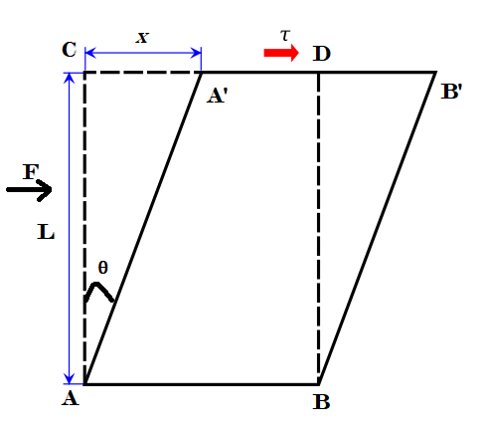
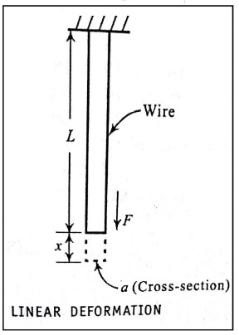
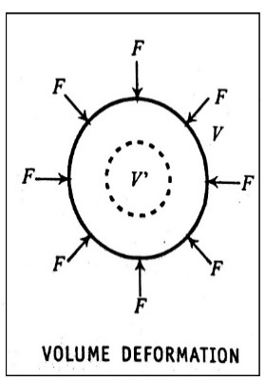
The above figures represent Longitudinal, Compressive and Shear stress respectively.
Strain
Definition: The ratio of the change in dimensions to original dimension is called strain.
$$Strain=\frac{x}{L}$$
Types of strain
- Tensile strain $(T)$:
- If force is applied at one along its length keeping the other end fixed, the wire undergoes a change in length.
- If $x$ is the change in length produced in an original length ‘L’ then,
$$Linear Stress or longitudinal Strain (T)=\frac{Change in length}{Original length}=\frac{x}{L}$$
- Volume strain:
- If a uniform force is applied all over the surface of a body, the body undergoes a change in its volume. If $v$ is the change in volume to the original volume V then
$$Volume Strain=\frac{v}{V}$$
- Shear Strain $(θ)$:
- in case of shearing, the shearing angle itself is a measure of the ratio of change in dimension to original dimensions.
$$Shearing strain=θ=\frac{CA^{'}}{AC}=\frac{x}{L}$$
Hooke’s law:
Hooke’s law can be stated that, “Within elastic limit, the stress is directly proportional to the strain”.
$$i,e Stress α Strain$$
$$\frac{Stress}{Strain}=Constant=E$$
Where E is known as the modulus of elasticity.
Failure of Hook’s law:
A limitation to Hooke's Law is that, it is only applicable under the elastic limit of any material, which means that a material should be perfectly elastic to obey. Beyond the elastic limit the Hooke's law essentially breaks down.

Elastic moduli:
- Young’s Modulus (Y):
The ratio of longitudinal stress to Longitudinal strain with in the elastic limits is called Young’s modulus.
$$Young^{'}s Modulus \left(Y\right)=\frac{Longitudinal stress}{Longitudinal strian}=\frac{F/a}{x/L}$$
$$Young^{'}s Modulus \left(Y\right)=\frac{FL}{ax} N/m^{2}$$
- Bulk modulus(K):
The ration of compressive stress or pressure to the volume strain without change in shape of the body within the elastic limits is called the Bulk Modulus.
$$Bulk Modulus\left(K\right)=\frac{Compressive Stress}{Volume strain}=\frac{F/a}{v/V}=\frac{P}{v/V}$$
$$K=\frac{PV}{v} N/M^{2}$$
$$Where P=F/a$$
- Rigidity Modulus (n):
The rigidity modulus is defined as the ratio of the tangential stress to the shearing strain.
$$Rigidity Modulus \left(n\right)=\frac{Tangential Stress}{Shearing Strain}=\frac{F/a}{x/L}$$
$$n=\frac{FL}{ax} N/m^{2}$$

Poisson’s Ratio (σ)
- When the material is loaded within the elastic limit, then, the ratio of lateral strain to longitudinal strain remains constant and is called “Poisson’s ratio”($σ$).
- Its value ranges from 0.1 to 0.5
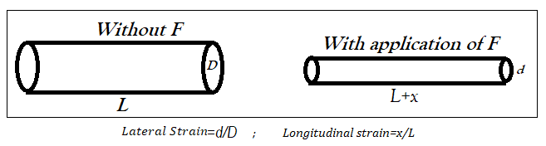

$$Poisson^{'}s Ratio (σ)=\frac{Lateral Strain}{Longitudinal Strain}=\frac{Change in diamter /Original diameter}{Change in Length / Original Length}=\frac{\frac{d}{D}}{\frac{x}{L}}$$
$$σ= \frac{Ld}{xD}$$
- The longitudinal strain produced per unit stress (T) is called Longitudinal Strain Coefficient.
$i.e. Longitudinal Strain Coefficient, α=\frac{\frac{x}{L}}{T}=\frac{x}{TL}$

- The lateral strain produced per unit stress is called Lateral Strain Coefficient.
$$i.e. Lateral Strain Coefficient, β=\frac{\frac{d}{D}}{T}=\frac{d}{TD}$$

$$σ=\frac{Lateral Strain Coefficient}{Longitudinal Stain Coefficient}=\frac{β}{α}=\frac{\frac{d}{TD}}{\frac{x}{TL}}=\frac{Ld}{xD}$$
$$σ=\frac{β}{α}$$
Expression for Y, n and K in terms of α and β:
- $Y=\frac{1}{α}$
- $K=\frac{1}{3\left(α-2β\right)}$
- $n=\frac{1}{2(α+β)}$

Relation between elastic constants:
When a body undergoes an elastic deformation, it is studied under any one of three elastic moduli depending upon the type of deformation. And these are related to each other.
Relation between shearing strain, elongation strain and compression strain.
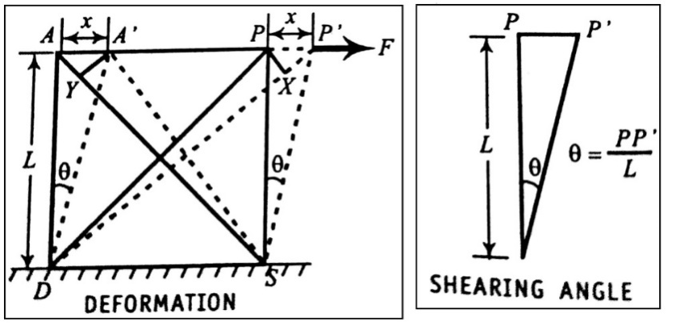

Consider a face of cube APSD, let θ be the angle of shear. If PX is drawn perpendicular to P’D and A’Y to AS then $DP≈DX and A'S≈YS$. So it could be approximated that P’X is the extension in an original length PD and AY is the contraction in an original length AS.
$$Elongation Strain = \frac{P^{'}X}{PD}$$
$$Compression Strain=\frac{AY}{AS}$$
If L is the length of the each side of the cube, then $AS=PD=\sqrt{2}L$
$$P^{'}X=PP^{'}Cos∠PP^{'}X=PP^{'}Cos∠AP^{'}D=PP^{'}Cos {45}^{0}=\frac{PP^{'}}{\sqrt{2}} (∵Isosceles right angled triangle)$$
$$Elongation Strain = \frac{P^{'}X}{PD}=\frac{\frac{PP^{'}}{\sqrt{2}}}{\sqrt{2}L}=\frac{PP^{'}}{2L}=\frac{θ}{2}$$
Similarly, $Compression Strain along AS=\frac{θ}{2}$
$Elongation Strain+Compression Strain=\frac{θ}{2}+\frac{θ}{2}=θ=Shearing Strain$

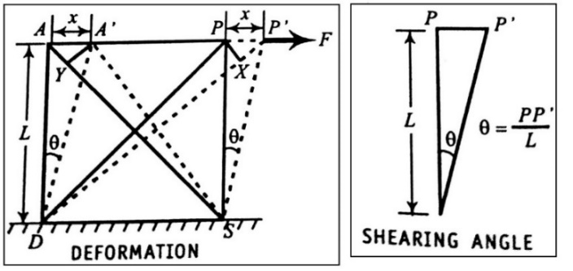
Relation between Young’s Modulus(Y), Rigidity Modulus(n), and Poisson’s ratio$(σ)$: $[Y,n and σ]$

If α and β are the longitudinal and lateral strain coefficients produced along DP/unit stress which is applied along AP. Since T is applied stress, extension produced for the length DP due to tensile strain =T.DP. α and extension produced for the length DP due to compression strain=T.DP. β. The total extension in DP is approximately equal to PʹX when PX is drawn perpendicular to DPʹ.
$$Total extension along DP=DP.T.\left(α+β\right)---(1)$$
From the figure,
$$P^{'}X=DP.T\left(α+β\right)=\left(\sqrt{2} L\right) T \left(α+β\right)---(2)$$
and $P^{'}X=PP^{'}Cos {45}^{0}=\frac{PP^{'}}{\sqrt{2}}---(3)$
From figure,
$$PP^{'}=Lθ$$
$$∴ \frac{Lθ}{\sqrt{2}}=\left(\sqrt{2} L\right)× T×\left(α+β\right)$$
By rearranging
$$\frac{T}{θ} =\frac{1}{2(α+β)}$$
$$wkt n=\frac{T}{θ}$$
$$∴ n=\frac{1}{2(α+β)}=\frac{1}{2α\left(1+\frac{β}{α}\right)}$$
$$n=\frac{1/α}{2\left(1+σ\right)}---(4)$$
$$(∵σ=β/α)$$
But young’s modulus is given by
$$Y=\frac{Stress}{Longitudinal strain}=\frac{1}{(Longitudinal strain/Stress)}=\frac{1}{Strain along DP/Unit stress}=\frac{1}{α}$$
Substitute this in (4) we get,
$$n=\frac{Y}{2\left(1+σ\right)}$$
$$Y=2n\left(1+σ\right)$$
Relation between Bulk Modulus(K), Young’s Modulus (Y) and Poisson’s ratio ($σ)$:$)$: $[K,Y and σ]$
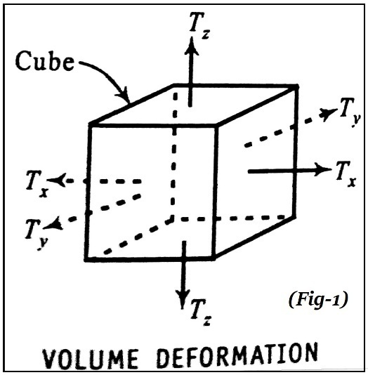
Let $T_{x}{, T}_{y }and T_{z}$ be the stress along length, breadth and height of a cube in X, Y and Z-axis respectively.
Let α and β be the elongation and contraction per unit length per unit stress.
Hence a length which was unity along X direction,
Length along X-axis =$1+{αT}_{x}-{ βT}_{y}-βT_{z}$
Length along Y-axis = $1+{αT}_{y}-{ βT}_{z}-βT_{x}$
Length along Z-axis = $1+{αT}_{z}-{ βT}_{x}-βT_{y}$
$∴Volume of a cubic=(1+{αT}_{x}-{ βT}_{y}-βT_{z})(1+{αT}_{y}-{ βT}_{z}-βT_{x})(1+{αT}_{z}-{ βT}_{x}-βT_{y})$
Since α and β are very small and their product can be neglected.
$$New volume of the cube=1+α\left(T_{x}{+T}_{y}+T_{z}\right)-2β\left(T_{x}{+T}_{y}+T_{z}\right)$$
$=$ $1+(α-2β)\left(T_{x}{+T}_{y}+T_{z}\right)$
$If T_{x}{=T}_{y}=T_{z}=T$, $= \left[1+(α-2β)\left(3T\right)\right]$
Since the cube is under consideration of unit volume,
Increase in volume $= \left[1+(α-2β)\left(3T\right)\right]-1=3T(α-2β)$
If instead of stress T, a pressure P is applied,
Decrease in volume$= 3P(α-2β)$
$$∴Volume Strain=\frac{Change in Volume}{Original Volume}=\frac{3P\left(α-2β\right)}{1}=3P\left(α-2β\right)$$
$$∴Bulk Modulus=\frac{Pressure}{Volume Strain}=\frac{P}{3P\left(α-2β\right)}=\frac{1}{3\left(α-2β\right)}$$
$$=\frac{1}{3\left(α-2β\right)}=\frac{1}{3α\left(1-2β/α\right)}$$
$$K= \frac{Y}{3\left(1-2σ\right)} |Where Y=1/α and σ=β/α$$

Relation between Young’s Modulus(Y), Rigidity Modulus (n) and Bulk Modulus ($K)$:$)$: $[Y,n and K]$
The relation between Y, n and $σ$is given by
$Y=2n(1+σ)$ and $\frac{Y}{n}=2+2σ---(1)$
And for K, Y and $σ as,$
$K=\frac{Y}{3\left(1-2σ\right)}$ and $Y=3K(1-2σ)$

$$∴\frac{Y}{3k}=1-2σ---(2)$$
(1) + (2) gives
$$\frac{Y}{n}+\frac{Y}{3K}=3$$
or, $\frac{Y\left(3K+n\right)}{3nK}=3$
$$∴ Y=[\frac{9nk}{3K+n}]$$
Relation between Bulk Modulus(K), Rigidity Modulus (n) and Poisson’s ratio($σ)$:$[K,n and σ]$
We have the relations $Y=2n\left(1+σ\right)$
And $Y=3K\left(1-2σ\right)$
Equating above equations we get,
$$2n+2nσ=3K-6Kσ$$
$2nσ+6Kσ=3K-2n$
Or , $σ\left(2n+6K\right)=3K-2n$
$$σ=\frac{3K-2n}{2n+6K}$$
Limiting values of $σ$:
We have the relation, $Y=2n\left(1+σ\right)$ and $Y=3K(1-2σ)$,
From the above equations we get,
$$2n\left(1+σ\right)=3K\left(1-2σ\right)$$
- If σ is positive, then left side of the equation is positive. If left side of the equation is positive, then right side should also be positive when σ is not more than ½. Therefore, σ takes the value less than 0.5.
- The limiting value for σ is taken between 0 and 0.5.

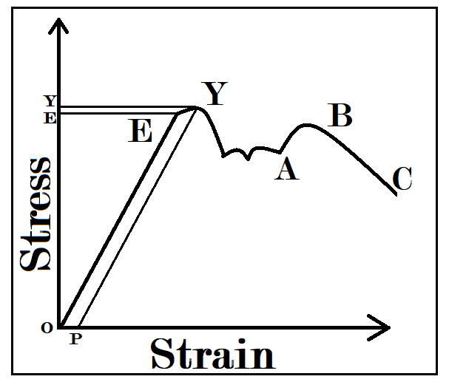
Behavior of the wire under increase in load (Stress Strain diagram):

- Up to point E the curve OE is straight line showing that stress is directly proportional to strain and obeys Hooke’s law. E denotes the elastic limit of the wire. If the stress is removed at any point up to E the wire recovers its original condition of zero strain
- As the elastic limit is extended the strain produced increases more rapidly than the stress and the curve EY departs from the straight line extension. This stress increases up to the Y, after which there is practically no increase in stress for a corresponding increase in strain. The point Y is called the yield point. And the corresponding maximum stress is called the yielding stress.
- If the stress is removed before Y and after E there is a residual strain remaining in the wire which is represented by OP, it is the permanent stress acquired by the wire.
- Beyond the point Y, there start a large but irregular increase in the strain up to A with little or no increase in stress. Beyond A, the material of the wire behaves partly as elastic and partly plastic, both stress and strain increases beyond A.
- Point B represents the breaking stress of the wire; beyond B the wire goes on thinning if the load is increased or decreased.
- At point C local constriction occurs as the wire develops a neck and the stress at the neck becomes quite large and the wire ultimately breakdown at the neck.

Plastic body:
If a body a body does not regain its original size and shape on removal of applied force is called as plastic body.
- Ex: Putty (Material with high plasticity, similar in texture to clay. Used in domestic construction), It is irreversible, they have low yield strength, the shape and size changes permanently, the ratio of stress to strain is high.
Plasticity:
- Plasticity begins where the elasticity ends during the elongation. The elasticity ends at the yielding point Y (From the above Figure). Next in commencement of plastic range.
- Brittle material undergo fracture early, while ductile materials show yielding over an appreciable range. Yield is due to slip; slip occur when two planes of atoms in the metal slip against each other.
Important of elasticity in engineering applications:
- Iron is less elastic than steel. When a tool made up of iron is used in an application where there is a lot of vibration, a small fracture formed in the tool. When in use, the fracture propagates in the body of the tool and end up shattering suddenly.
- If tool is made from steel, it springs back to shape repeatedly as steel is more elastic. Even if it affected also, it undergoes plastic deformation.
- Pure metals are soft by property, ductile and have low tensile strength. Hence they are rarely used in engineering applications. Alloys are generally harder than pure metals, they exhibit unique properties that are different to other constituent metals of which the alloy is made of and offer better elastic properties useful for engineering applications.
Effect of continuous stress and Temperature:
- Under Constant stress, they begin to undergo creep (Creep is the property due to which a material under steady stress undergoes deformation continuously) instead.
- At higher temperature which is significantly higher than room temperature, metals no longer exhibits strain hardening.

Annealing:
- It is a type of heat treatment, Heat treatment are used to alter the physical and mechanical properties of metals without changing its shape.
- Annealing is process to make a metal or alloy or glass soft by heating and then cooling slowly. Which increases strength, hardness, toughness, elasticity and ductility.
- The material can be machines well to achieve a proper shape.
Effect of impurities on elasticity:
- Depend on type of impurity added to a metal, either it increases or decreases the elasticity.
- If the impurity enables the movement of dislocation it causes cracks and thus reduces the strength.
Strain hardening and strain softening:
- Certain materials that are plastically deformed earlier are stressed again, show up an increased yield point, this effect is called strain hardening.
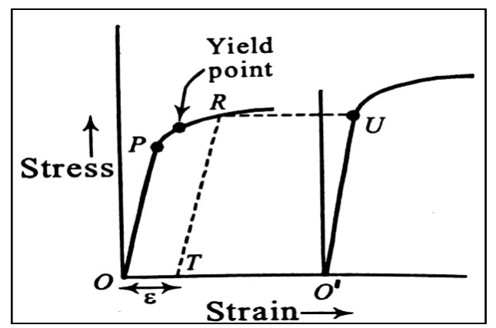
- It is the process of making a metal harder by plastic deformation. Also called work hardening or cold hardening.

Let a material be deformed beyond the yield point so that, it is in the plastic range as shown in the fig. let it be unloaded gradually from some point R (Before fracture). It is observed that the stress-strain curve pertaining to unloading develops in a path (Dashed line) parallel to the curve corresponding to loading (OP). This curve meets the strain axis at T when the unloading is complete. But, it shows a residual plastic strain OT=ε.
When the material is subjected to stress, the new stress-strain curve develops along a line parallel to earlier curve. This shows that, a plastically deformed specimen has a higher yield. In essence, it has been hardened. This effect is called strain hardening.

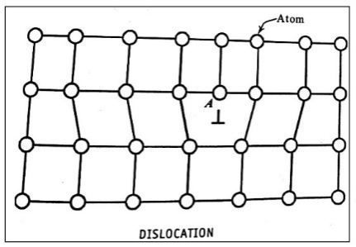
Cause of strain hardening:
- In a crystal if small group of atoms whose positions skip the regularity causing slight lattice distortion called dislocations (⊥).
- Strain hardening is due to dislocations.
- Dislocations repel each other because of similar stresses around them.
Strain softening:
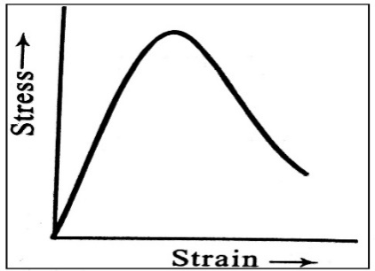
For certain materials like concrete or soil the stress strain curve “turns down” as shown in figure the curve will have negative slope after the elastic region. The negative slope indicates there is a softening effect of the material over this range called strain softening.
Failures(fracture/fatigue):
- Mechanical failure is defined as any change in the size, shape or material properties of a structure, machine or machine parts that renders it in capable of satisfactorily performing its intended function.
- A fracture it is the failure of a material at stress value less than the maximum value of stress under repeated or fluctuating loads.
  - Fatigue failure occurs over a long period of time.
  - 90% of mechanical failure is due to fatigue.
  - It is more prominent in IC Engines, aircrafts, compressors and pumps.
  - Fatigue failures starts from internal cracks or holes then the cracks reach the surface producing fractures of components.
- There are two types of fractures:
1) Brittle(fast) fracture: A brittle fracture occurs due to swift propagation of a crack formulated suddenly. The failure occurs without plastic deformation.
2) Ductile fracture: It propagates slowly with considerable plastic deformation on its way. Failure occurs following necking or shearing.
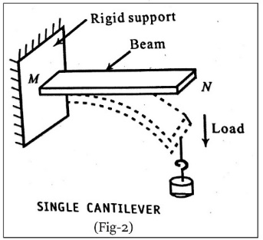
- A fatigue cause due to slow crack growth at loads less than that described by the fast fracture criterion. It occurs due to cycling loading and wherever there are stress concentrations
Bending of beams:
A homogeneous body of uniform cross section whose length is large compared to its other dimensions is called a beam. Whenever a beam is subjected to any bending, shearing stresses between different layers come into play.
Neutral surface and neutral axis:
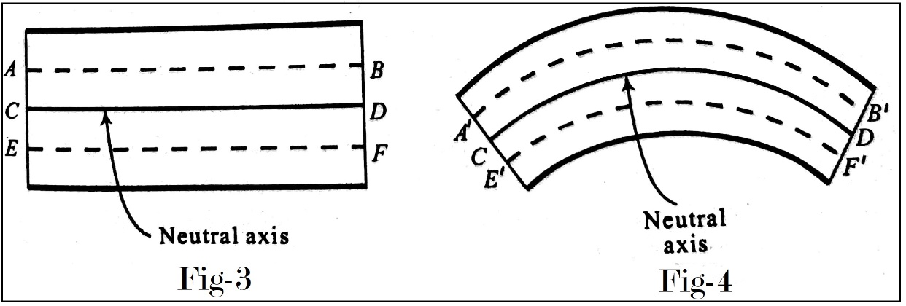

Neutral surface:
Neutral surface is that layer of a uniform beam which doesn’t undergo any change in its dimensions when beam is subjected to bending within its elastic limit.
Neutral axis:
Neutral axis is a longitudinal line along which the neutral surface is intercepted by any longitudinal plane considered in the plane of bending.
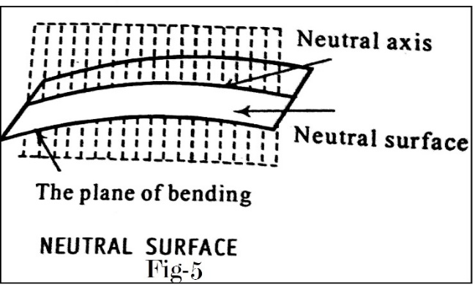
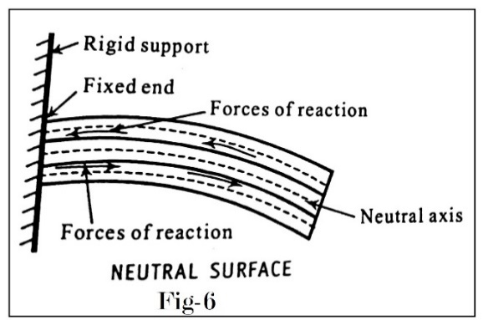

- When a uniform beam is bent, all its layers are above the neutral surface undergo elongation. Whereas the below layers undergo compression. As a result, the forces of reaction came into play develops and inward pull towards the fixed end for the layers above the neutral surface and an outward push directed away from the fixed end for layers below the neutral surface.
Different types of beams and their Engineering Applications:
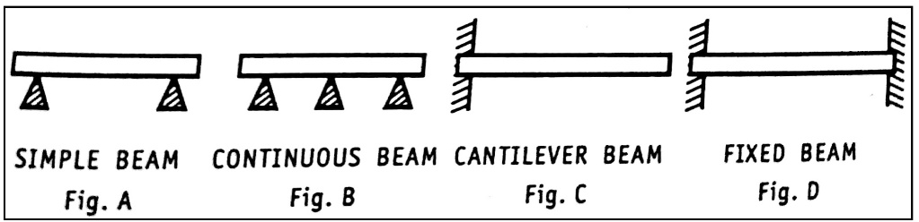

There are four types of beams-
- Simple beam
- Continuous beam
- Cantilever beam
- Fixed beam
A simple beam is bar resting upon supports at its ends (Fig A), and is the kind most commonly on use.
A continuous beam is a bar resting upon more than two supports (Fig B)
A cantilever beam is a beam whose one end is fixed and the other end is free. (Fig C)
A beam is fixed at its both ends is called a Fixed beam (Fig D)
Applications:
- In the fabrications of trolley ways
- In the chassis/frame as truck beds
- In the elevators
- In the construction of platforms and bridges
- As girders in the buildings and bridges.

Bending moment of a beam:
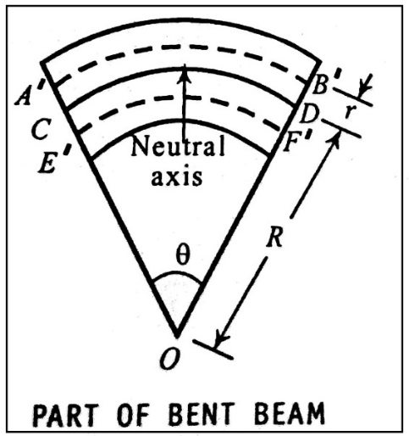

Consider the above beam, CD is the neutral beam, the layers like AB which is above neutral surface will be elongated to A’B’ and the one like EF below the neutral surface will be contracted to E’F’.
The shape of different layers of the bent beam can be imagined to form part of concentric circles of varying radii as shown in figure. Let R be the radius of the circle to which the neutral surface forms a part.
$$∴ CD=Rθ$$
Where $θ→common angle subtended by the layers from the centre O$
$$AB has been elongated to A^{'}B^{'}$$
$$∴Change in length=A^{'}B^{'}-AB$$
But AB=CD=Rθ (From figure)
If the successive layers are separated by a distance r then,
$$A^{'}B^{'}=\left(R+r\right)θ$$
$$Change in length=\left(R+r\right)θ-Rθ=rθ$$
But $Original length=AB=Rθ$
$$Linear Strain=\frac{rθ}{Rθ}=\frac{r}{R}$$
$$But, Young^{'}s Modulus \left(Y\right)=\frac{Longitudinal Stress}{Linear Strain}$$
$$Longitudinal Stress=Y ×Linear Strain$$
$$=Y\left[ \frac{r}{R} \right]$$
$$But, Stress=\frac{F}{a}$$
$$\frac{F}{a}=Y\left[ \frac{r}{R} \right]$$
$$F=\frac{Yar}{R}$$
$$∴Moment of this force about the neutral axis=F ×Its distance from neutral axis$$
$$=F×r=\frac{Yar^{2}}{R}$$
$$Moment of the force acting on the entire beam=\sum{\frac{Yar^{2}}{R}}$$
$$=\frac{Y}{R}\sum{ar^{2}}$$
The moment of inertia of a body about a given axis is given by $\sum{m}r^{2}$ where $\sum{m}$ is the mass of the body and $\sum{a}r^{2}$ is called the geometric moment of inertia I_{g}.
$$∴ I_{g}=\sum{ar^{2}=AK^{2}}$$
where A is the area of cross section of the beam and K is the radius of gyration about the neutral axis.
$$Moment of the force=\frac{Y}{R}I_{g}$$
$$Bending moment=\frac{Y}{R}I_{g}$$
Expression for Bending moment:
The expression for I_{g} varies with the geometrical shape of the beam’s cross-section. Accordingly, the expression for bending moment also varies. The actual expression for bending moment for beams of circular and rectangular cross-sections are given as follows-
- Bending moment for a beam of rectangular cross section
$$=\frac{Y}{R}\left(\frac{bd^{3}}{12}\right)---\left(1\right)$$
$$where b \& d are the breadth and thickness of the beam respectively.$$
- Bending moment for a beam of circular cross-section
$$=\frac{πY}{4R}ρ^{4}$$
Where $ρ$ is the radius of the beam.

SINGLE CANTILEVER:
Consider a uniform beam of length L fixed at M. Let a load W act on the beam at N. As a result, the beam bends as shown in figure.
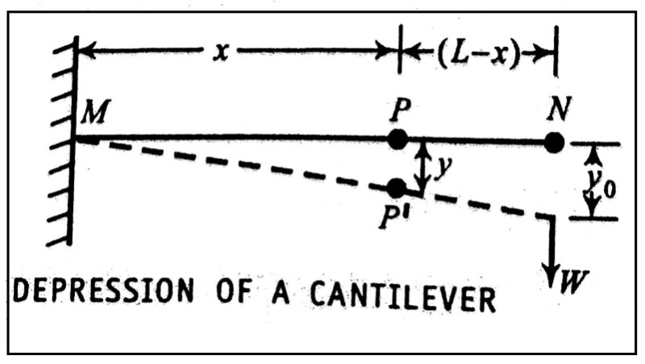

Consider a point P on the free beam at a distance x from the fixed end which will be at distance of (L-x) from N.
Let P’ be its position after the beam is bent.
$$∴ Bending moment=force×Perpendicular distance$$
$$=W(L-x)$$
But bending moment of a beam is given by, $\frac{Y}{R}I_{g}$
$$∴ \frac{Y}{R}I_{g }=W(L-x)$$
Or, $\frac{1}{R}=\frac{W\left(L-x\right)}{YI_{g}}---(1)$
But if y is depression of point P then it can be shown that,
$$\frac{1}{R}=\frac{d^{2}y}{dx^{2 }} approximately---(2)$$
Where, R is the radius of the circle to which the bent beam becomes a part, Comparing, (1) and (2),
$$\frac{d^{2}y}{dx^{2 }}=\frac{W\left(L-x\right)}{YI_{g}}---(3)$$
Integrating (3) twice w.r.t x on both sides, we get
$$\frac{dy}{dx}=\frac{W}{YI_{g}}\left(Lx-\frac{x^{2}}{2}\right)$$
$$y= \frac{W}{YI_{g}}\left(\frac{Lx^{2}}{2}-\frac{x^{3}}{6}\right)$$
$$\frac{d}{dx}\left(\frac{dy}{dx}\right)=\frac{W\left(L-x\right)}{YI_{g}}$$
At the loaded end, y=y₀ and x=L.
$$∴ y_{0}=\frac{W}{YI_{g}}\left(\frac{L^{3}}{2}-\frac{L^{3}}{6}\right)$$
Depression produced at the loaded end is,
$$y_{0}=\frac{WL^{3}}{3YI_{g}}---(4)$$
$$∴ The Young^{'}sModulus of the material of the cantilever=Y=\frac{WL^{3}}{3y_{0}I_{g}}---\left(5\right)$$
If the beam is having rectangular cross section with breath b and thickness d then,
$$I_{g}=\frac{bd^{3}}{12}$$
Substitute the above in (5) we get
$$Y=\frac{WL^{3}}{3y_{0}}×\frac{12}{bd^{3}}$$
$$Y=\frac{4WL^{3}}{y_{0}bd^{3}}$$
Torsion of cylinder:
- A long body which is twisted around its length as an axis is said to be under torsion.
- The twisting is brought into effect by fixing one end of the body to a rigid support and applying a suitable couple at the other end.

Expression for Torsion of a cylindrical rod:
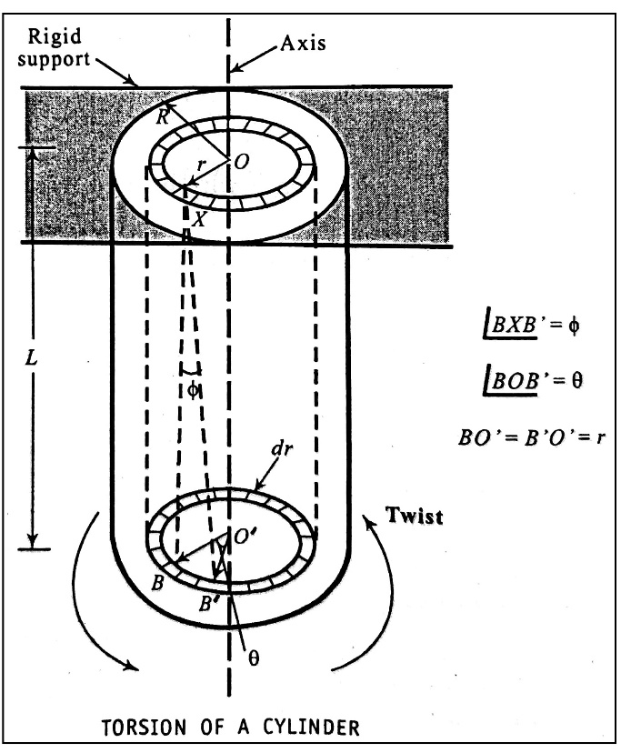

Consider a long cylindrical rod of length L and radius R rigidly fixed to upper end. Let OO’ be its axis.
We can imagine the cylindrical rod to be made of thin concentric hallow cylindrical layers each of thickness dr. Let us consider one concentric circular layer of radius r and thickness dr.
The point X is fixed and B shifts to B’, $∠BXB^{'}=ϕ$is the angle of shear. Since $ϕ$ is also small, we can have BB’=L$ϕ$ Also, $BO^{'}B^{'}=θ,$then arc length BB’=rθ.
$$Lϕ=rθ, or ϕ=\frac{rθ}{L}---(1)$$
Now, the cross sectional area of the layer under consideration is $2πrdr.$ If F is the shearing force, then the shearing stress T is given by,
$$T=\frac{Force}{Area}=\frac{F}{2πrdr}$$
$$∴ Shearing Force F= T\left(2πrdr\right)---(2)$$
If $ϕ$ is the angle through which the layer is sheared then the rigidity modulus,
$$n=\frac{Shearing stress}{Shearing strain }=\frac{T}{Φ} From \left(1\right)$$
After substituting for T, Eq(2) becomes
$$F=\frac{nrθ}{L}\left(2πrdr\right)=\frac{2πnθ}{L}r^{2}dr$$
$$∴ Moment of the force about OO^{'}=\left(\frac{2πnθ}{L}r^{2}dr\right)r$$
$$=\frac{2πnθ}{L}r^{3}dr$$
This is regarding only one layer of the cylinder.
Therefore, the twisting couple acting on the entire cylinder,
$$=\int_{r=0}^{r=R}{\frac{2πnθ}{L}r^{3}dr}$$
$$=\frac{2πnθ}{L}\left[\frac{r^{4}}{4}\right]{R \atop 0}$$
$$=\frac{πnR^{4}θ}{2L}$$
Couple per unit twist is given by,
$$C=\frac{Total twisting couple}{angle of twist}=\frac{πnR^{4}θ/2L}{θ}$$
$$C=\left(\frac{πnR^{4}}{2L}\right)---(3)$$

Torsional Pendulum and its period:
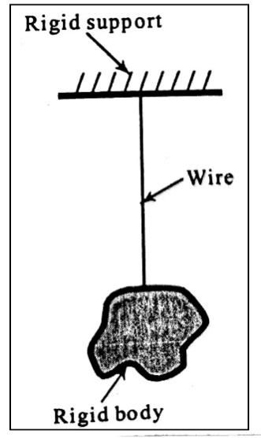
Consider a straight uniform wire whose one end is fixed to a rigid support and its other end a rigid body is attached. If the suspended body is rotated slightly around the wire as its axis, then the wire gets twisted. When the body is let free, then because of the elasticity of the material of the wire, it undergoes regular to and fro turning motion around the wire as its axis. Such type of oscillations are called Torsional Oscillations and the setup is called Torsional Pendulum.
Definition: A body suspended by a thread or wire which twists first in one direction and then in the reverse direction, in the horizontal plane is called a torsional pendulum and the oscillation is called Torsional oscillation.
As per the theory of vibrations, the time period of oscillation T for a torsional pendulum is given by
$$T=2π\sqrt{\frac{I}{c}}$$
Where l is the moment of inertia of the rigid body about the axis through the wire. C is the couple/unit twist for the wire. It is derived on the basis that, the amplitude is small, hence it is not applicable when the amplitude is large.
Applications of Torsional Pendulum:
- The working of “Torsion pendulum clocks " (shortly torsion clocks or pendulum clocks), is based on torsional oscillation.
- The freely decaying oscillation of Torsion pendulum in medium (like polymers), helps to determine their characteristic properties.
- New researches, promising the determination of frictional forces between solid surfaces and flowing liquid environments using forced torsion pendulums.
- To determine moment of inertia of the irregular bodies.
- To find the rigidity modulus of the material.

Problems on Module 2
- Calculate the force required to produce an extension of 1 mm in steel wire of length 2 meters and diameter 1 mm. (Young’s modulus for steel Y = 2 $×{10}^{11}$N/m²)
Given, Extension to be produced, $x= {10}^{-3} m$
Length of the wire, L =2 m
Diameter, $d=1 mm= {10}^{-3} m$
Young’s modulus, Y = 2 $×{10}^{11}$N/m²
Force required to produce extension, F = ?
Solution: Radius of the wire, $R=\frac{d}{2}= \frac{{10}^{-3}}{2}= {0.5 ×10}^{-3} m.$
Young’s modulus of the material of the wire is given by,
$$Y= \frac{FL}{ax}$$
Where, a is the area of cross section of the wire,
$∴substituting, a= π R^{2}$, the equation for Y becomes,
$$Y= \frac{FL}{π R^{2}x}$$
$$F= \frac{π R^{2}Yx}{L}$$
$$F= \frac{(3,14×{\left({0.5 ×10}^{-3}\right)}^{2}× 2 ×{10}^{11}×{10}^{-3}) }{2}$$
$$F=78.54 N$$
- Calculate the extension produced in a wire of length 2 m and radius 0.013$×{10}^{-2}$ m due to a force of 14.7 N applied along its length.
(Given, Young’s modulus of the material of the wire, Y = 2 $×{10}^{11}$N/m² .)
Given, Length of the wire, L =2 m
Radius of the wire, $R=$0.013$×{10}^{-2}$ m
Applied force, F = 14.7 N
Young’s modulus, Y = 2 $×{10}^{11}$N/m²
Extension to be produced, $x= ?$
Solution: Young’s modulus of the material of the wire is given by,
$$Y= \frac{FL}{ax}$$
Where, a is the area of cross section of the wire,
$$∴ Extension produced, x= \frac{FL}{aY}$$
$$x= \frac{FL}{π R^{2}Y}$$
$$x= \frac{14.7 ×2}{3.14× {(0.013×{10}^{-2})}^{2}×2 ×{10}^{11}}$$
$$x=2.6 × {10}^{-3} m$$

- Calculate the torque required to twist a wire of length 1.5 m, radius 0.0425$×{10}^{-2}$ m, through an angle ($π$/45) radian, if the value of rigidity modulus of its material is 8.3 $×{10}^{10}$ N/m² .
Given, Length of the wire, L =1.5 m
Radius of the wire, $R=$0.0425$×{10}^{-2}$ m
Angle of twist, $θ= \frac{π}{45} radian$
Rigidity modulus of its material, $n=$8.3 $×{10}^{10}$ N/m²
Torque required for twisting, $τ= ?$
Solution: We know couple/unit twist is given by,
$$C=\left(\frac{πnR^{4}}{2L}\right)$$
$$C=\left(\frac{3.14 × 8.3 ×{10}^{10} × {(0.0425×{10}^{-2})}^{4}}{2 ×1.5}\right)$$
$$C=2.8357 ×{10}^{-3}$$
$But$Torque required for twisting, $τ= Cθ$
$$τ= 2.8357 ×{10}^{-3} × \frac{π}{45}$$
$$τ=1.98 ×{10}^{-4} Nm$$

- Calculate the angular twist of a wire of length 0.3 m, and radius 0.2$×{10}^{-3}$ m when a torque of 5$×{10}^{-4}$ Nm is applied. Rigidity modulus of the material 8 $×{10}^{10}$ N/m².
Given, Length of the wire, L = 0.3 m
Radius of the wire, $R=$0.2 $×{10}^{-3}$ m
Torque required for twisting, $τ= 5 × {10}^{-4} Nm$
Rigidity modulus of its material, $n=$8.3 $×{10}^{10}$ N/m²
Angular twist produced, $θ=?$
Solution: Torque acting on the wire, $τ= Cθ$,
Where, $C=\left(\frac{πnR^{4}}{2L}\right)$
$$∴ τ=\frac{πnR^{4}}{2L}θ$$
$$θ= \frac{2 τ L}{πnR^{4}}$$
$$θ= \frac{2 ×5 × {10}^{-4} ×0.3}{3.14 ×8.3 ×{10}^{10}×{(0.2 ×{10}^{-3})}^{4}}$$
$$θ=0.75 radian$$

- An increment in length by 1 mm was observed in a gold wire of diameter 0.3 mm, when it was subjected to a longitudinal force of 2 N, and a twist of 0.1 radian was observed in the same wire when its one end was subjected to a torque of 7.9$×{10}^{-7}$ Nm, while its other end was fixed. Calculate the value of Poisson’s ratio for gold.
Given, Diameter, $d=0.3 mm= {0.3 ×10}^{-3} m$
Applied force, F = 2 N
Increment in length, $x=1 mm= {1 ×10}^{-3} m$
Applied torque, $τ= 7.9 × {10}^{-7} Nm$
Observed twist, $θ=0.1 radian$
Poisson’s ratio for gold, $σ= ?$
Solution: Radius of the wire, $R=\frac{d}{2}= \frac{{0.3 ×10}^{-3}}{2}= {0.15 ×10}^{-3} m.$
Couple/unit twist, $C= \frac{τ}{θ}= \frac{7.9 × {10}^{-7}}{0.1}= 7.9 × {10}^{-6}$
Equation for Young’s modulus is given by,
$$Y= \frac{FL}{π R^{2}x}---(1)$$
And equation for couple/unit twist given by,
$C=\left(\frac{πnR^{4}}{2L}\right)$
$$n= \frac{2LC}{πR^{4}}---(2)$$
Dividing Eq. (1) & Eq. (2), we have,
$$\frac{Y}{n}= \frac{FL}{π R^{2}x} × \frac{πR^{4}}{2LC}$$
$$\frac{Y}{n}= \frac{FR^{2}}{2xC}$$
$$\frac{Y}{n}= \frac{2 ×{({0.15 ×10}^{-3})}^{2}}{2×{1 ×10}^{-3}×7.9 × {10}^{-6}}$$

$$\frac{Y}{n}=2.848$$
We have relation between $Y, n \& σ$given by,
$$\frac{Y}{n}=2 \left(1+σ \right)$$
$$2.848=2 \left(1+σ \right)$$
$$σ=0.424$$

- A rod of cross section of area 1 cm X 1 cm is rigidly planted into the earth vertically. A string which can withstand a maximum tension of 2 Kg is tied to the upper end of the rod and pulled horizontally. If the length of the rod from the ground level is 2 meters, calculate the distance through which its upper end is displaced just before the string snaps.
(Young’s modulus for steel Y = 2 $×{10}^{11}$N/m² and g = 9.8 m/$\sec^{2}$)
Given, Breadth, $b=1 cm=1 ×{10}^{-2} m$
Thickness, $d= 1 cm=1 ×{10}^{-2} m$
Mass, $m=2 Kg$
Length, $L=2 m$
$Y$= 2 $×{10}^{11}$N/m²
g = 9.8 m/$\sec^{2}$
Distance through which the upper end of the rod is displaced
before the string snaps, $y_{0}$ = ?
Solution: The string snaps when the pulling force becomes equal to the maximum tension the string can withstand, i.e., when, tension = 2 kg
Also, the tension plays the same role as the load in the present context.
$$∴W=mg=2 ×9.8$$
We know that, displacement, $y_{0}=\frac{4WL^{3}}{Ybd^{3}}$
$$y_{0}=\frac{4×2 ×9.8×2^{3}}{2 ×{10}^{11}×1 ×{10}^{-2}{×(1 ×{10}^{-2})}^{3}}$$
$$y_{0}=0.314 m$$

- A solid lead sphere of radius 10.3 m is subjected to a normal pressure of 10 N/m² acting all over the surface. Determine the change in its volume. (Given bulk modulus for lead 4.58$×{10}^{10}$ N/m²)
Given, Radius of the sphere, $r=10.3 m$
Pressure, $P=$10 N/m²
Bulk modulus for lead, $K=$ 4.58$×{10}^{10}$ N/m²
Change in the volume of the sphere, $v= ?$
Solution: We have equation for ,
- The volume of the sphere as, $V=\frac{4}{3} π R^{3}$
- The Bulk modulus as, $K= \frac{P V}{v}$
$∴ v= \frac{P V}{K}$ = $\frac{P }{K} × \frac{4}{3} π R^{3}$
$$v= \frac{10 ×4×π×{(10.3)}^{2} }{4.58×{10}^{10}×3}$$
$$v=1 × {10}^{-6 }m^{3}$$
- A water column of length 1m is held in a cylinder, between its base and a tightly fitted piston. Calculate through which the piston would move if the water column is subjected to pressure of 205$×{10}^{4}$ N. Given Bulk modulus of water = 2.05 $×{10}^{9}$ N/m²
Given, Length of the water column, $l_{1}=1 m$
Pressure applied, $P=205×{10}^{4}$ N
Bulk modulus of water, K = 2.05 $×{10}^{9}$ N/m²
Distance of movement of the piston, $∆x= ?$
Solution: Distance, through which the piston moves,
$$∆x= l_{1}- l_{2}$$
Initial volume of water column, $V= πr^{2}l_{1}----(1)$
Final volume of water column, $V^{'}$ = $πr^{2}l_{2}$
$∴$ Change in volume, $v=V- V^{'}= πr^{2} (l_{1}- l_{2})$
Or, $v= πr^{2} ∆x----(2)$
We know that, $K= \frac{P V}{v}$
$v= \frac{P V}{K}$
From (1) & (2)
$πr^{2} ∆x= \frac{P πr^{2}l_{1}}{K}$
$∆x= \frac{P l_{1}}{K}= \frac{205 ×{ 10}^{4} × 1}{2.05 ×{10}^{9}}$
$$∆x=1 × {10}^{-3}m$$

Module 2: Elastic properties of materials

Q. No. | Question Bank
01 | What is stress and strain. Explain the types of stress and strain
02 | State Hooke’s law and mention its failure. (Dec/Jan 2019)
03 | Differentiate between plastic and Elastic body. (Dec/Jan 2019)
04 | Explain stress strain diagram for a wire under increase in load.
05 | Explain the effect of temperature and continues stress
06 | Explain the process of Annealing and mention effect of impurity on elasticity
07 | Explain strain hardening and strain softening.
08 | Explain poison’s ratio.
09 | Explain fracture and fatigue
10 | Explain types of elastic moduli
11 | Obtain relation between elongation strain, compression strain and shearing strain and obtain relation between K, Y and σ (Dec/Jan 2019)
12 | obtain relation between K, n and Y
13 | obtain relation between K, n and σ
14 | Explain limiting value of σ
15 | Explain neutral surface and neutral axis
16 | Obtain an expression for bending moment of a beam
17 | Obtain an expression for Young’s modulus in single cantilever (Dec/Jan 2019)
18 | Explain different types of beams and their engineering applications
19 | Obtain an expression for torsion of cylindrical rod.
20 | Explain torsional pendulum and its period and mention its applications.

MODULE 3
MODULE- III:
Optical fibres

OPTICAL FIBERS

Optical fibres: Propagation mechanism, angle of acceptance. Numerical aperture. Modes of propagation and Types of optical fibres. Attenuation: Causes of attenuation and Mention of expression for attenuation coefficient. Discussion of block diagram of point to point communication. Merits and demerits

Total Internal Reflection:
- When a ray of light travels from Denser to rarer medium, it bends away from the normal.
- The angle of incidence in the Denser medium is directly proportional to the angle of Refraction in the Rarer medium.
- Critical angle: It is an angle of incidence at which the angle of refraction becomes 90⁰, denoted by$θ_{c}.$
If $θ_{i }and θ_{r} are the angle of incidence and angle of refraction then,$
$If θ_{i}=θ_{c}$
$θ_{r}={90}^{0}$
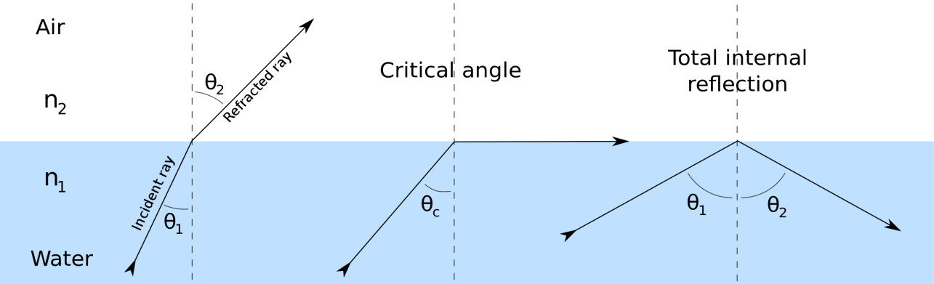
- If the angle of incidence is greater than the critical angle the light ray is reflected back to the same medium this is called “Total Internal Reflection(TIR)”

From Snell’s law we have
$n_{1}\sin{θ_{1}=}n_{2}\sin{θ_{2}}$
For Total Internal Reflection we have
$θ_{1}=θ_{c }and θ_{2}=90^{0}$
$∴n_{1}\sin{θ_{c}=}n_{2}\sin{{90}^{0}}$ $\left(∵\sin{{90}^{0}}=1\right)$
$θ_{c}=\sin^{-1}\left(\frac{n_{2}}{n_{1}}\right)$
In Total Internal Reflection, there is no loss or absorption of light energy.

Optical fibers
Optical fibers are essentially light guides used in optical communication as wave guides. They are transparent dielectrics and able to guide visible and IR rays over long distances.
Construction and working of optical fibers {Propagation Mechanism of optical fibers}
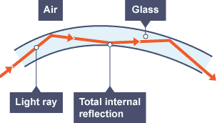

An optical fiber is cylindrical in shape and it has three layers
- Core:
Which is the inner part of the optical fiber, Cylindrical in shape, made up of plastic or glass, having a refractive index $n_{1}$, which is always greater than the refractive index of cladding $n_{2}$.
- Cladding:
The outer part which is concentric cylinder surrounding the core made up of plastic or glass having a refractive index less than the refractive index of core.
- Polyurethane Jacket:
The cladding is enclosed by polyurethane jacket, which is the safeguard against chemical reaction with the surroundings.
- Optical fibers which works on the principle of Total Internal Reflection.
- The working principle is based on the Guiding mechanism.
- Guiding mechanism says
  - In any optical fiber, the refractive index of cladding is always lesser than that for its core$\left(n_{1}>n_{2}\right)$.
  - The light signal enters the core strikes the core-cladding interface only at large angles of incidence as shown in the figure.
- The signal undergoes TIR, thus the signal sustains its strength during propagation.
- The propagation of light continues as long as the fiber is not bent too sharply. Since for the sharp bend light fails to undergo TIR.
- Ray propagation in the fiber:
- Angle of Acceptance$(θ_{0})$ :
It is the maximum angle which can be sent into the optical fiber such that it suffers Total Internal reflection and reaches other end of the fiber.
- Numerical Aperture:
It is light gathering capacity of an optical fiber and it is given by
$N.A=\sin{θ_{0}}$

Expression for Numerical Aperture.
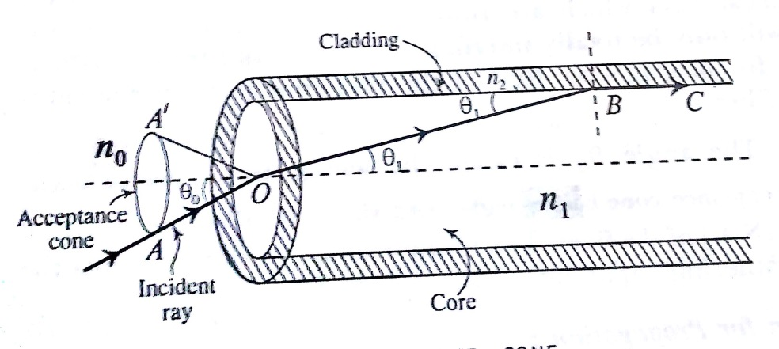

- Consider a light ray ‘AO’ incident at an angle $θ_{0}$ enters into the fiber. Let $θ_{1}$ be the angle of refraction for the ray ‘OB’.
- The refracted ray ‘OB’ incident at a critical angle $\left(90-θ_{1}\right)$ at B and grazes the interface between core and cladding along BC.
- If the angle of incidence is greater than critical angle it undergoes Total Internal reflection. (i.e the angle of incidence must be less than $θ_{0}$)
- $θ_{0} is called wave guide acceptance angle and\sin{θ_{0}}is called Numerical Aperture.$
Let $n_{1 , }n_{2} and n_{3}$ are the refractive indices of the medium, core and cladding respectively.
From Snell’s law at the point of entry ‘O’, we get
$n_{0}{\sin{θ}}_{0}=n_{1}{\sin{θ}}_{1}$
${\sin{θ}}_{0}=\left(\frac{n_{1}}{n_{0}}\right){\sin{θ}}_{1}$---- (1)
From Snell’s law at the point ‘B’, we obtain
$n_{1}{\sin{θ}}_{c}=n_{2}\sin{{90}^{0}}$ $\left(∵{\sin{90}}^{0}=1 and \sin{ \left[90-θ_{1}\right]}=\cos{θ_{1}} \right)$
$n_{1}\sin{ \left[90-θ_{1}\right]}=n_{2}\sin{{90}^{0}}$
$n_{1}{\cos{θ}}_{1}=n_{2}$
${\cos{θ}}_{1}=\left(\frac{n_{2}}{n_{1}}\right)$------ (2)
From equation (1)
${\sin{θ}}_{0}=\left(\frac{n_{1}}{n_{0}}\right)\sqrt{{1-cos}^{2}θ_{1}}$ ---- (3) $\left(∵{\sin{θ}}_{1}=\sqrt{{1-cos}^{2}θ_{1}} \right)$
Substitute (2) in (3)
${\sin{θ}}_{0}=\left(\frac{n_{1}}{n_{0}}\right)\sqrt{1-{\left(\frac{n_{2}}{n_{1}}\right)}^{2}}$
${\sin{θ}}_{0}=\frac{\sqrt{n_{1}^{2}-n_{2}^{2}}}{n_{0}}$
From the definition Numerical Aperture(NA) = ${\sin{θ}}_{0}$
$NA={sin θ}_{0}=\frac{1}{n_{0}}\sqrt{n_{1}^{2}-n_{2}^{2}}$
If the fiber is in air, $n_{0}=1$ then
$$NA=\sqrt{n_{1}^{2}-n_{2}^{2}}$$
Light is transmitted through the fiber only when
$$θ_{i}<θ_{0}$$
$${sin θ}_{i}<{sin θ}_{0}$$
${sin θ}_{i}<NA$
This is the condition for propagation

Fractional index change:
“It is the ratio of the refractive index difference between the core and cladding to the refractive index of the core of an optical fiber”
$$Δ=\frac{\left(n_{2}-n_{1}\right)}{n_{1}}$$

Relationship between Numerical Aperture and fractional index change ($Δ$):
We know that
$Δ{ n}_{1}=\left(n_{2}-n_{1}\right)$----(1)
$NA=\sqrt{n_{1}^{2}-n_{2}^{2}}$
$NA=\sqrt{(n_{1}+n_{2})(n_{1}-n_{2})}$----(2)
From equation (1) , equation (2) can be written as
$NA=\sqrt{(n_{1}+n_{2})Δ{ n}_{1}}$----(3)
Since $n_{1}≈n_{2} which gives \left(n_{1}+n_{2}\right)=2n_{1}$
$∴equation \left(3\right)becomes$
$$NA=\sqrt{2n_{1}^{2}Δ}$$
$$NA=n_{1}\sqrt{2Δ}$$
An increase in the value of $Δ,$ NA increases and thus enhances the light gathering capacity of the fiber.
Note:
Refractive index profile: The curve which represents the variation of RI wrt the Radial distance from the axis of the fiber is called refractive index profile.

Modes of propagation:
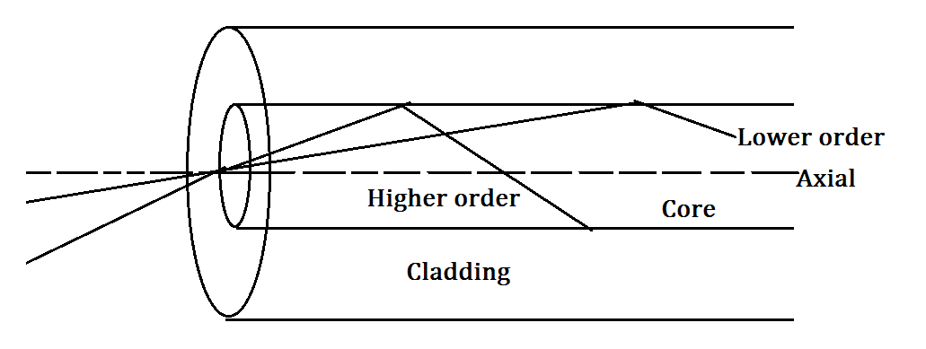

When light is transmitted through optical fiber core of diameter in the range of 50µm to 200µm, it can travel along different ray paths known as modes of propagation.
The modes are shown in the figure
- A ray travelling along the axis is known as axial mode
- Rays travelling at smaller angle of incidence on the core-cladding interface are the higher order modes.
- Rays travelling at higher angle of incidence on the core-cladding interface are the smaller order modes.

V-Number:
The number of Modes supported for propagation in the fiber is determined by a parameter is called V-Number.
$V=\frac{πd}{λ}\sqrt{n_{1}^{2}-n_{2}^{2}}$
Where d$→$ Diameter of the core
$n_{1}and n_{2}→$Refractive index of core and cladding
$λ→$ Wavelength of light propagation
Also,
$V=\frac{πd}{λ}(N.A)$
If the fiber is surrounded by a medium of refractive Index, $n_{0}$ then
$V=\frac{πd}{λ}\frac{\sqrt{n_{1}^{2}-n_{2}^{2}}}{n_{0}}$
For $V≫1$, the Number of Modes supported by the fiber is given by
Number of Modes (N)$≅\frac{V^{2}}{2}$

Types of optical Fibers:
Based on Refractive Index profile and number of Modes optical fibers are classified into three types-
- Step Index single-mode Fiber
- Step Index multi-mode fiber.
- Graded Index multi-mode Fiber

1) Step Index single-mode Fiber.
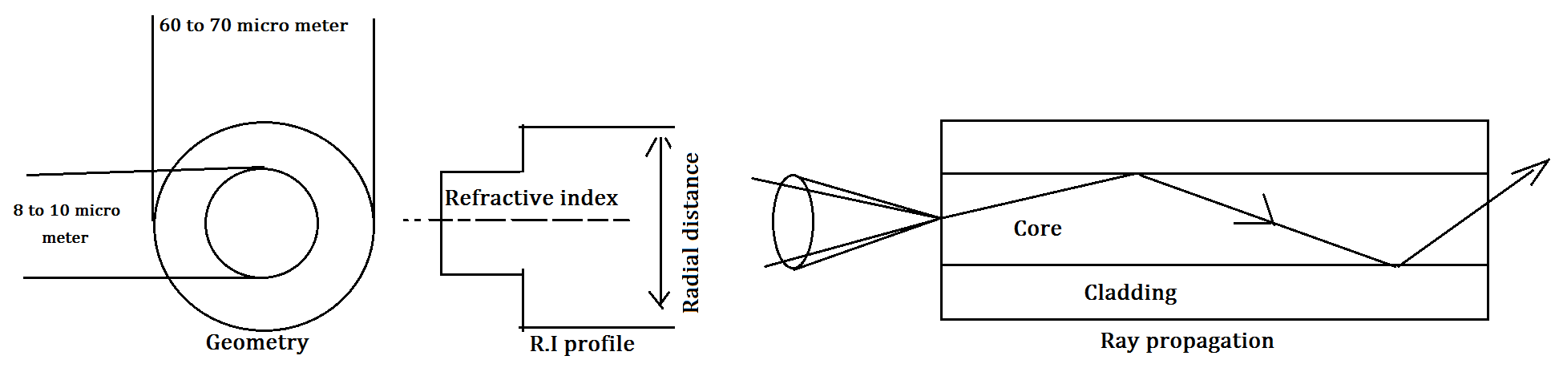
- A single mode fiber can propagate only one mode
- It has uniform refractive index of both core and cladding with a condition that RI of core greater than RI of cladding by lesser value. This results in sudden increase in the value of the RI from cladding to core, thus its Refractive index profile takes the shape of a step.
- Its diameter value of the core is about 8 to 10 µm and external diameter of cladding is 60 to 70 µm
- Lasers were used as source in step index single mode fiber.
- The condition for the singe mode is given by V-Number
$V=\frac{πd}{λ}\frac{\sqrt{n_{1}^{2}-n_{2}^{2}}}{n_{0}};V≤2.405$
- Application: Used in submarine cable system.

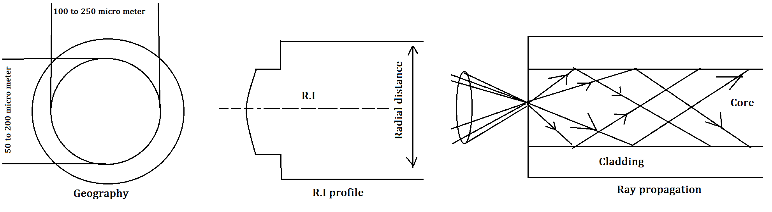
2) Step Index multi-mode fiber.
- Multimode fiber allows a large number of paths or modes for light ray travelling through it.
- It has uniform Refractive index of both core and cladding. Its core has a much larger diameter therefore it supports propagation of large number of modes.
- The diameter value of core is about 50µm to 200µm and cladding of 100µm to 250µm.
- Lasers and LED’s used as a source of light.
- Launching of light into fiber and fabrication is less difficult.
- Application: Used in data links.

3) Graded Index Multimode Fiber (GRIN):
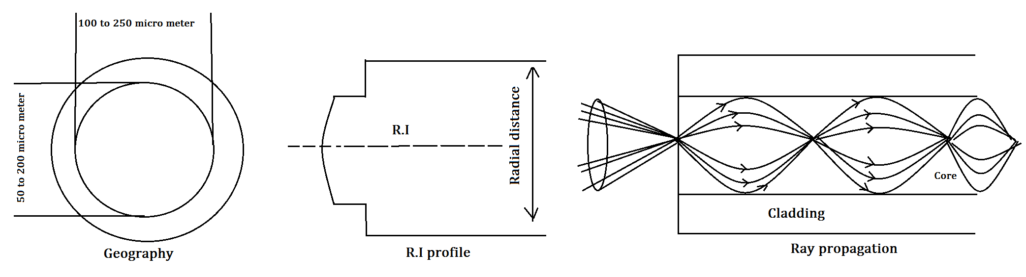
- Its core material has a special feature that its refractive index value decreases in the radially outward direction from the axis and becomes equal to cladding at the interface.
- The diameter of core is about 50µm and cladding of 100µm to 250µm.
- Laser and LED are used as a source of light.
- Application: used in telephone trunk between central offices.

Attenuation:
“Attenuation is the loss of power suffered by the optical signal as it propagates through the fiber”. It is also called fiber loss.
There are three types of attenuation
- Absorption loss
- Scattering loss
- Radiation loss

1) Absorption loss:
The loss of signal power occurs due to absorption of photons associated with the signal, photons are absorbed by
- Impurities:
- During signal processing the types of impurities such as iron, chromium, cobalt and copper interact with the photons and the electrons in the impurities absorbs photons and get excited to higher energy level.
- The absorption occurs predominantly due to the presence of impurities.
- Intrinsic absorption:
- The fiber itself as a material has a tendency to absorb light energy.
- The absorption that takes place in the fiber material assuming that there are no impurities in it and that the material is free of all inhomogeneity’s.

2) Scattering loss:
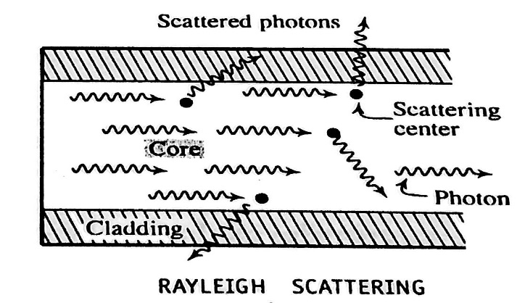

- While the signal travels in the fiber the photons may be scattered because of sharp changes in refractive index values.
- Rayleigh scattering occurs when the scattering objects whose dimensions are smaller than the wavelength
- The change in refractive index induced due to localized structural inhomogeneity during solidification.
- Since the Rayleigh scattering has a characteristic of $λ^{-4}$ dependence, it increases enormously with decreasing $λ,$Rayleigh scattering is responsible for the maximum loss in optical fibers.

3) Radiation Loss:
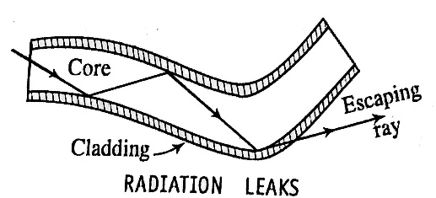
It occurs due to – (a) Macroscopic bends
(b) Microscopic bends
(a) Macroscopic bends: They are the bends with radii much larger
compared to the fiber diameter which occurs while wrapping
the fiber on a spool or turning it around a corner
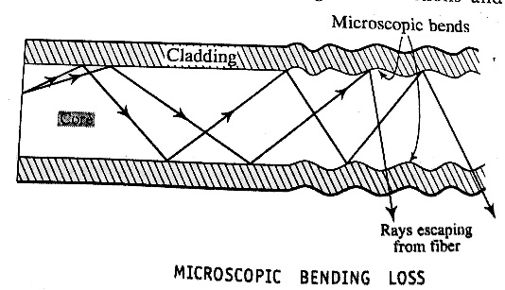

(b) Microscopic bends: They occur due to non-uniformities
in the manufacturing of the fiber. The micro bends causes
irregular reflections and some of them leak through the fiber.

Attenuation coefficient:
- When light travels in a material there will always be a loss of intensity obeys a law called Lambert’s law.
- Lambert’s law states that “The rate of decrease of intensity of light with distance travelled in a homogeneous medium is proportional to the initial intensity”
If P is the initial intensity and L is the distance travelled, then
$-\frac{dP}{dL} ∝ P$----(1)
$-\frac{dP}{dL}=αP$
Where the –ve sign indicates rate of decrease of intensity of light
And $α$ (alpha) is the attenuation co-efficient.
Consider an optical fiber of length L, if $P_{in}$is the initial intensity and $P_{out}$ is the output then we have
$\frac{dP}{P}=-α dL$ ----(2) (From 1)
By integrating both the sides of the equation (2) we get
$$\int_{P_{in}}^{P_{out}}{\frac{dP}{P}=-α\int_{0}^{L}{dL}}$$
$$\left[\log{P}\right]{P_{out} \atop P_{in}}=-α\left[L\right]{L \atop 0}$$
$$\log\left[\frac{P_{out}}{P_{in}}\right]=-α L$$
$α=-\frac{1}{L}\log\left(\frac{P_{out}}{P_{in}}\right)$----(3)
Equation (3) can be written as
$$α=-\frac{1}{L}\log_{10}\left(\frac{P_{out}}{P_{in}}\right) Bel/unit length$$
We know that 1Bel=10 decibel so the above equation becomes
$$α=-\frac{10}{L}\log_{10}\left(\frac{P_{out}}{P_{in}}\right) dB/km$$
$P_{in} and P_{out} are expressed in watt$
Applications of optical fibers

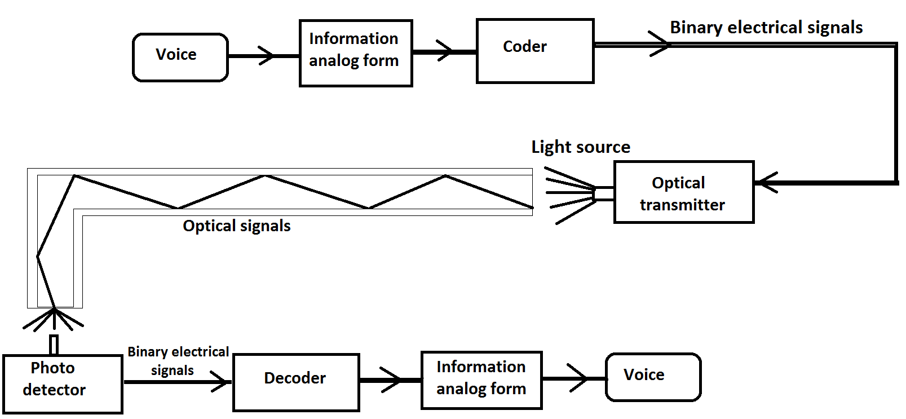
Point to point communication in optical fibers

- A fiber optic communication system is very much similar to a traditional communication system.
- It has three major components, a Transmitter converts electrical signal to light signal, an Optic fiber transmits the light signals and Receiver captures the signals at the other end and converts them to electrical signals.
- The transmitter consists of a light source supported by necessary drive circuits.
- First voice is converted into electrical signals using transducer then to binary electrical signal using coder then fed to optical transmitter.
- The optical transmitter emits modulated light which is transmitted through optical fiber.
- The modulated light is detected by photo detector, it is amplified and is decoded using decoder.
- The output is fed to suitable transducer to convert it into audio or video form.
2. Sensing device: Optical fibers can be used to sense parameters like pressure, voltage or current etc..
3. Data link: By using optical fiber in data link can overcome the limitations like impedance, mismatching, cross talk etc..
4. LAN: Optical fibers provide more efficient communication facilities in Local Area Network.
Advantages of optical fibers:
- It carries very large amount of information in either digital or analog form due to its large bandwidth.
- Since it is made by using dielectrics, it doesn’t produce or receive any electromagnetic interference.
- It is easily compatible with electronic system
- Can operate in high temperature range
- Not affected by corrosion and moisture
- Doesn’t affect by nuclear radiations etc..

________________________
Module 3: Maxwell’s Equations and Optical fibers

Q. No. | Question Bank
1 | Define Divergence, Curl, Line Integral, Surface integral and volume integral.
2 | State and explain Gauss divergence theorem. (Dec/Jan 2019)
3 | Mention gauss flux theorem and stokes theorem. (Dec/Jan 2019)
4 | State and explain gauss law of magnetostatics.
5 | State and explain Amperes and Biot-savarts law
6 | State and explain Faraday’s law of Electromagnetic induction.
7 | Explain equation of continuity.
8 | Define displacement current and explain Maxwell Ampere’s law.
9 | Obtain an expression for displacement current.
10 | Mention Maxwell’s equation.
11 | Obtain an expression for wave equation for electromagnetic waves in vacuum in terms of electric field using Maxwell’s equation. (Dec/Jan 2019)
12 | Mention types of polarization for EM Waves.
13 | Obtain an expression for NA of an optical fiber and mention condition for propagation. (Dec/Jan 2019)
14 | Explain types of Optical fiber.
15 | What is attenuation? Mention the types of attenuation. (Dec/Jan 2019)
16 | Explain point to point communication in optical fiber.

Problems on Optical fibers
- The refractive indices of core and cladding are 1.50 and 1.48 respectively in an optical fiber. Find the numerical aperture and angle of acceptance.
Solution: Given, RI of Core, $n_{1}=1.50$
RI of cladding, $n_{2}=1.48$
$NA$ = ?
Acceptance angle, $θ_{o}= ?$
We have, $NA= \sqrt{{n_{1}}^{2}-{n_{2}}^{2}}$ = $\sqrt{{1.50}^{2}-{1.48}^{2}}$
$NA=0.244$
We also have, $NA=\sin{θ_{o}}$
$θ_{o}=\sin^{-1}{NA}$ = $\sin^{-1}{0.244}$
$θ_{o}={14.1}^{o}$
- An optical fiber has a core material with refractive index 1.55, and its cladding material has a refractive index of 1.50. The light is launched into it in air. Calculate its numerical aperture, the acceptance angle and also the fractional index change.
Solution: Given, RI of Core, $n_{1}=1.55$
RI of cladding, $n_{2}=1.50$
$NA$ = ?
Acceptance angle, $θ_{o}= ?$
Fractional index change, $∆ = ?$
We have, $NA= \sqrt{{n_{1}}^{2}-{n_{2}}^{2}}$ = $\sqrt{{1.55}^{2}-{1.50}^{2}}$
$NA=0.39$
We also have, $NA=\sin{θ_{o}}$
$θ_{o}=\sin^{-1}{NA}$ = $\sin^{-1}{0.39}$
$θ_{o}={23}^{o}$
We have, Fractional index change, $∆ = \frac{n_{1}- n_{2}}{n_{1}}$ = $\frac{1.55-1.50}{1.55}$
$∆ =0.032$

- The NA of an optical fiber is 0.2 when surrounded by air. Determine the refractive index of its core given the refractive index of the cladding is 1.59. Also find the acceptance angle when the fiber is in water. Assume the refractive index of water as 1.33.
Solution: Given, $NA=0.2$ when surrounded by air, $n_{o}=1$
RI of cladding, $n_{2}=1.59$
Acceptance angle, $θ_{o}= ?$ when kept in water; $n_{o}=1.33$
We have, ${\left(NA\right)}_{air}= \sqrt{{n_{1}}^{2}-{n_{2}}^{2}}=0.2$ (from data)
$$0.2= \sqrt{{n_{1}}^{2}-{1.59}^{2}}$$
Squaring on both sides,
$$0.04= {n_{1}}^{2}-{1.59}^{2}$$
$$n_{1}=1.6$$
When in water NA is given by
$${\left(NA\right)}_{water}= \frac{\sqrt{{n_{1}}^{2}-{n_{2}}^{2}}}{n_{o}}= \frac{0.2}{1.33}$$
${\left(NA\right)}_{water}=0.1504$
We also have, ${\left(NA\right)}_{water}=\sin{θ_{o}}$
$θ_{o}=\sin^{-1}{{\left(NA\right)}_{water}}$ = $\sin^{-1}{0.1504 }$
$θ_{o}={8.65}^{o}$
- The angle of acceptance of an optical fiber is ${30}^{o}$ when kept in air. Find the angle of acceptance when it is in a medium of refractive index 1.33.
Solution: Given, Acceptance angle in air, $θ_{o}= {30}^{0}$
RI of refracting medium, $n_{o}^{'}$ = 1.33
We have, $NA=\sin{θ_{o}}= \frac{\sqrt{{n_{1}}^{2}-{n_{2}}^{2}}}{n_{o}^{'}}$
When the surrounding medium is air, then, $n_{o}=1$ and $θ_{o}={30}^{o}$
$$\sin{{30}^{o}= }\sqrt{{n_{1}}^{2}-{n_{2}}^{2}}$$
$$0.5= \sqrt{{n_{1}}^{2}-{n_{2}}^{2}}$$
For surrounding medium,
$$\sin{θ_{o}^{'}}= \frac{\sqrt{{n_{1}}^{2}-{n_{2}}^{2}}}{n_{o}^{'}}$$
$$\sin{θ_{o}^{'}}= \frac{\sqrt{{n_{1}}^{2}-{n_{2}}^{2}}}{1.33}$$
$$1.33 \sin{θ_{o}^{'}}=\sqrt{{n_{1}}^{2}-{n_{2}}^{2}}$$
$$1.33 \sin{θ_{o}^{'}}=0.5$$

MODULE 4

QUANTUM MECHANICS AND LASERS
QUANTUM MECHANICS
Quantum mechanics: Introduction to Quantum mechanics, Wave nature of particles, Heisenberg’s uncertainty principle and applications (non confinement of electron in the nucleus), Schrodinger time independent wave equation, Significance of Wave function, Normalization, Particle in a box, Energy Eigen values of a particle in a box and probability densities

Lasers: Review of spontaneous and stimulated processes, Einstein’s coefficients (derivation of expression for energy density). Requisites of a Laser system. Conditions for laser action. Principle, Construction and working of CO2 and semiconductor Lasers.
Application of Lasers in Defense (Laser range finder) and Engineering (Data storage)
Numerical problems

Introduction:
- Quantum mechanics is a physical science dealing with the behavior of matter and energy on the scale of atoms and sub-atomic particles/waves
- According to classical mechanics the position, mass, velocity, acceleration of a particle or a body can be measured accurately and the trajectory of the particle could be continuously traced.
- In Quantum Mechanics, the presence of a particle is purely probabilistic in nature.
- According to Louis De-Broglie matter waves possess wave as well as particle characteristics whose wavelength is given by
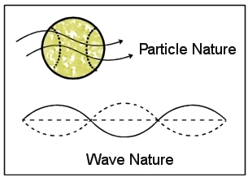
$λ=\frac{h}{p}$

- Consider a wave packet as shown in the figure. The particle to which the wave packet corresponds may be located anywhere within the wave packet at any instant of time.
- If the wave packet is smaller in the extension $Δx$ the position of the particle can be specified more precisely. But wavelength is related to momentum through De-Broglie relation, momentum is not known precisely.
- If wave packet is in lager extension, momentum can be defined more clearly but not the position.
- $∴$ It is impossible to determine both position and momentum simultaneously and accurately at given instant of time.
_________

Wave nature of Particles

Wave-particle Dualism
- From the Compton scattering experiment, Compton observed that X-ray radiation is scattered by an electron, here X-ray radiation assumes the status of a particle.
- X-rays can also diffract by a crystal; diffraction is a wave phenomenon.
- To Explain interference and diffraction in physical optics, light is considered purely as waves.
- Waves which are associated with moving particles are called matter waves.

De-Broglie wavelength:
When a particle has a momentum ‘p’, its motion is associated with a wavelength $λ$, called De-Broglie wavelength, and it is given by,
$λ=\frac{h}{p}---(1)$
Relation between De-Broglie wavelength and Kinetic energy:
The kinetic energy of a particle of mass m moving with velocity v is given by
$$E=\frac{1}{2}{mv}^{2}={\frac{p}{2m}}^{2}$$
$$p=\sqrt{2mE}---(2)$$
Substitute (2) in (1) we get
$λ=\frac{h}{\sqrt{2mE}}---(3)$

De-Broglie wavelength of an accelerated electron:
Consider an electron in an electric potential V, the energy is given by
$$E=eV---(4)$$
Substitute (4) in (3) we get
$$λ=\frac{h}{\sqrt{2meV}}$$
$λ=\frac{1}{\sqrt{V}}\left[\frac{{6.624 X 10}^{-34}}{\sqrt{2 X {9.1X10}^{-31 }X{1.602X10}^{-19}}}\right]$
$$λ=\frac{1.226}{\sqrt{V}}nm$$

Heisenberg Uncertainty principle

- In classical mechanics if the position and momentum of a particle is known at any instant of time, it is possible to calculate its position and momentum at any later instant of time and the path of the particle can be traced.
- This concept breaks down in quantum mechanics leading to Heisenberg uncertainty principle.
Statement:
“It is impossible to measure simultaneously both position and momentum of a particle accurately”
If $Δx$ and $Δp_{x}$ are the uncertainties in the measurement of position and momentum of the particle, then uncertainties can be written as
$Δx ×{Δp}_{x}≥\frac{h}{4π} or Δx ×{Δp}_{x}≥\frac{ħ}{2}$
Where, $ħ$ =$\frac{h}{2π}$and h$→$ Planck’s constant
Similarly,
$ΔE ×Δt≥\frac{h}{4π}$
$ΔL ×Δθ≥\frac{h}{4π}$
Where, $ΔE→Uncertainty in energy$
$Δt→Uncertainty in time$
$ΔL→Uncertainty in angular momentum$
$Δθ→Uncertainty in angular displacement$

Physical significance of Uncertainty principle:
- This principle is based on the assumption that a moving particle is associated with a wave packet.
- It is impossible to measure the position and momentum of a particle simultaneously and accurately
- It is possible to find the probability of particle state or momentum of the particle.
- This principle can be represented using probability function in case of momentum (p), position(x), time(t), energy(E), angular momentum(L) and angular displacement$(θ)$ as-
    - $Δx ×{Δp}_{x}≥\frac{h}{4π}$
    - $ΔE ×Δt≥\frac{h}{4π}$
    - $ΔL ×Δθ≥\frac{h}{4π}$

Application of Uncertainty principle

Impossibility of existence of electron in the atomic nucleus:
The Energy E of a body can be expressed asp;
$$E={\frac{p}{2m}}^{2}---(1)$$
Where $m→$ Mass of the body and $p→$ its momentum.
Heisenberg’s Uncertainty Principle states that
$$Δx ×{Δp}_{x}≥\frac{h}{4π} ---(2)$$
From (2)
$${Δp}_{x}≥\frac{h}{4π×Δx }---(3)$$
The typical value of a diameter of the nucleus is given by
$$Δx≤1×{10}^{-14}m---(4)$$
By substituting (4) in (3) we get
$${Δp}_{x}≥\frac{h}{4π×Δx }=\frac{6.6×{10}^{-34}}{4×3.142 × {10}^{-14} }$$
$${Δp}_{x}≥5×{10}^{-21}kg m/s$$
Since the momentum of the electron must at least be equal to the uncertainty in the momentum, so
$$p_{x}≥5×{10}^{-21}kg m/s---(4)$$
Substitute (4) in (1) we get
$$E≥\frac{{\left(5×{10}^{-21}\right)}^{2}}{\left(2×9.11×{10}^{-31}\right)}$$
$E≥1.3×{10}^{-11} J$
$E≥85 MeV$
Conclusion:
- If an electron exists in the nucleus its energy must be greater than or equal to 85 MeV.
- It is experimentally observed that the $β-particle$ ejected from the nucleus during $β-decay$ has the energies about 3 to 4 MeV. This shows that electron cannot exist in the nucleus.

_______

Wave function
- In order to describe the displacement of free particle Schrödinger introduced a quantity $ψ(x,t)$ which is called wave function.
- We use this wave function to define matter waves and it is related to the probability of finding the particle at any place at any instant which varies periodically.
- The wave function for a free particle moving in the positive $x$-direction is given by
$ψ\left(x,t\right)=ψ_{0}e^{i(kx-ωt)}$
Where,
$ψ\left(x,t\right)→Displacement along x-direction$
$ψ_{0}→Amplitude of the wave$
$k, ω→Wave number and Angular frequency$
Since wave function contains the imaginary term $i=\sqrt{-1}$ hence $ψ\left(x,t\right)$ is ‘Complex quantity’

Physical significance of wave function:
- The wave function $ψ\left(x,t\right)$ contains the information about the system it represents.
- It gives the statistical relationship between the particle and wave nature.
- It is a complex quantity and one cannot measure it.
- It is a function of ‘$x' and 't'$ so it cannot locate the position of the particle.
- $ψ\left(x,t\right)$ allows energy calculations using Schrödinger equation.
- $ψ\left(x,t\right)$ establishes the probability distribution in three dimensions.

Probability Density
- German physicist Max-Born gave the physical interpretation of wave function.
- If $ψ$ is the complex number, then its complex conjugate is obtained by replacing $i by-i$ and $ψ by ψ^{*}$
- The product $ψψ^{*}dx$ gives the probability of finding the particle between the positions $x and x+dx$
- Probability density defined by $p\left(x\right)$ and it is always real quantity, this can be written as
$p\left(x\right)=ψψ^{*}$
- Probability density for a free particle is given by
$p\left(x\right)=ψ_{0}e^{i(kx-ωt)}×ψ_{0}e^{-i(kx-ωt)}$
${p\left(x\right)=\left|ψ_{0}\right|}^{2 }is constant$
- We can conclude that there is an equal probability of finding the particle at any point along the $x$-direction from $x=-∞ to+∞$

Normalization of wave function:
The integral of ${\left|ψ\right|}^{2}$ taken over all space must have some finite value. The integral cannot be either zero or infinity, it can neither be negative nor complex.
If the wave function $ψ$ should describe a real body, the integral of ${\left|ψ\right|}^{2}$ taken over all space must have a finite value then
$\int_{-∞}^{∞}{{\left|ψ\right|}^{2} dv=1}$ ------- (1)
The wave function that satisfies equation (1) is called Normalized wave function.

Properties of wave function:
- A system or state of the particle is defined by its energy, momentum, position etc., If $ψ(x,t)$ of the system is known the system can be defined.
- To find$ψ(x,t)$, Schrödinger equation has to be solved. As it is 2nd order differential equation, we have to choose the suitable wave function which satisfies the following properties.

1. $'ψ'$ Must be single valued everywhere:
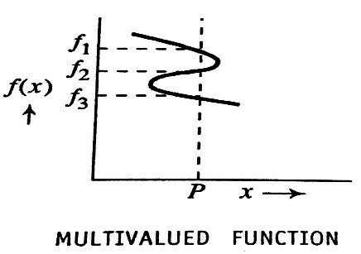
- Consider the function $f(x)$ which varies with position
as shown in the figure.
- $f(x)$ has three different values $f_{1,}{ f}_{2,}{ f}_{3}$ at $x=P$
- If $f(x)$ were to be the wave function the probability of
finding the particle in all the location must be same.
- But in this case $f_{1}{≠f}_{2}≠{ f}_{3}$ so the wave function is not acceptable.
- Thus the wave function should have a single valued everywhere in the region of space.

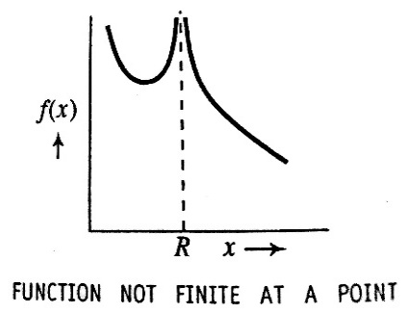
2. $'ψ'$ Must be finite everywhere:
- Consider the function $f(x)$ which varies with position
as shown in the figure.
- The function $f(x)$ is not finite at $x=R$ but$f\left(x\right)=∞$.
- Thus it indicates large probability of finding the particle at location, it violates uncertainty principle. So the wave function cannot be acceptable.

3. $'ψ'$ And its derivatives with respect to its variable are continues everywhere:
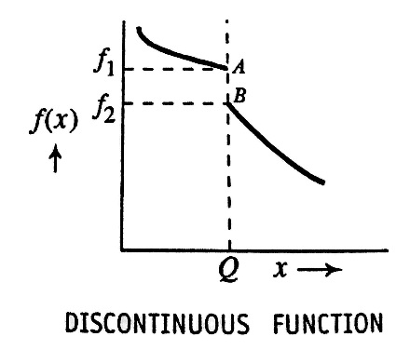
- From figure, at $x=Q$, $f\left(x\right)$ truncated at A and restarts at B, between A and B it is not defined.
- The wave function$f(x)$ is discontinues at $A$
- Also, when wave function is not continues, its first derivative will not be finite, thus the second derivative will not be finite. But we need the second derivatives in evaluating the Schrödinger equation.
4. For bound states $ψ$ must vanish at potential boundary and outside. If $ψ$ is a complex function, then $ψψ^{*}$must vanish at infinity.

- Thus, the wave function $ψ$ which satisfies the above 4 properties are called Eigen functions.
___________

SETTING UP OF SCHRÖDINGER ONE-DIMENSIONAL WAVE EQUATION.

The Schrödinger equation is the fundamental equation of physics for describing quantum mechanical behaviour of a particle.
There are two types of Schrödinger wave equation
1. The time dependent Schrödinger wave equation.
It takes care of both the position and time variations of the wave function.
$$\left(E+V\right)ψ=iℏ\frac{∂ψ}{∂t}$$
2. The time independent Schrödinger wave equation.
$$\frac{d^{2}ψ}{dx^{2}}+\frac{8π^{2}m}{h^{2}}\left(E-V\right)ψ=0$$

Derivation of time independent Schrödinger wave equation.
Consider a wave equation
$ψ=Ae^{i(kx-ωt)}$----(1)
Where A is amplitude and $ω$ is angular frequency
Differentiate the equation (1) twice we get
$\frac{∂ψ}{∂t}=\left(-iω\right)×Ae^{i(kx-ωt)}$
$\frac{∂^{2}ψ}{∂t^{2}}=(-iω)^{2}×Ae^{i(kx-ωt)}$
$\frac{∂^{2}ψ}{∂t^{2}}={-ω}^{2}ψ$----(2)
The general differential equation of a wave travelling in $x-derection$ with velocity $v$ having a wave function $ψ$ is given by
$\frac{∂^{2}ψ}{∂x^{2}}=\frac{1}{v^{2}}\frac{∂^{2}ψ}{∂t^{2}}$----(3)
Where $ψ$ is the displacement and $t$ is time
Put equation (2) in (3) we get
$\frac{∂^{2}ψ}{∂x^{2}}=\frac{{-ω}^{2}}{v^{2}}ψ$----(4)
But $ω=2πϑ=\frac{2πv}{λ}$ $\left\{∵ ϑ=\frac{v}{λ}\right\}$
$\frac{ω^{2}}{v^{2}}=\frac{4π^{2}}{λ^{2}}$
$\frac{ω^{2}}{v^{2}}=\frac{4π^{2}p^{2}}{h^{2}}$----(5)$\left\{∵λ=\frac{h}{p} is the De-Broglie wavelength \right\}$
The total energy $E$ is the sum of kinetic energy and potential energy
$E=\frac{p^{2}}{2m}+V$
$p^{2}=2m(E-V)$----(6)
Substitute equation (6) in (5) we get
$\frac{ω^{2}}{v^{2}}=\frac{8π^{2}m}{h^{2}}(E-V)$----(7)
By substituting equation (7) in (4) we obtain
$\frac{∂^{2}ψ}{∂x^{2}}+\frac{-8π^{2}m}{h^{2}}\left(E-V\right)ψ$
$\frac{∂^{2}ψ}{∂x^{2}}+\frac{8π^{2}m}{h^{2}}\left(E-V\right)ψ=0$----(8)
Equation (8) is used when the potential energy is constant in time but varies in space. $∴$ $ψ$ depends on space-coordinate.
For the total derivative
$\frac{d^{2}ψ}{dx^{2}}+\frac{8π^{2}m}{h^{2}}\left(E-V\right)ψ=0$
This equation gives the solution for $ψ$ as a function of $x$ only. This is the equation for time independent wave equation.

Eigen functions and Eigen values:

Eigen functions: Eigen functions are those wave functions of Quantum Mechanics which possess the properties like
- They are single valued
- Finite Everywhere
- The wave function and their First derivatives with respect to their variables are continuous
Eigen values:
The Eigen functions are used in Schrodinger equation to determine the energy of the system. These will be only restricted set of energy values. These energy values are called “Eigen values”
But all the Eigen functions when operated by the operator may not give value for physical observable. For a physical quantity only possible values that can be observed like Angular momentum, Energy etc. these are the values $'λ^{'}(Eigen value)$ in the operator equation.
$\hat{A}ψ=λψ$
Where $\hat{A}$ is the operator for the physical quantity and $ψ$ is the Eigen function.
__________

Applications of Schrodinger wave equation:

Energy Eigen values of a particle in One-Dimensional infinite potential well (potential well of infinite Depth) of a particle in a box:
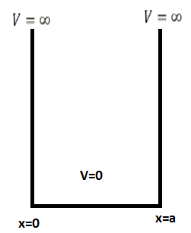

- Consider a particle of mass $m$, free to move in one-dimension along positive x-direction between $x=0 to x=a$
- There are two absolutely rigid impenetrable potential walls of infinite height then
- $V=0 for 0≤x≤a$ $∵Inside the box V is zero$
- $V=∞ for 0>x>a$ $∵Outside the box V is infinity$

Wave equation:
For a particle inside the box the Schrodinger wave equation is given by
$\frac{d^{2}ψ}{dx^{2}}+\frac{8π^{2}m}{h^{2}}\left(E-0\right)ψ=0$---- (1)
$\frac{d^{2}ψ}{dx^{2}}+K^{2}ψ=0$---- (2) $\left(where k^{2}=\frac{8π^{2}mE}{h^{2}}\right)$---- (3)
The solution for the equation (2) is
$ψ=A\cos{kx+B\sin{kx}}$---- (4)
Where $A$ and $B$ are constants and depends only on the boundary conditions.
Boundary conditions:
- At $x=0 ; ψ\left(x\right)=0$
$∴ 0=A\cos{0+B\sin{0}}$
$A=0$
- At $x=a ; ψ\left(x\right)=0$
$∴ 0=A\cos{ka+B\sin{ka}}$
$B\sin{ka=0}$
Here $B≠0$ $∴ka=nπ$ and $a=\frac{nπ}{k}$
$k=\frac{nπ}{a}$------ (5)
Where n=1,2,3… Called Quantum number and $n≠0$ because particle with zero energy cannot present in the box.
So, we can obtain the wave function inside the box by substituting equation (5) in (4) & the condition A=0; $ψ_{n}\left(x\right)=B\sin\left(\frac{nπ}{a}\right)x$ ----- (6)

Energy Eigen values:
From equation (3) and (5)
$k^{2}=\frac{8π^{2}mE}{h^{2}}$
$E_{n}=\frac{k^{2}h^{2}}{{8π}^{2}m}$ Where $k=\frac{nπ}{a} from (5)$
$E_{n}=\frac{{\left(\frac{nπ}{a}\right)}^{2}h^{2}}{{8π}^{2}m}$
$E_{n}=\frac{n^{2}h^{2}}{{8ma}^{2}}$ ----- (7)
Equation (7) shows that Energy Eigen values are discrete (Not continuous)
Since $n≠0$ the lowest accepted value is $n=1$
$E_{1}=\frac{h^{2}}{{8ma}^{2}}$
Is called Ground state or Zero Point Energy.
_________________________________________________________

Normalization (Evaluation of B):
$$\int_{0}^{a}{{\left|ψ_{n}(x)\right|}^{2}dx=1}----(8)$$
Put (6) in (8)

$$\int_{0}^{a}{B^{2}\sin^{2} \left(\frac{nπ}{a}\right)dx=1}$$
We know that, $\sin^{2}θ=\frac{1-\cos{2θ}}{2}$
$$∴\frac{B^{2}}{2}\int_{0}^{a}{\left[1-\cos\left(\frac{2nπ}{a}\right)x\right]dx=1}$$

$$\frac{B^{2}}{2}\left[x-\frac{\sin\left(2nπ/a\right)x}{\left(2nπ/a\right)}\right]a=1$$
The second term equation becomes zero
$$∴\frac{B^{2}a}{2}=1$$
$$B=\sqrt{\frac{2}{a}}$$
$∴ψ_{n}\left(x\right)=\sqrt{\frac{2}{a}}\sin\left(\frac{nπ}{a}\right)x$
This is the normalized wave function for a particle in 1-D potential well.

Probability:
$${p\left(x\right)=\left|ψ_{n}(x)\right|}^{2}$$
$$p\left(x\right)=\frac{2}{a}\sin^{2}\left(\frac{nπ}{a}\right)x$$
$p\left(x\right)$ is maximum when $\frac{nπx}{a}=\frac{π}{2}, \frac{3π}{2}, \frac{5π}{2}$
$\frac{nπx}{a}=\frac{π}{2} which gives x=\frac{a}{2n}$
$\frac{nπx}{a}=\frac{3π}{2} which gives x=\frac{3a}{2n}$ and so on.
For n=1, the most probable position of the particle is at $x=\frac{a}{2}$
For n=2; $x=\frac{a}{4}, \frac{3a}{4}$
For n=3; $x=\frac{a}{6}, \frac{3a}{6}, \frac{5a}{6}$
Representation of Wave function, Energy Eigen values, Probability Density for a particle in 1-D potential well:
The wave function: $ψ_{n}\left(x\right)=\sqrt{\frac{2}{a}}\sin\left(\frac{nπ}{a}\right)x$
Energy Eigen value: $E_{n}=\frac{n^{2}h^{2}}{{8ma}^{2}}$
Probability Density: $p\left(x\right)=\frac{2}{a}\sin^{2}\left(\frac{nπ}{a}\right)x$
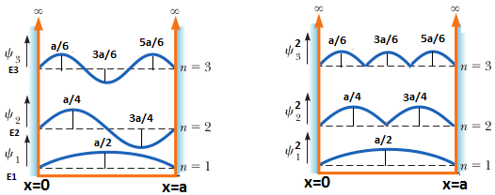

Case 1: When n=1 Case 2: When n=2
The wave function: $ψ_{1}=\sqrt{\frac{2}{a}}\sin\left(\frac{π}{a}\right)x$ The wave function: $ψ_{2}=\sqrt{\frac{2}{a}}\sin\left(\frac{2π}{a}\right)x$
Energy Eigen value: $E_{n}=\frac{n^{2}h^{2}}{{8ma}^{2}}=\frac{h^{2}}{{8ma}^{2}}=E_{1}$ Energy Eigen value $E_{2}={\left(2\right)}^{2}E_{1}$

Probable position: $x=\frac{a}{2}$ Probable position: $x=\frac{a}{4},\frac{3a}{4}$
Problems
- An electron has a speed of 100 m/s. The inherent uncertainty in its measurement is 0.005%. find the corresponding uncertainty that arises in the measurement of its position.
Solution: Given: Speed of an electron = 100 m/s.
Inherent uncertainty in speed (v)= 0.005%
$∴Uncertainty in speed\left(Δv\right)=100×\frac{0.005}{100}=0.005 m/s$
$$Uncertainty in position=Δx≥\frac{h}{4πmΔv}=\frac{6.624{×10}^{-34}}{4π×9.1×{10}^{-31}×0.005}=0.011 m$$

2. A spectral line of wavelength 5461 A⁰ has a width of 10⁻⁴ A⁰. Evaluate the minimum time spent by the electron in the upper energy state between the excitation and de-excitation process.
Solution: Given: $Wavelength λ=5461 A^{0}=5461×{10}^{-10}m$
$width Δλ={10}^{-4} A^{0}={10}^{-4}×{10}^{-10}m$
$Δt=?$
$E=\frac{hc}{λ}$
$ΔE=hc × Δ\left(\frac{1}{λ}\right)=hc×\frac{Δλ}{λ^{2}}--(1)$
$ΔE × Δt=\frac{h}{4π}$
$Δt≥\frac{h}{4πΔE}--(2)$
From (1) and (2)
$\frac{h}{4πΔE}=\frac{hλ^{2}}{4π(hc×Δλ)}$
$\frac{h}{4πΔE}=\frac{λ^{2}}{4πcΔλ}=ΔE=7.9×{10}^{-9}sec$

3. The inherent uncertainty in the measurement of time spent by the Iridium-191 nuclei in the excited state is found to be $1.4 ×{10}^{-10}sec.$ Estimate the uncertainty that results in its energy in the excited state.
Solution: Given: $Δt=1.4 ×{10}^{-10}sec$
$ΔE=?$
$$ΔE×ΔE≥\frac{h}{4π}$$
$$ΔE≥\frac{h}{4πΔt}=\frac{6.624×{10}^{-34}}{4×3.142×1.4×{10}^{-10}}=3.76×{10}^{-25}J=2.35×{10}^{-6}eV$$

4. An electron is bound in one-dimensional potential well of width 1 A⁰ but of infinite wall height. Find the energy values on the ground state and also in the first two excited states.
Solution: Given: $Width a=1 A^{0}=1×{10}^{-10}m$
$$E_{1}=?, E_{2}=?, E_{3}=?$$
$$E=\frac{n^{2}h^{2}}{8ma^{2}}$$
$$E_{1}=\frac{{\left(1\right)}^{2}{\left(6.624×{10}^{-34}\right)}^{2}}{8×9.1×{10}^{-31}×{\left(1×{10}^{-10}\right)}^{2}}=6.02×{10}^{-18}J=37.66 eV$$
$$E_{2}=\frac{{\left(2\right)}^{2}{\left(6.624×{10}^{-34}\right)}^{2}}{8×9.1×{10}^{-31}×{\left(1×{10}^{-10}\right)}^{2}}=2.4×{10}^{-17} J=150.5 eV$$
$$E_{3}=\frac{{\left(1\right)}^{2}{\left(6.624×{10}^{-34}\right)}^{2}}{8×9.1×{10}^{-31}×{\left(1×{10}^{-10}\right)}^{2}}=5.08 ×{10}^{-17}J=338.6eV$$

On Heisenberg uncertainty principle.

- An electron has speed of $5×{10}^{5}m/s$ accurate to 0.2% with what accuracy can be located the position of the electron.
Solution: $Δx?$
$Δx ×{Δp}_{x}≥\frac{h}{4π}$
- A spectral line of wavelength 5461 A⁰ has a width of 10⁻⁴ A⁰, Evaluate the minimum time spent by the electron spent by the electron in the upper energy state between the excitation and de-excitation process.
Solution: $Δt=?$ And E =$\frac{hc}{λ}$ so $ΔE=\frac{hc}{λ^{2}}Δλ$
$ΔE ×Δt≥\frac{h}{4π}$
- The position and momentum of 1KeV electron are simultaneously determined and if its position is located within 1A⁰ what is the % of uncertainty in its momentum
Solution: $Δx ×{Δp}_{x}≥\frac{h}{4π}$
${Δp}_{x}=?$
$p=\sqrt{2mE } and \% of Uncertainty \frac{Δp}{p} ×100$
- On the basis of uncertainty principle estimate the maximum energy of an electron that is confined in a cavity of volume 60 X 60 X 60 A⁰
Solution : E = E_{x} + E_{y} + E_{z}
E_{x}=p²/2m
On Eigen value and Eigen functions:
- An electron is bound in an 1-D potential well of width of 2 A⁰ but of infinite wall height. Find its energy values in the ground state and also first two excited states.
Solution: a=2 A⁰ and E_{n}=n²h²/8ma²
- A particle is moving in a 1-D potential box of infinite height of width 2.8nm; calculate the probability of finding the particle within an interval of 0.8nm at the box when it is in its state of least energy.
Solution : ${p\left(x\right)=\left|ψ_{n}(x)\right|}^{2}$
- Find the value of B for which the wave function $\frac{B}{\sqrt{x^{2}+a^{2}}}$ is normalized in the region $-∞<x<∞$
Solution : ${p\left(x\right)=\left|ψ_{n}(x)\right|}^{2}$
- A particle in 1-D box is described by the wave function $ψ=x\sqrt{3}$ for $0<x<1$ and $ψ=0$elsewhere. Find the probability of finding the particle within the interval $\left(0,1/2\right)$
$$solution: {p\left(x\right)=\left|ψ_{n}(x)\right|}^{2}$$

- Calculate the kinetic energy of an electron of wavelength 18nm.
$λ=\frac{h}{\sqrt{2mE}}$
********

LASER
Lasers: Review of spontaneous and stimulated processes, Einstein’s coefficients (derivation of expression for energy density). Requisites of a Laser system. Conditions for laser action. Principle, Construction and working of CO2 and semiconductor Lasers.
Application of Lasers in Defense (Laser range finder) and Engineering (Data storage)

Introduction:
- Under the normal circumstances when a light interacts with matter, electrons in the matter may absorb the light energy and go to the higher energy level and come back to the ground state by emitting the light of same frequency.
- The laser is based on the principle of “Light Amplification by the Stimulated Emission of Radiation”. This is achieved by having excess concentration of electrons in the higher energy states and stimulating the system by radiation to bring about the de-excitation process.
- Coherence: the waves are said to be coherent if the phase difference between them is constant.
- Energy states of an atom:
  - Ground state: Lowest possible state of an atom, atom stays here for an infinite time.
  - Excited state: It has a higher energy than the ground state, life time of these states are very short, typically of the order of 10⁻⁸sec
  - Metastable state: These are excited states of an atom with relatively longer time of the order of 10⁻³ sec

Interaction of electromagnetic radiation with matter.
- The interaction of electromagnetic radiation with matter leads to the transition of an atom from one energy state to other.
- If the transition is from lower state to higher state, it absorbs the incident energy. If the transition is from higher state to lower state it emits part of the energy.
- If $ΔE$ is the path difference between two energy levels, then
$ΔE={(E}_{2}-E_{1})=hϑ Joule$s
$$ϑ=\frac{(E_{2}-E_{1})}{h} Hz$$
These are the three types of interaction –
- Induced absorption
- Spontaneous emission
- Stimulated emission.
- Induced absorption:
- It is the absorption of an incident photon by a system as a result of which the system is elevated from lower energy state to the higher energy state.
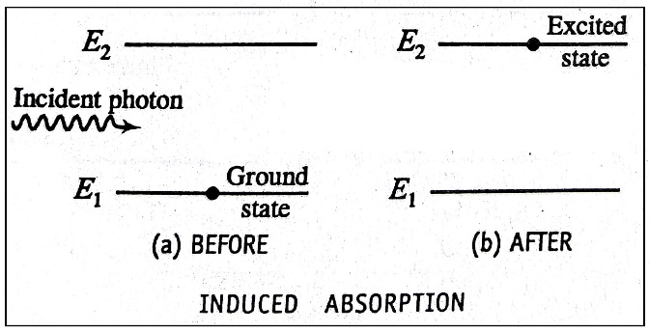
- Consider a system having two energy levels$E_{1}and E_{2}$, if an electromagnetic wave of suitable frequency $ν$ is applied the atom get excited to the higher energy level $E_{2}$ after absorbing the incident radiation.
- It is represented as $atom+photon→{atom}^{*}$
- The frequency of absorbed photon is
$ν=\frac{(E_{2}-E_{1})}{h}$
- The rate of induced absorption is $α N_{1}E_{ϑ}$
The rate of induced absorption is $= B_{12}N_{1}E_{ϑ}$
Where
$E_{ϑ}→Energy density of incident radiation$
$N_{1}→Number density of lower energy state$
$B_{12}→Einstein coefficient of induced absorption constant$

- Spontaneous Emission:
- It is the emission of a photon by transition of a system from a higher energy state to a lower energy state without the aid of an external energy.
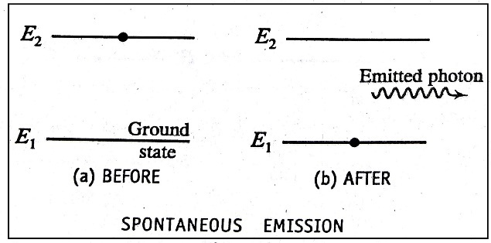
- Consider a system having two energy levels$E_{1}and E_{2}$, atom in $E_{2}$ is unstable than$E_{1}$. The difference in the energy state is $\left(E_{2}-E_{1}\right)=hϑ$.
- The spontaneous emission can be represented as
${atom}^{*}→atom+photon$
- The emitted photon in spontaneous emission may not have same direction and phase similarities, it is incoherent. Ex: glowing electric bulb, candle flame etc.
- The rate of rate of spontaneous emission is $α N_{2}$
The rate of spontaneous emission $= A_{21}N_{2}$
Where
$N_{2}→Number density of excited state$
$A_{21}→Einstein coefficient of spontaneous emission constant$

- Stimulated emission.
- It is the process of emission of photon by a system under the influence of passing photo of just the right energy due to which the system transists from higher energy to lower energy.
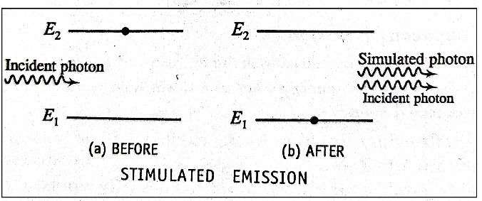
- The photon thus emitted is called stimulated photon and will have the same energy and direction of movement.
- The incident photon stimulates the excited atom to emit the photon of exactly the same energy as that of incident photon, the emitted photons have the same frequency, direction of polarization with the incident photon, this kind of action is responsible for lasing action.
$${atom}^{*}+photon→atom+photon+photon$$
The rate of induced absorption is $∝ N_{2}E_{ϑ}$
The rate of induced absorption is $= B_{21}N_{2}E_{ϑ}$
Where
$E_{ϑ}→Energy density of incident radiation$ ${ N}_{2}→Number density of excited energy state$
$B_{21}→ Einstein coefficient of stimulated emission constant$

Boltzmann Equation
At thermal equilibrium, the number of atoms of any level is given by
$$N_{i}=N_{0}e^{-E_{i}/kT}$$
For two level system let $N_{1}and N_{2}$ be the number of atoms for the energy levels $E_{1}and E_{2}$
Then
$$N_{1}=N_{0}e^{-E_{1}/kT}$$
And
$$N_{2}=N_{0}e^{-E_{2}/kT}$$
$$∴Ratio of population is given by,$$
$$\frac{N_{2}}{N_{1}}=e^{\frac{-(E_{2}-E_{1})}{kT}}=e^{-hν/kT}$$

Einstein A and B Coefficients (Expression for Energy density)
Consider two energy states $E_{1}and E_{2} \left(E_{2}>E_{1}\right)$ , let $N_{1} and N_{2}$be the number density of atom in the states $E_{1}and E_{2}$ respectively. $E_{ϑ}$ be the energy density of radiations of frequency $ϑ$. Then $E_{ϑ}dϑ$ will be the energy density of radiations whose frequencies lies in the range $ϑ and ϑ+dϑ$.
Case 1: Induced absorption
- $atom+photon→{atom}^{*}$
- The rate of induced absorption is $∝ N_{1}E_{ϑ}$
The rate of induced absorption is $= B_{12}N_{1}E_{ϑ}---(1)$
Where
$E_{ϑ}→Energy density of incident radiation$
$N_{1}→Number density of lower energy state$
$B_{12}→Einstein coefficient of induced absorption constant$
Case 2: spontaneous emission
- ${atom}^{*}→atom+photon$
- The rate of spontaneous emission is $∝ N_{2}$
The rate of spontaneous emission $= A_{21}N_{2}----(2)$
Where
$N_{2}→Number density of excited state$
$A_{21}→Einstein coefficient of spontaneous emission constant$
Case 3: stimulated emission
- ${atom}^{*}+photon→atom+photon+photon$
- The rate of induced absorption is $∝ N_{2}E_{ϑ}$
The rate of induced absorption is $= B_{21}N_{2}E_{ϑ}----(3)$
At thermal equilibrium, using conservation of energy
Rate of Induced absorption = Rate of spontaneous emission + Rate of stimulated emission
Using equation (1)(2) and (3) in the above equation we get
$B_{12}N_{1}E_{ϑ}=A_{21}N_{2}+B_{21}N_{2}E_{ϑ}$
$E_{ϑ}=\frac{A_{21}N_{2}}{[B_{12}N_{1}-B_{21}N_{2}]}$
By rearranging we get
$E_{ϑ}=\frac{A_{21}}{B_{21}}\left[\frac{1}{\frac{B_{12}N_{1}}{B_{21}N_{2}}-1}\right]----(4)$
From Boltzmann law we know that the ratios of population densities $N_{1} and N_{2}$ in the ground state $E_{1}$and excited state $E_{2}$ respectively is given by
$\frac{N_{1}}{N_{2}}=e^{\frac{hϑ}{kT}}----(5)$
Using (5) in (4)
$E_{ϑ}=\frac{A_{21}}{B_{21}}\left[\frac{1}{\frac{B_{12}}{B_{21}}e^{\frac{hϑ}{kT}}-1}\right]----(6)$
Planck’s law is given by
$E_{ϑ}=\frac{8πhϑ^{3}}{c^{3}}\left[\frac{1}{e^{\frac{hϑ}{kT}}-1}\right]----(7)$
Comparing (6) and (7) we can obtain
$\frac{A_{21}}{B_{21}}=\frac{8πhϑ^{3}}{c^{3}} ; \frac{B_{12}}{B_{21}}=1$
$$B_{12}=B_{21} which implies that probability of induced absorption is equal to that of stimulated$$
$$emission, hence we can use simply A and B to denote the Einstein coefficients with these our equation$$
$for the energy density at thermal equillibrium takes the form$
$E_{ϑ}=\frac{A}{B\left(e^{\frac{hϑ}{kT}}-1\right)}$

Conditions for laser action:
E₃
E₂
E₁
1. Metastable state:
- It is the state at which the atoms or molecules stay for an unusual long time of the order of 10⁻³ to 10⁻⁴ seconds.
- The state plays an important role in lasing action. This property helps in achieving population inversion.
2. Population inversion:
E₃
E₂ N₂
E₁ N₁
- It is the state of a system at which the population of a particular energy level is made to be greater than that of the lower energy level.
- let E₁, E₂ and E₃ be the energy of the system here E₁<E₂<E₃. And E₂ represents the metastable state.
- When the atom gets excited from E₁ to E₃, and comes to E₂ and stays there for longer time than E₃ and a stage is reached in which the number of atoms in E₂ is more than number of atoms in E₁ is called population inversion. (N2>N1)

Requisites of a Laser system:
1. Excitation source
2. Active medium
3. Laser cavity
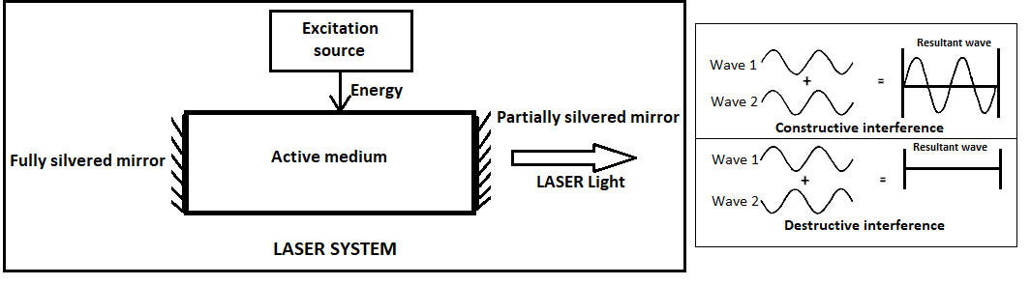
1. Excitation Source:
The excitation source provides energy in an appropriate form for pumping the atoms to higher energy levels.
Ex: Light energy (Optical pumping), Electrical energy (Electrical pumping)
2. Active medium:
Active medium is one which the population inversion takes place.
3. Laser cavity:
- Two mirrors along with active medium form a laser cavity.
- Inside the cavity two types of waves exist; one type comprises waves moving to the right and to the left.
- When two waves interfere constructively which gives no phase difference, if its destructive gives phase difference of $π$.
- Condition for constructive interference is
$L=n\frac{λ}{2}$
$$where$$
$$n→integer>0$$
$$λ→Wavelength, λ=\frac{2L}{n}$$
- The laser cavity provides the feedback necessary to tap certain permissible part of laser energy from the active medium.

Introduction to Carbon dioxide laser.
In order to understand CO₂ Laser, it is required to understand types of collisions, Brewster window and vibrational energy levels of CO₂ and N₂.
- Types of collisions:
I) Collision of I kind:
e₁+A=e₂+A*
where e₁ and e₂ are the energies of electrons before and after collisions, A and A* are the atoms in ground and excited states.
II) Collision of II kind:
A₁*+A₂=A₁+A₂*
Where A₁* and A₁ represents the energy values of the atom of 1st type in the metastable state and in the ground state and A₂ and A₂* represents the energy values of the atom of 2nd type in the ground state and the excited state.
- Brewster window:
- Brewster window is designed on the principle of Brewster angle.
- Quartz is used for Brewster window
- Brewster window is arranged such that to get plane polarized laser beam.
- Vibrational energy levels of CO2 molecule.
I) Symmetric stretching mode:
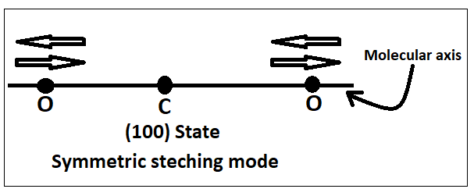

- In this mode, the oxygen atom oscillates along the molecular axis towards or departing from the carbon atom.
- The carbon atom remains stationary.
- Co₂ molecule will have intermediate energy.
- This state is referred as (100) state.
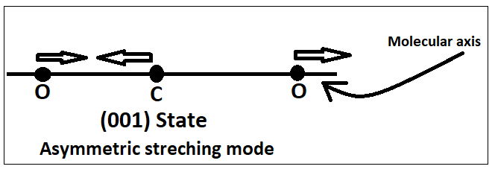
II) Asymmetric stretching mode:

- In this mode, all the three atoms oscillate along the molecular axis.
- Two oxygen atoms moves in one direction while the carbon atom moves in the opposite direction.
- Co₂ molecule has the “highest energy” in this state.
- This state is referred as (001) state.
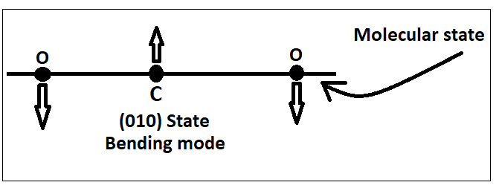
III) Bending mode:

- In this mode, all the three atoms oscillate normal to the molecular axis, while vibrating, the two oxygen atoms pull together in one direction and carbon in other direction.
- The energy of this state is very close to (100) state
- (010) is the lowest excited state and (020) is the next excited state of Bending mode.
(020)

(010)
- Vibrational energy levels of N2 molecule.
- For N₂ molecule, the vibrational energy levels are metastable.
- There is a close coincidence between its first excited state of N₂ and (001) state of CO_{2.}
- This helps in causing population inversion in Co₂ gas laser by means of resonance transfer of energy.
- The states of N₂ are represented as v=0 and v=1.
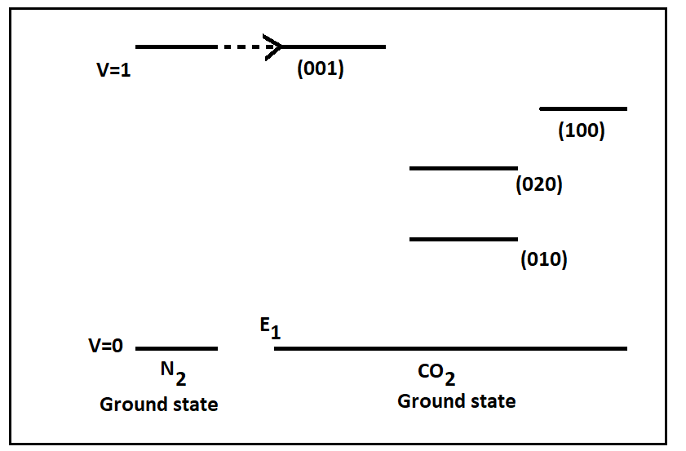

Carbon Dioxide Laser(CO₂ -Laser):

Introduction
- CO₂ laser was developed by C.K.N Patel in 1964.
- CO₂ laser operates with an efficiency of 30%.
- CO₂ laser has an output power range of few kilowatts.
- Pumping method used in CO₂ laser is electrical discharge.
- CO₂ emits continuous laser beam at wavelength $10.6μm or 9.6 μm$ depending on the transition.

Construction of CO₂ laser:
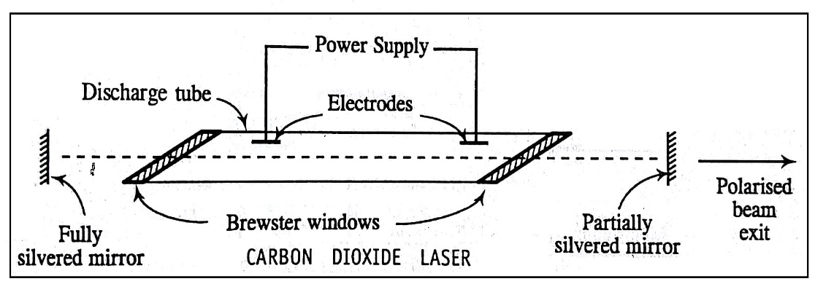

- CO₂ laser consists of a discharge tube of 2.5cm in diameter and 5cm length.
- The tube is filled with a mixture of CO_{2,} N₂ and He gases in the ratio of 1:2:3.
- To re-oxidize Co₂ molecules due to breaking of CO₂ into CO and O. hydrogen or water vapours is added.
- The pressure inside the tube is 6-17torr.
- The tube is provided with electrodes for electrical discharge.
- Two plane mirrors M₁ and M₂ are fixed on either side of the tube, where M₁ is fully silvered and M₂ is partially silvered.
- Brewster’s windows are attached to tube to get plane polarized light from M₂

Working of CO₂ laser.
- Suitable voltage is applied across the two electrodes due to which electrical discharge in initiated in the tube.
- During discharge, many free electrons are free from the gas molecules. These free electrons collide with the N₂ and Co₂ molecules in their path.
- There are two possible kind of interactions takes place
I kind: In this kind N₂ molecules are raised to v=1 level which is a metastable state.
$e_{1}+N_{2}=e_{2}+N_{2}$*
$$where e_{1} and e_{2 }are the energy values of electron before and after collision.$$
$and N_{2} and N_{2}$* are the ground state and v=1 state energies of N₂ molecule.
- Corresponding equation holds good for ${Co}_{2}$ molecule for the 001 state.
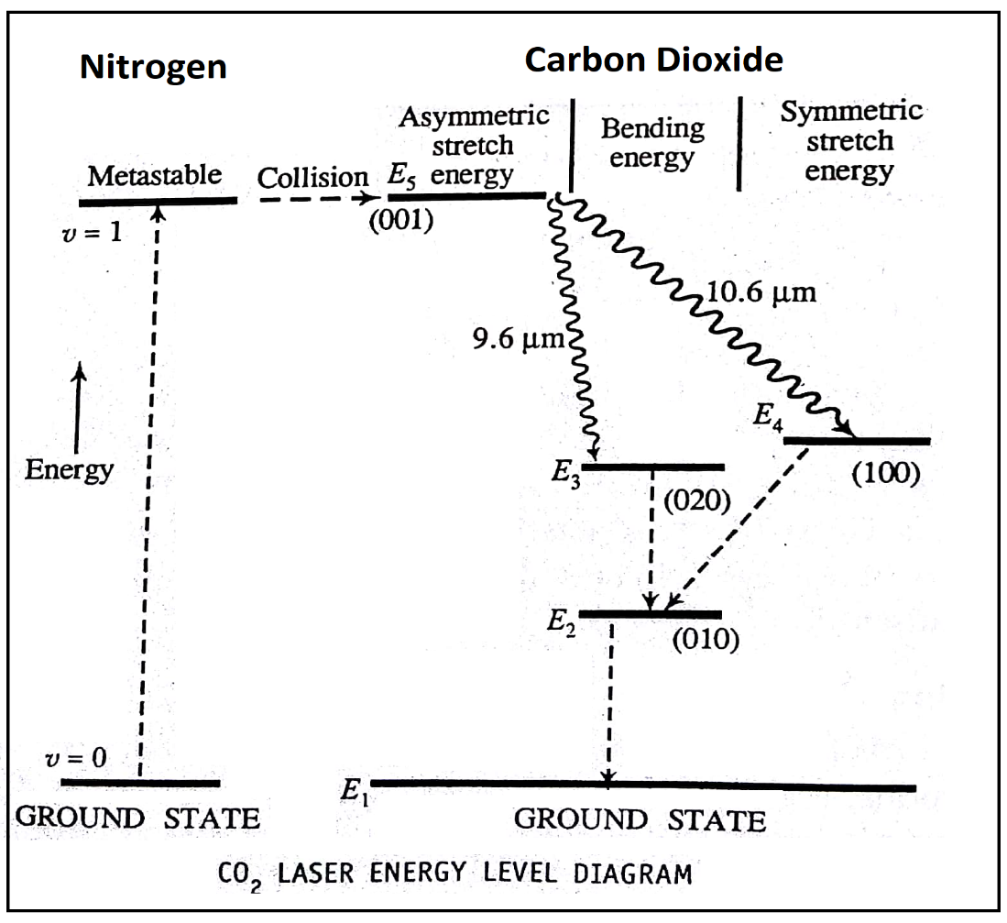

- There is a close coincidence in energy of 001 state of CO₂ molecule with v=1 state of N₂ molecule. Therefore, there will be a resonant transfer takes place, which is represented as II kind of interaction.
II kind:
$$N_{2}^{*}+{CO}_{2}=N_{2}+{CO}_{2}^{*}$$
- Due to this population inversion condition is achieved in 001 state of CO₂
- Let E_{1,} E_{2,} E_{3,} E_{4,} and E₅ are the energy levels of CO₂ vibrational modes then
a) Transition from $E_{5}→E_{4} which gives radiation of wavelength 10.6μm$
b) Transition from $E_{5}→E_{3} which gives radiation of wavelength 9.6μm$
- The CO₂ molecules in E₂ level undergoes collision with He and water vapour and come down to the ground state.
- Thus, CO₂ is used for lasing
N₂ is used for selective pumping of CO₂
He is used for depopulate E₂ level.
- Applications: It has very high efficiency and is widely used for industrial drilling, cutting and welding. Also, used in medical surgery.

Semi-conductor diode laser (Ga-As Laser):
Semi-conductor laser was developed by Hall in the year 1962.

Principle:
- In semiconductor, there will be electrons and holes when they meet they release energy and this process is called recombination.
- Only direct band gap semiconductors are used for lasers, due to no energy loss in direct band gap semiconductor.
- Semiconductor laser are topmost efficient and of low cost compared to other lasers.
- The output power ranges from 20 watts to 50 watts.
- Pumping method used in Ga-As laser is high forward bias.

Construction of Ga-As laser:
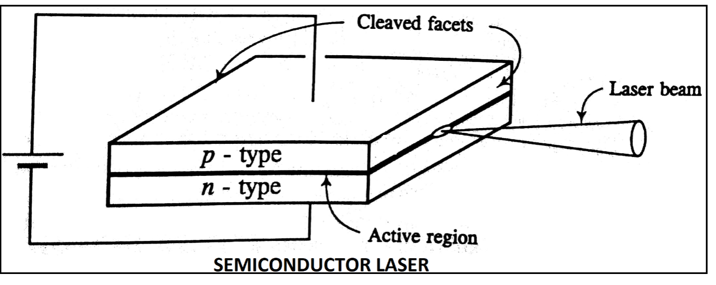

The Ga-As laser diode is a single crystal and consists of heavily doped n and p sections. n section is doped with Tellurium and p section with Zinc.
- The overall size of the diode is very small; the p-n junction layer has a width of $1μm.$
- A pair of parallel planes of the Ga-As crystal are cleaved or polished, these planes acts as reflecting mirrors.
- The remaining sides of the diode are made rough to avoid leakage of laser beam.
- The end surfaces of p and n sections are provided with electrodes to supply forward bias voltage using voltage sources.

Working of Ga-As laser.
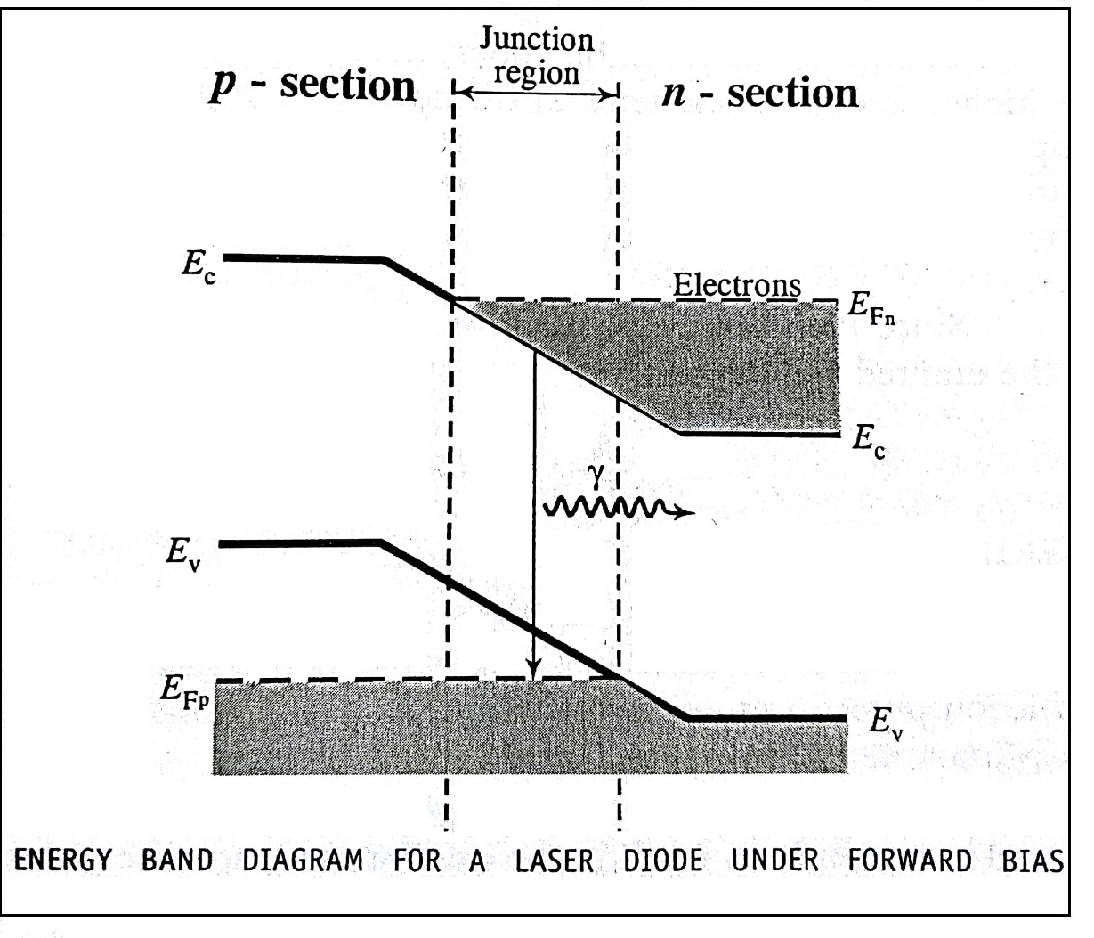

- A suitable forward bias voltage is applied to the diode to overcome the potential barrier.
- After the threshold current the population inversion is created close to the junction between filled conduction band and empty valence band.
- The energy band diagram is as shown in the diagram, Ef_{n} and Ef_{p} are the fermi levels in the n-type and p-type region respectively.
- Thus an active region is formulated in the junction, the active region will be very thin and is of the order $1μm$.
- At this stage, a photon released by a spontaneous emission may trigger stimulated emission over large number of recombination’s leading to the laser radiation of high power.
- Since the energy gap of Ga-As is 1.4 eV, the wavelength of the emitted light is
$$λ=\frac{hc}{E_{f}}=8862A^{0}$$
Applications:
- Semiconductor lasers are used in Optical fiber communication
- They are used in reading devices like ROM
- Used in compact disc player like CD’s.

Application of laser

1. Laser Rangefinder in Defense
- The principle of laser rangefinder is the same as that of conventional RADAR.
- It is the best equipment to find the distance of range of enemy’s target.
- In Military, all battle tanks are fitted with laser rangefinder interfaced with computer to provide information in a digital readout form within 1% of actual distance.
- It is also used for continuous tracking and ranging of missiles & aircrafts from ground or from air.
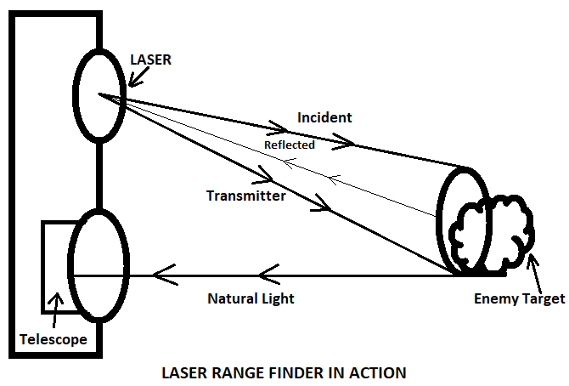
Working
- A high-powered pulsed laser beam from a solid-state laser device (Nd-YAG laser) is directed towards the enemy target from a transmitter.
- The pulses are narrow with high peak power. Upon incidence, the beam bounces from the surface of the target as a reflection.
- A part of reflected beam called ‘echo’ is received as a signal by a receiver. Inside the receiver there will be an interface filter. It is a narrow band optical filter tuned to the frequency of the laser light so that all the background noise entering the receiver is wiped off.
- Then the signal is amplified by using a photomultiplier.
- The range finder high speed clock measures the exact time from the instant the pulses left the unit and until they returned and then convert it into distance.

2. Application of laser in use of compact disc (Data Storage)
- A compact disc is a thin circular disc of about 12cm diameter and its shining side is made up of metal & plastic consisting of three layers. At the bottom is a layer of polycarbonate which is tough but it is brittle plastic. Above that is a layer of aluminum coated with plastic and lacquer.
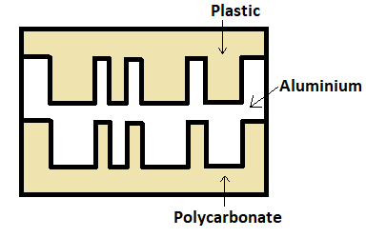

- The information is created in digital form in the CD by using a laser beam. The laser beam burns and etches (carve/stamp) bumps on its surface at certain specific intervals on a track. These bumps are called pits. Presence of a bump in a fixed length in a track indicates a zero.
- An unburnt space in a specific length of the track remains flat on the length is called ‘land’ and represents the number one.
- Thus the laser beam can store information by burning some length (for zeroes) and leaving some length unburned (for ones) in the binary language.
- While reading the CD, a laser beam scans the tracks. As it is bounced, it follows the patterns of pits and lands. A photocell converts these into electric pulses.
- In turn, an electric circuit generates zeroes and ones. A decoder converts the binary number into a changing pattern of electric currents in the analog form.
- CD – 700MB, DVD-4.7GB, BD (Blue-ray Disc-5 times the DVDs), BDXL (Blue-ray Disc Extra Large – 50Gb to 128GB)
- In a compact disc (CD), digital information is stored as a sequence of raised surfaces called “pits” and recessed surfaces called “lands”. Both pits and lands are highly reflective and are embedded in a thick plastic material with refractive index of 1.5.

Important Formulas:
- Heisenberg’s Uncertainty principle
$Δx ×{Δp}_{x}≥\frac{h}{4π}$
- To find the percentage of uncertainty in momentum $\frac{Δp}{p} ×100 , where p=\sqrt{2mE}$
- Time Independent Schrodinger equation $\frac{d^{2}ψ}{dx^{2}}+\frac{8π^{2}m}{h^{2}}\left(E-V\right)ψ=0$
- $E_{n}=\frac{n^{2}h^{2}}{{8ma}^{2}}$
- Probability: ${p\left(x\right)=\left|ψ_{n}(x)\right|}^{2}$
- $Normalisation: \int{{\left|ψ_{n}(x)\right|}^{2}dx=1} ψ_{n}\left(x\right)=\sqrt{\frac{2}{a}}\sin\left(\frac{nπx}{a}\right)$
- $\frac{{ N}_{2}}{N_{1 }} = e^{\frac{-∆E}{kT}}= e^{\frac{-\left(E_{2}-E_{1}\right)}{kT}}$ = $e^{\frac{-hν}{kT} }=e^{\frac{-hc}{λkT}}$
- ${ U}_{ν}= \frac{A}{B}\left[\frac{1}{e^{\frac{hν}{kT }}- 1}\right]$
- $Rate of absorption= B_{12}N_{1}U_{ν}$
- $Rate of absorption= A_{21}N_{2}$
- $Rate of absorption= B_{21}N_{2}U_{ν}$
- $No. of photons in each pulse=\frac{Energy of each pulse}{Eergy of photon}= \frac{E}{∆E}= \frac{pt}{\frac{hc}{λ}}= \frac{ptλ}{hc}$
- $L=n \left(\frac{λ}{2}\right)$

Question Bank

Module 4: Quantum Mechanics & LASER

Q. No. | Question Bank
1 | Explain the wave nature of particle.
2 | State De-Broglie hypothesis. Derive an expression for de Broglie wavelength of an electron accelerated by a potential difference V.
3 | State and explain Heisenberg’s uncertainty principle. Mention its physical significance.
4 | Show that, non-confinement of electron in the nucleus of an atom.
5 | What are wave functions? Mention their properties & physical significance.
6 | Set up one dimensional, time-independent Schrodinger’s wave equation.
7 | Obtain the time-independent Schrodinger’s wave equation for a particle in an one dimensional potential well of infinite height and solve to get the Eigen value and Eigen function.
8 | Find the Eigen value, Eigen function and probability density for a particle in an one dimensional potential well of infinite height for ground state & first two excited state.
9 | Explain the term spontaneous emission and stimulated emission.
10 | Derive an expression for energy density of radiation under thermal equilibrium condition in terms of Einstein coefficients.
11 | Explain the condition for laser action.
12 | Explain the requisites of a laser system.
13 | Explain the principle, construction and working of CO₂ Laser with the help of suitable diagrams.
14 | Explain the principle, construction and working of semiconductor Laser with the help of suitable diagrams.
15 | Describe how a laser range finder is made use of in defense.
16 | Explain how data storage is achieved in a compact disk.

Problems
- Find the number of modes of standing waves and their frequency separation in a resonance cavity of length 1m of He-Ne Laser operating at wavelength 632.8nm.
Data:
Length of the cavity L=1m
Wavelength of the light $λ=632.8×{10}^{-9}m$
To find:
- Number of modes m=?
- Frequency separation $V_{n}-V_{n-1}=?$
Solution:
For the Laser cavity we have the relation
$$λ=\frac{2L}{m}---(1)$$
$$m=\frac{2L}{λ}=3160556$$
For a light wave
$$λ=\frac{c}{ν}---(2)$$
From (1) & (2)
$$\frac{c}{ν}=\frac{2L}{m}$$
$$ν=\frac{mc}{2L}---(3)$$
Let (n-1) & n be two successive integer values that m can have for which the corresponding frequencies be $ν_{n-1} and ν_{n}.$ Following (3) we have
$$ν_{n}=\frac{nc}{2L} and ν_{n-1}=\frac{\left(n-1\right)c}{2L}$$
Using the above equations,
$$ν_{n}-ν_{n-1}=\frac{c}{2L}$$
$${Frequency seperation ν}_{n}-ν_{n-1}=1.5×{10}^{8} Hz$$
Number of modes $m= 3160556$ and ${Frequency seperation ν}_{n}-ν_{n-1}=1.5×{10}^{8} Hz$

2. A pulsed laser emits photons of wavelength 780nm with 20mW average power/pulse. Calculate the number of photons contains in each pulse if the pulse duration is 10ns.
Solution: Given, Wavelength of photon = 780nm = 780$×{10}^{-9}m.$
Power of each pulse, P = 20 mW = 20 $×{10}^{-3}W$
Duration of each pulse, t = 10ns = 10$×{10}^{-9}s$
No. of photons in each pulse, N =?
Energy of each photon, $∆E= \frac{hc}{λ}$
= $\frac{\left(6.63 ×{10}^{-34}×3×{10}^{8}\right)}{\left(780×{10}^{-9}\right)}$
= 2.55 $×{10}^{-19} J$.
Now, we have, energy of each pulse,
E = power $×$ duration of the pulse
= p$×t=20 ×{10}^{-3} ×10×{10}^{-9}$
= 2$×{10}^{-10}$ J
If N is number of photons (each of energy $∆E$) in the pulse, then,
$$N×∆E=E$$
$$N= \frac{E}{∆E}=\frac{\left(2×{10}^{-10} \right)}{\left(2.55 ×{10}^{-19}\right)}=7.86×{10}^{8}$$
Number of photon in each pulse is $7.86×{10}^{8}.$

3. A medium in thermal equilibrium at temperature 300K has two energy levels with a wavelength separation of 1µm. Find the ratio of population densities of upprer and lower levels.
Solution: Given, T=300K
$λ= {10}^{-6}m$
$\frac{N_{2}}{N_{1}}= ?$
We have Boltzmann factor,
$$\frac{N_{2}}{N_{1}}=e^{-\frac{hc}{λkT}}$$
$$= e^{- \frac{(6.63×{10}^{-34}×3×{10}^{8})}{\left({10}^{-6}×1.38×{10}^{-23}×300\right)}}$$
$$= e^{-48.043}$$
$$\frac{N_{2}}{N_{1}}=1.365×{10}^{-21}$$
The ratio of population densities = $1.365×{10}^{-21}.$

4. The ratio of population of two energy levels is 1.059 $×{10}^{-30}.$ Find the wavelength of light emitted by spontaneous emissions at 330K.
Solution: Given, $\frac{N_{2}}{N_{1}}=$1.059 $×{10}^{-30}$
T = 330K
$λ=?$
We have Boltzmann factor,
$$\frac{N_{2}}{N_{1}}=e^{-\frac{hc}{λkT}}$$
$$ln\left(\frac{N_{2}}{N_{1}}\right)=-\frac{hc}{λkT}$$
$$λ= -\frac{hc}{ln\left(\frac{N_{2}}{N_{1}}\right)kT}$$
$$λ= -\frac{(6.63×{10}^{-34}×3×{10}^{8})}{(ln\left(1.059 ×{10}^{-30}\right)×1.38×{10}^{-23}×330)}$$
$$λ=632nm.$$
The wavelength of light emitted by spontaneous emissions is $632nm$.
5. A semiconductor laser has a peak emission radiation of wavelength of 1.24$μm$. What is its band gap value in eV?
Data: Wavelength of the peak emission radiation $λ=1.24×{10}^{-6}m.$
To find:
Band gap value $E_{g}=?$
Solution: We have the equation for the energy of the radiation emitted due to electrons loosing equal to band gap energy $E_{g}$ as,
$$E_{g}=hν=hc/λ$$
$$E_{g}=1.6×{10}^{-19}=1eV$$
$∴the value of band gap E_{g}=1eV$
MODULE 5

MATERIAL SCIENCE
Quantum Free electron theory of metals: Review of classical free electron theory, mention of failures. Assumptions of Quantum Free electron theory, Mention of expression for density of states, Fermi-Dirac statistics (qualitative), Fermi factor, Fermi level, Derivation of the expression for Fermi energy, Success of QFET.
Physics of Semiconductor: Fermi level in intrinsic semiconductors, Expression for concentration of electrons in conduction band, Hole concentration in valance band (only mention the expression), Conductivity of semiconductors(derivation), Hall effect, Expression for Hall coefficient(derivation)
Dielectric materials: polar and non-polar dielectrics, internal fields in a solid, Clausius-Mossotti equation(Derivation), mention of solid, liquid and gaseous dielectrics with one example each. Application of dielectrics in transformers.
Numerical problems

Free electron concept
The stable configuration of a solid is due to the arrangement of atoms and distribution of electrons in the atom. In atoms the electrons in the inner orbits which are bound to the nuclei from core electrons which cannot be distributed easily.
Valence electrons: The electrons which are in the outer orbits and loosely bound to the nuclei can be disturbed easily and are called valence electrons.
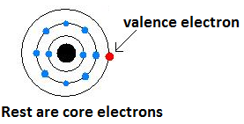

Free electrons: In metals, due to close packing of atoms the boundaries of neighboring atoms overlap, due to this the valence electrons find continuity from one atom to other. These electrons are free to move within the metal and hence are called free electrons. These are responsible for conduction in solids so called conduction electrons.
Classical free electron theory: (Drude Lorentz Theory)
- This theory was proposed by P.Drude in 1900, extended by H.A Lorentz in 1909.
- It is based on classical laws and Maxwell-Boltzmann Statistics so called Classical free electron theory.

Assumptions of Classical free electron theory:
The basic assumption of this theory is that a metal consists of large number of free electrons which can move freely throughout the body.
- In a metal, there are freely moving valence electrons called free electrons confined to its body. Under the application of an applied field these electrons are responsible for conduction and hence called conduction electrons.
- The free electrons are treated equivalent to gas molecules, and thus assumed to obey the laws of kinetic theory of gases.
In the absence of electric field, the kinetic energy associated with an electron at temperature T will be $\left(\frac{3}{2}\right)kT,$. It is related to kinetic energy as-
$\left(\frac{3}{2}\right)kT=\left(\frac{1}{2}\right){mv_{th}}^{2}$
$v_{th} is thermal velocity; k$ is the Boltzmann constant.
- The electric potential due to ionic cores is taken to be essentially constant throughout the metal.
- The interaction between the free electrons and positive ionic core, and free electrons themselves are considered to be negligible.
_______________________

Electrical conductivity:
As per the classical free electron theory, the conductivity $σ$ of a conductor is given by
$$σ=\frac{{ne}^{2}τ}{m}$$
Where $τ→Mean collision time$
$e→Charge of electron$
$m→Mass of electron$
$n→free electron concentration$

Failures of classical free electron theory:

1. Specific heat capacity:
Experimentally it is observed that contribution of electrons to specific heat capacity of metal is $C_{v}={10}^{-4}RT$---(1)
But according to classical theory, the electron behaves like a gas molecule and obeys kinetic theory of gases
$i,e \frac{1}{2}{{mv}_{th}}^{2}=\frac{3}{2}kT$
The total Kinetic Energy for a mole of electron is
$U=\frac{3}{2}N_{A}kT$
The specific heat at constant volume
$C_{v}=\frac{dU}{dT}=\frac{3}{2}N_{A}k=\frac{3}{2}R$
Where $N_{A}→Avagadro number, R→Universal gas constant$
$C_{v}=\frac{3}{2}R$---(2)
From (1) and (2) classical theory could not explain the results obtained by the experiments.

2. Temperature dependence of Electrical conductivity:
Experimentally, we have $σ_{exp}∝\frac{1}{T}$----(1)
Form classical free electron theory
$\frac{3}{2}kT=\frac{1}{2}{mv_{th}}^{2}$
${v_{th}}^{2}=\frac{3kT}{m}$ $\left(∵τ ∝\frac{λ}{v_{th}}\right)$
$v_{th }α \sqrt{T}$
$τ ∝ \frac{λ}{\sqrt{T} }$
From conductivity
$σ=\frac{{ne}^{2}τ}{m}$
$σ α τ$ which gives $σ ∝ \frac{1}{\sqrt{T}}$---(2)
From (1) and (2) the prediction of classical free electron theory failed to explain the temperature dependence of $σ$

3. Dependence of electrical conductivity on electron concentration $\left(n\right):$
From classical free electron theory
$σ=\frac{{ne}^{2}τ}{m}$
$σ ∝ n$
Let us consider the specific case of copper and silver, both are monovalent with silver having lesser $n$ value compared to copper, but $σ$ value for silver is higher than copper.

Metal | $$σ/Ωm$$ | n/m³
Cu | $$5.88 X {10}^{7}$$ | $$8.45 X {10}^{28}$$
Ag | $$6.3 X {10}^{7}$$ | $$5.85 X {10}^{28}$$
From the above example, the prediction of classical free electron theory the $σ ∝ n$ doesn’t holds good.
Quantum Free electron theory:
In 1928, to account for failures of classical free electron theory Arnold Summerfield came up with quantum free electron theory.

Assumptions of Quantum Free electron theory:
- The energy values of conduction electrons are quantized. The allowed energy values of electrons are called energy levels.
- The electrons are distributed among the energy levels according to Pauli’s exclusion principle and also obey Fermi-Dirac statistics.
- The electrons travel in a constant potential inside the metal but stays confined within the boundaries.
- The electron-electron and electron-lattice ion interaction are neglected and therefore electrons are treated free.

Density of states $g\left(E\right)dE$:
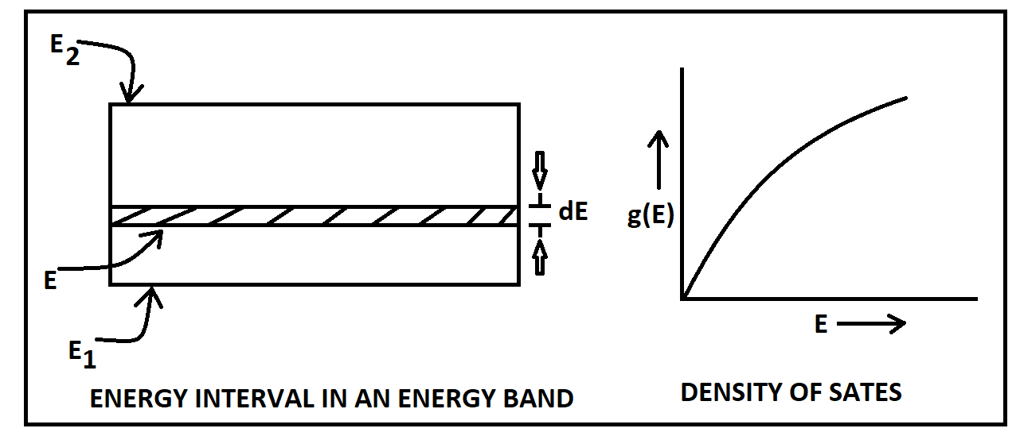

- Density of states $g\left(E\right)dE$ is defined as “The number of available energy states per unit volume of a metal in an energy interval $E and E+dE$”.
- Let the material be unit volume, the energy band be separated in an energy interval between $E_{1 }and E_{2}.$ Consider a small increment dE at energy E in the band, then the number of energy levels in the range $E and E+dE$ is obtained by product of $g\left(E\right)and dE$.
$i,e g\left(E\right)dE=\left[\frac{8 \sqrt{2} π m^{\frac{3}{2}}}{h^{3}}\right]E^{\frac{ 1}{ 2}} dE$
- As per the equation it is clear that $g\left(E\right)dE ∝ E^{\frac{ 1}{ 2}}$. The plot
of $g\left(E\right)versus E$is shown in figure. It is parabolic in shape.

Fermi Energy(E_{F}):
- Definition: “The energy of the highest occupied level at absolute zero temperature (0K) is called Fermi Energy and the level is called Fermi Level”
- When there is no external energy supply for the electrons,
the electrons are free and thus settle in the lowest allowed state
available.
- Thus, at a temperature of absolute zero all the energy level lying above
the fermi levels are empty and those lying below are completely filled.
- Since there are two electrons in each energy level out of N allowed energy level, N/2 of them will be filled.

Fermi Temperature(T_{F}):
“It is the Temperature at which the average thermal energy of the free electrons in a solid becomes equal to E_{F} at 0K”
$$T_{F}=\frac{E_{F}}{K}$$

Fermi Velocity(V_{F}):
“The velocity of electrons which occupy the fermi level is called the Fermi Velocity.
$E_{F}=\frac{1}{2}{mv_{f}}^{2}$
$v_{F}=\sqrt{\frac{{2E}_{F}}{m}}$

Fermi-Dirac Statistics:
- When an external field is applied to the metal, the free electrons keep moving from filled to vacant energy levels.
- Under thermal equilibrium the free electrons acquire energy obeying a statistical rule known as Fermi-Dirac statistics.
Fermi-Dirac statistics:
- F-D statistics is applicable to the assembly of particles which obey Pauli’s exclusion principle, they must also be identical particles of spin ½ and they ate indistinguishable, since electrons obey these conditions they obey F-D statistics.
- In statistics in general we deal with the probability, F-D statistics permits the evaluation of probability of finding electrons occupy energy levels.
- The evaluation done through Fermi-Factor $[f\left(E\right)]$

Expression for Fermi Energy at Zero kelvin ($E_{F_{0}}$):
The total number of electrons in the energy range E & E+dE “$N\left(E\right)dE$” is given by product of density of state in the given range “$g\left(E\right)dE$” and probability of occupation of energy level called Fermi factor “$f\left(E\right)$”.
$∴ N\left(E\right)dE= g\left(E\right)dE × f\left(E\right)$ ----- (1)
The number of electrons/unit volume “$n$” is given by integrating Eq. (1) with the limit $E=0$ to $=$ $E_{max}$.
$∴n= \int_{0}^{E_{max}}{g\left(E\right) × f\left(E\right)} dE$ ------ (2)
But, $f(E) = 1, at T=0K$
$$∴n= \int_{0}^{E_{max}}{g\left(E\right) dE× 1}$$
$g\left(E\right) dE$ is given by,
$g\left(E\right) dE=C E^{1/2} dE$ ----- (3)
Where, $C = \frac{8 \sqrt{2 }π m^{3/2}}{h^{3}}$ is a constant, (m is mass of electron & h is Planck’s constant)
$$∴n= \int_{0}^{E_{max}}{C E^{1/2} dE}$$
$n=C {\left[\frac{2}{3} E^{3/2}\right]}_{0}^{E_{max}}$
But at T=0k, the maximum energy possessed by an electron is Fermi energy, Hence$E_{max}= E_{F_{0}}$.
$$∴n=C × \frac{2}{3} {\left(E_{F_{0}}\right)}^{3/2}$$
Or, ${\left(E_{F_{0}}\right)}^{3/2}= \frac{3n}{2c}$
$∴ E_{F_{0}}= {\left(\frac{3}{2C}\right)}^{2/3}n^{2/3}$ Joules ----- (4)
Substituting the value for C from Eq. (3) in Eq. (4)
$E_{F_{0}}= {\left(\frac{3h^{3}}{2×8 ×\sqrt{2 }π m^{3/2}}\right)}^{2/3}n^{2/3} Joules$ ----- (5)
$$E_{F_{0}}=\left(\frac{h^{2}}{8m}\right){\left(\frac{3}{π}\right)}^{(2/3)}n^{(2/3 )} Joules$$
The first term in the above equation is a constant and is equal to 5.85$×{10}^{-38}.$
Eq. (5) is the expression for Fermi energy of an electron in a material at$T=0K$.
This shows that the Fermi energy $E_{F_{0}}$ depends only on the number of electrons$n$.

Fermi factor$[f\left(E\right)]$:
The probability $f(E)$ that a given energy state with energy E is occupied at a steady temperature T is given by
$$f\left(E\right)=\frac{1}{e^{\frac{{(E-E}_{F})}{kT}}+1}$$
Where $f(E)$ is the Fermi factor and defined as “Probability of occupation of any given energy state for a material in thermal equilibrium”

Dependence of Fermi-Factor on temperature and Effect on occupation of Energy level:
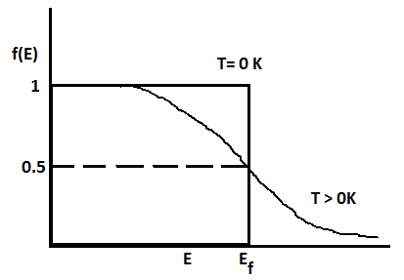
The dependence of Fermi-Factor on temperature and the effect on occupancy of energy levels is shown in the figure.

- Probability of occupation for $E<E_{F} at T=0:$
When $T=0 and E<E_{F}, we have f\left(E\right)=\frac{1}{e^{\frac{{(E-E}_{F})}{kT}}+1}$
$f\left(E\right)=\frac{1}{e^{-∞}+1}=\frac{1}{0+1}$
$$f\left(E\right)=1 for E<E_{F}$$
Here $f\left(E\right)=1$means the energy level is certainly occupied and $E<E_{F}$ applies to all energy levels below $E_{F}$
$∴At T=0, E<E_{F} All the energy levels below the fermi level are occupied$
- Probability of occupation for ${E>E}_{F} at T=0K:$
$When T=0, and {E>E}_{F},$
$f\left(E\right)=\frac{1}{e^{+∞}+1}=\frac{1}{∞}$
$f\left(E\right)=0 for {E>E}_{F}$
$∴At T=0, {E>E}_{F} All the energy levels above the fermi level are unoccupied$
- Probability of occupation at ordinary temperature.
At ordinary temperature, the value of probability starts reducing from 1 for values of $E$ close to but lesser than $E_{F}$.
The value of $f(E)$ becomes ½ at ${E=E}_{F}$
$∵for E=E_{F}, e^{(E-E_{F})/kT}=e^{0}=1$
$∵f\left(E\right)=\frac{1}{e^{\frac{{(E-E}_{F})}{kT}}+1}=\frac{1}{1+1}=\frac{1}{2}$
$f\left(E\right)=\frac{1}{2}$
Further for $E>E_{F}$ the probability values fall off to zero rapidly
Note: Effective mass(m*): “When a free electron is under the influence of electric field E, it possesses a mass with the combined influence of E and periodic potential due to lattice ions is called Effective mass (m*).

Expression for Electrical conductivity based on Quantum free electron theory:
According to Summerfield only those electrons which occupy energy states near $E_{F}$ can participate in conduction for such electron $v_{d}=v_{F}$
$$Also, τ=\frac{λ}{v_{d}}=\frac{λ}{v_{F}}$$
$$σ=\frac{{ne}^{2}}{m^{*}}\left(\frac{λ}{v_{F}}\right)$$
This is the expression for electrical conductivity on Quantum Mechanical approach
____________________________

Merits of Quantum Free Electron theory:
- Specific Heat capacity:
From classical free electron theory, all the conduction electrons are capable of absorbing heat energy. This results in a large value of specific heat.
According to Quantum Free electron theory it is only those electrons which occupy energy levels close to Fermi energy (E_{F}) that are capable of absorbing heat energy to get excited to higher energy levels. As a result, the value of the specific heat becomes very small for the conduction electrons.
On the basis of Quantum theory
$$c_{v}=\left(\frac{2k}{E_{F}}\right)RT$$
Considering $E_{F}=5 eV (∵The value of E_{F} lies between 1eV to 10 eV for metals)$
$$\left(\frac{2k}{E_{F}}\right)={10}^{-4}$$
$$c_{v}={10}^{-4}RT$$
The above result agrees with the experimentally observed values.

- Temperature dependence of Electrical conductivity:
The scattering mechanism is not collision of electrons with ions but rather scattering of electrons by vibration of ions in the lattice(Phonons)
As per Quantum free electron theory, the electrical conductivity for metals is given by
$σ=\frac{{ne}^{2}}{m^{*}}\left(\frac{λ}{v_{F}}\right)$-----(1)
The amplitude of lattice ions(r) can be shown that,
$$λ∝\frac{1}{{πr}^{2}}$$
And $E∝r^{2 }and E∝T also λ∝ \frac{1 }{T}$-----(2)
From (1) and (2)
$$σ∝\frac{1}{T}$$
Thus, temperature dependence of electrical conductivity is successfully explained by Quantum free electron theory.

- Dependence of Electrical conductivity on electron concentration:
From quantum free electron theory
$$σ=\frac{{ne}^{2}}{m^{*}}\left(\frac{λ}{v_{F}}\right)$$
From the above equation the value of $σ$ dependence on both n and ratio $\left(\frac{λ}{v_{F}}\right)$.
If we consider Cu and Al, the value of n for AL is 2.13 times higher than that of Cu. But the value of $\left(\frac{λ}{v_{F}}\right)$ for Cu is about 3.73 times higher than that of Al. Thus the conductivity of Cu exceeds Al.
___________________

Important formulas:
- Electrical conductivity:
- Classical
$σ=\frac{{ne}^{2}τ}{m}$
- Quantum
$σ=\frac{{ne}^{2}}{m^{*}}\left(\frac{λ}{v_{F}}\right)$
- Velocities:
- Thermal velocity
$v_{th}=\sqrt{\frac{3kT}{m}}$
- Fermi velocity
$v_{f}=\sqrt{\frac{{2E}_{f}}{m}}$
- Fermi Energy
$E_{F_{0}}= { 5.85×{10}^{-38}n}^{2/3}$J
3. Mobility.
- $μ=\frac{v_{d}}{E}=\frac{eτ}{m}$
$4.$Density of states.
- $g\left(E\right)dE=\left[\frac{8 \sqrt{2} π m^{\frac{3}{2}}}{h^{3}}\right]E^{\frac{ 1}{ 2}} dE$
5. Fermi factor:
- $f\left(E\right)=\frac{1}{e^{\frac{{(E-E}_{F})}{kT}}+1}$
$case 1:E<E_{F};$
$f\left(E\right)=1$
$case 2:E>E_{F};$
$f\left(E\right)=0$
$case 3:E=E_{F};$
$f\left(E\right)=\frac{1}{2}$
$6.$Free electron concentration on Avogadro Number
$n=\frac{Number of free eletcron per atom ×N_{A}× D}{Atomic weight}$
$7.$ Electrical conductivity for semiconductor
$$σ_{i}=n_{i}e(μ_{e}+μ_{h})$$

$$8. Hall coefficient R_{H}= \frac{1}{ne}$$

*******

Problems
- Calculate the Fermi velocity and the mean free path for the conduction electrons in silver, given that its Fermi energy is 5.5 eV, and the relaxation time for electrons is $3.83 × {10}^{-14}$ s.
Solution:
Given, Fermi energy, $E_{f}$ = 5.5 eV = $5.5 ×1.602 × {10}^{-19}$J.
Relaxation time for electrons, $τ=3.83 × {10}^{-14}$ s.
Fermi velocity, $v_{F}$ = ?
Mean free path, $λ= ?$
We have,
$$v_{F}=\sqrt{\frac{{2E}_{F}}{m}}$$
$$=\sqrt{\frac{2 ×5.5 ×1.602 × {10}^{-19} }{9.11 × {10}^{-31}}}$$
$=1.39 × {10}^{6}$ m/s
Mean free path is given by,
$$λ= v_{F} τ$$
$$λ= 1.39 × {10}^{6}× 3.83 × {10}^{-14}$$
$=$ 5.518$×{10}^{-8} m$
Fermi velocity and mean free path for electrons in silver have the values, $1.39 × {10}^{6}$ m/s
and 5.518$×{10}^{-8} m$ respectively.
- The Fermi level in silver is 5.5 eV at zero kelvin. Calculate the number of free electrons per unit volume for electrons with energy 5.6 eV in silver at the same temperature.
Solution: Given, $E_{F_{0}}=5.5 eV=5.5 ×1.602 × {10}^{-19} J$
$=$ $8.811× {10}^{-19} J$
The free electron concentration, $n= ?$
We have the equation,
$$E_{F_{0}}= \left(\frac{h^{2}}{8m}\right) {\left(\frac{3}{π}\right)}^{2/3} n^{2/3}$$
$$8.811× {10}^{-19}= \frac{{\left(6.63× {10}^{-34} \right)}^{2}}{\left(8 ×9.11× {10}^{-31} \right)}{\left(\frac{3}{π}\right)}^{2/3}n^{2/3}$$

= 5.85 $× {10}^{-38}$ $×$ $n^{2/3}$
$$n^{2/3}= \frac{8.811× {10}^{-19}}{5.85 × {10}^{-38}}$$
$n^{2/3}=1.$56 $× {10}^{19}$
$$n= {\left(1.56 × {10}^{19}\right)}^{3/2}$$
$$n=5.84 × {10}^{28}/m^{3}$$
The number of free electrons/unit volume in silver is $5.84 × {10}^{28}/m^{3}$.
- Calculate the probability of an electron occupying an energy level 0.02 eV above the Fermi level at 200 K in a material.
Solution: Given, ${E-E}_{F }=0.02 eV=0.02 ×1.6 × {10}^{-19} J$
$f\left(E\right)$ at 200 K = ?
We have,
$$f\left(E\right)=\frac{1}{e^{\frac{{(E-E}_{F})}{kT}}+1}$$

$$=\frac{1}{e^{\frac{\left(0.02 ×1.6 × {10}^{-19}\right)}{\left(1.38 ×{10}^{-23} ×200 \right)}}+1}$$
$$= \frac{1}{e^{1.1594}+1}$$

$$= \frac{1}{3.188+1}$$

$$f\left(E\right)=0.24 at 200 K$$
- Calculate the probability of an electron occupying an energy level 0.02 eV below the Fermi level at 200 K in a material.
Solution: Given, ${E-E}_{F }=-0.02 eV=-0.02 ×1.6 × {10}^{-19} J$
$f\left(E\right)$ at 200 K = ?
We have,
$$f\left(E\right)=\frac{1}{e^{\frac{{(E-E}_{F})}{kT}}+1}$$

$$=\frac{1}{e^{\frac{-\left(0.02 ×1.6 × {10}^{-19}\right)}{\left(1.38 ×{10}^{-23} ×200 \right)}}+1}$$
$$= \frac{1}{e^{-1.1594}+1}$$

$$= \frac{1}{0.3137+1}$$

$$f\left(E\right)=0.76 at 200 K$$

Semi-conductor physics
Physics of Semiconductor: Fermi level in intrinsic semiconductors, Expression for concentration of electrons in conduction band, Hole concentration in valance band (only mention the expression), Conductivity of semiconductors(derivation), Hall effect, Expression for Hall coefficient(derivation)

Introduction:
- Solid state materials can be classified into three groups on basis of energy gaps as Conductors, Semi-conductors and Insulators.
- Valence band:
- The range of energies possessed by valence electrons called valence band.
- It is the band consisting of free valence electrons and these electrons has the highest energy. It may be partially or completely filled.
- Conduction band:
- The range of energies possessed by conduction electrons called valence band
- It is the empty band, conduction take place when an electron jump from valence band to conduction band.
- Energy gap:
- The separation between conduction band and valence band on the energy level diagram is known as empty gap or forbidden gap.

1. Conductors:
- Conduction band has the large number of free electrons
- The energy gap may be absent (E_{g}=0) or conduction band
and valence band overlap to each other.
- The resistivity is very low.
- Ex: Cu, Al, Iron etc...

2. Insulators:
- The energy gap E_{g} is very large.
- It requires large amount of energy to shift an electron from
Valence band to conduction band.
- Valence band is filled and the conduction band is empty
- Ex: Wood, Mica, diamond etc.

3. Semi-conductors:
- Semi-conductor conductivity lies between valence band and
Conduction band.
- The energy gap is about 1eV.
- They do not conduct electricity at low temperature, but as temperature increases conductivity increases, Ex: Si, Ge etc.
- We have two types of semi-conductors
1. Intrinsic or pure semiconductors {Ex: Si, Ge}
2. Extrinsic semi-conductors {p-type and n-type}

1. Intrinsic or pure semiconductors
- A perfect semi-conductor with no impurities or lattice defects are called Intrinsic.
- In case of intrinsic semi-conductors $Number of holes{ (p}_{0})=number of electrons \left(n_{0}\right)=n_{i}$
- In intrinsic semi-conductor, the electrical conductivity changes as temperature changes as
- At T=0K the covalent bond is strong and the semi-conductor behaves as Insulator.
- At T > 0K the covalent bond breaks and more free electrons will produce and semi-conductor behaves as conductor.

2. Extrinsic semi-conductors
- These are the semi-conductors produced by purposefully introducing impurities into the crystal called Doping. We have two types of Extrinsic semi-conductors

1. n-type semi-conductor:
- Majority charge carriers are electrons and minority charge carriers are holes
- It can be formed by adding pentavalent impurity like phosphorus(p) to pure semi-conductor.
- Once we add phosphorus(p) to Germanium (Ge) four of five valence electrons forms covalent bond with Ge atom, the remaining electron acts as a charge carrier.
- In n-type semi-conductor the conductivity is due to electrons only and is given by
$σ=neμ_{e}$

2. p-type semi-conductor:
- Majority charge carriers are holes and minority charge carriers are electrons
- It can be formed by adding trivalent impurity like Aluminum(Al) to pure semi-conductor.
- Once we add Aluminum(Al) to Germanium (Ge) three of four valence electrons forms covalent bond with Si atom, this leaves an empty space (hole), when temperature increases electron from another covalent bond jumps to fill this empty space, this leaves a hole behind, in this way conduction takes place.
- In p-type semi-conductor the conductivity is due to holes only and is given by
$σ=neμ_{h}$
$$___________________$$

Expression for electron concentration(Ne):
“The number of electrons in the conduction band per unit volume is called the electron concentration (N_{e})”
$N_{e}=\frac{4\sqrt{2}}{h^{3}}{(π{m_{e}}^{*}kT)}^{\frac{3}{2}}{ e}^{\left(\frac{E_{F}-E_{g}}{kT}\right)}$ -----(1)
$$where h→planck^{'}s constant$$
${m_{e}}^{*}→Effective mass of an electron$
$k→Boltzmann constant$
$E_{F}→Fermi energy$
$E_{g}→Energy gap$

Expression for hole concentration(Nh):
“The number of holes in the valence band per unit volume is called the hole concentration (N_{h})”
$N_{h}=\frac{4\sqrt{2}}{h^{3}}{(π{m_{h}}^{*}kT)}^{\frac{3}{2}}{ e}^{\left(\frac{{-E}_{F}}{kT}\right)}$ -----(2)
$$where h→planck^{'}s constant$$
${m_{e}}^{*}→Effective mass of an electron$
$k→Boltzmann constant$
$E_{F}→Fermi energy$
$$Note: Both N_{e }and N_{h} are depend on Fermi enrgy$$
_____________

Expression for Fermi-energy in an intrinsic semi-conductor, or

Relationship between $E_{F} and$ $E_{g}$ for an intrinsic semi-conductor
For an intrinsic semi-conductor, we have
$N_{e }=N_{h}$
$\frac{4\sqrt{2}}{h^{3}}{(π{m_{e}}^{*}kT)}^{\frac{3}{2}}{ e}^{\left(\frac{E_{F}-E_{g}}{kT}\right)}=\frac{4\sqrt{2}}{h^{3}}{(π{m_{h}}^{*}kT)}^{\frac{3}{2}}{ e}^{\left(\frac{{-E}_{F}}{kT}\right)}$
${{{(m}_{e}}^{*})}^{3/2}{ e}^{\left(\frac{E_{F}-E_{g}}{kT}\right)}={{{(m}_{h}}^{*})}^{3/2}{ e}^{\left(\frac{{-E}_{F}}{kT}\right)}$
${\left(\frac{{m_{e}}^{*}}{{m_{h}}^{*}}\right)}^{3/2}=\frac{{ e}^{\left(\frac{{-E}_{F}}{kT}\right)}}{{ e}^{\left(\frac{E_{F}-E_{g}}{kT}\right)}}={ e}^{\left(\frac{{-E}_{F}}{kT}\right)-\left(\frac{E_{F}-E_{g}}{kT}\right)}$
${\left(\frac{{m_{e}}^{*}}{{m_{h}}^{*}}\right)}^{3/2}={ e}^{\left(\frac{-2E_{F}+E_{g}}{kT}\right)}$
By taking natural log on both sides
$ln{\left(\frac{{m_{e}}^{*}}{{m_{h}}^{*}}\right)}^{3/2}={ ln e}^{\left(\frac{-2E_{F}+E_{g}}{kT}\right)}$ $\left\{∵{ ln e}^{x}=x\right\}$
$\frac{3}{2}ln\left(\frac{{m_{e}}^{*}}{{m_{h}}^{*}}\right)=\left(\frac{-2E_{F}+E_{g}}{kT}\right)$
$\frac{3}{2}kT ln\left(\frac{{m_{e}}^{*}}{{m_{h}}^{*}}\right)=-2E_{F}+E_{g}$
$2E_{F}=E_{g}-\frac{3}{2}kT ln\left(\frac{{m_{e}}^{*}}{{m_{h}}^{*}}\right)$
$E_{F}=\frac{E_{g}}{2}-\frac{3}{4}kT ln\left(\frac{{m_{e}}^{*}}{{m_{h}}^{*}}\right)$

Under practical condition we have
$${m_{e}}^{*}={m_{h}}^{*} which gives\ln{1=0}$$
$E_{F}=\frac{E_{g}}{2}$
Thus, the Fermi level is in the middle of the band gap for an intrinsic semi-conductor

Expression for electrical conductivity of semi-conductor:

- According to free electron theory the charge carrier’s electrons and holes can be assumed to be moving freely inside the semi-conductor, so they contribute to the conductivity as shown in fig.
- In a semi-conductor, the current is due to free electrons and holes.

The current due to free electron can be written as-
$I_{e}=N_{e}e{Av}_{e}$ -----(1)
Similarly, the current due to holes can be written as-
$I_{h}=N_{h}e{Av}_{h}$ -----(2)
$$where$$
$N_{e}, N_{h}→Number density of electrons and holes$
$v_{e},v_{h}→Drift velocity of electrons and holes$
The total current is given by
$I=I_{e}+I_{h}$
$∴ I=eA(N_{e}v_{e}+N_{h}v_{h})$ -----(3)
The current density is given by
$J=\frac{I}{A}$
$∴J=e(N_{e}v_{e}+N_{h}v_{h})$ ------(4)
From ohms’ law we have
$J=σE$-----(5)
From equation (4) and (5) we get
$σE=e\left[N_{e}v_{e}+N_{h}v_{h}\right]$
$σ=e\left[N_{e}(\frac{v_{e}}{E})+N_{h}(\frac{v_{h}}{E})\right]$
$σ=e(N_{e}μ_{e}+N_{h}μ_{h})$ -----(6) $\left\{∵μ=\frac{v_{d}}{E} which is mobility of electrons\right\}$
For an intrinsic semi-conductor
$N_{e}=N_{h}=n_{i}$
$∴ σ_{i}=n_{i}e(μ_{e}+μ_{h})$ -----(7)
$$where$$
$n_{i}→Number density of charge carriers$, $μ_{e}→Mobility of electrons$, $μ_{h}→Mobility of holes$.

Equation (7) is the expression for electrical conductivity of an intrinsic semi-conductor

Note: Fermi energy of Extrinsic Semi semiconductor
$$E_{f}=E_{fi}+KT {sin h}^{-1}\left(\frac{N_{d}-N_{a}}{{2N}_{i}} \right)$$
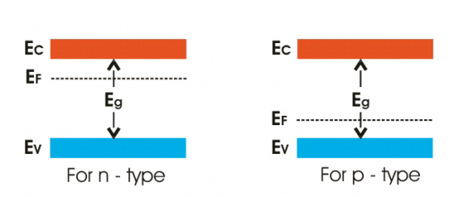

Problems
- For intrinsic germanium arsenide, the room temperature electrical conductivity is ${10}^{-6}$ /Ωm ; the electron and hole mobility are respectively 0.85 m²V⁻¹s⁻¹ and 0.04 m²V⁻¹s⁻¹ . Compute the intrinsic concentration at room temperature.
Solution: Given, Electrical conductivity, $σ_{i}= {10}^{-6} /Ωm .$
Electron mobility, $μ_{e}=$0.85 m²V⁻¹s⁻¹
Hole mobility,$μ_{h}=$0.04 m²V⁻¹s⁻¹
Intrinsic carrier concentration, $n_{i}= ?$
We have the relation for conductivity, $σ_{i}=n_{i}e(μ_{e}+μ_{h})$
$$n_{i}= \frac{σ_{i}}{e(μ_{e}+μ_{h})}$$
= $\frac{{10}^{-6}}{1.602×{10}^{-19}\left(0.85+ 0.04 \right) }$
= 7.0 $×{10}^{12}$ $m^{-3}$
The intrinsic carrier concentration at room temperature for intrinsic gallium arsenide is 7.0 $×{10}^{12}$ $m^{-3}$.

- The following data are given for intrinsic germanium at 300 K, $n_{i}=$2.4 $×{10}^{19}$/$m^{3},$
$μ_{e}=$0.39 m²V⁻¹s⁻¹, $μ_{h}=$0.19 m²V⁻¹s⁻¹. Calculate the resistivity of the sample.
Solution: Given, Intrinsic carrier concentration, $n_{i}= 2.4 ×{10}^{19}/m^{3}$
Electron mobility, $μ_{e}=$0.39 m²V⁻¹s⁻¹
Hole mobility,$μ_{h}=$0.19 m²V⁻¹s⁻¹
Resistivity of the sample, $ρ= ?$
We have the relation for conductivity $σ_{i}$ as,
$$σ_{i}=n_{i}e(μ_{e}+μ_{h})$$
But, resistivity $ρ_{i}= \frac{1}{σ_{i}}$
$∴$ $ρ_{i}= \frac{1}{n_{i}e(μ_{e}+μ_{h})}$
$$= \frac{1}{\left(2.4 ×{10}^{19} ×1.602 ×{10}^{-19}×\left(0.39+0.19\right)\right)}$$
$ρ_{i}=$0.449 $Ωm.$
- Calculate the concentration at which donor atoms need to be added to a silicon semiconductor so that it results in an n-type semiconductor with a conductivity of 2.2${×10}^{-4} /Ωm$, and the mobility of electrons being 125${×10}^{-3}$ m²V⁻¹s⁻¹.
Solution: Given, Resulting conductivity, $σ_{e}= 2.2 {×10}^{-4} /Ωm$
Mobility of electrons, $μ_{e}=$125${×10}^{-3}$ m²V⁻¹s⁻¹
Concentration of donor impurity, $N_{e}= ?$
We have, $σ_{e}= N_{e}{ e μ}_{e}$
Or, $N_{e}= \frac{σ_{e}}{{ e μ}_{e}}$
$$= \frac{(2.2 {×10}^{-4})}{\left(1.602 ×{10}^{-19} ×125{×10}^{-3} \right)}$$
$N_{e}$ $=$1.1 $×{10}^{16} m^{-3}$
The concentration of donor impurity is 1.1 $×{10}^{16} m^{-3}$.

Hall Effect
Statement: “If a piece of conductor carrying a current is placed in a transverse magnetic field, an Electric field is produced inside the conductor in a direction normal to both the current and the magnetic field. This phenomenon is known as Hall Effect and the voltage generated is called Hall Voltage ( $V_{H}$).”
Theory:
Consider a rectangular slab of a n-type semiconductor in which current I is flowing in the positive x-direction.
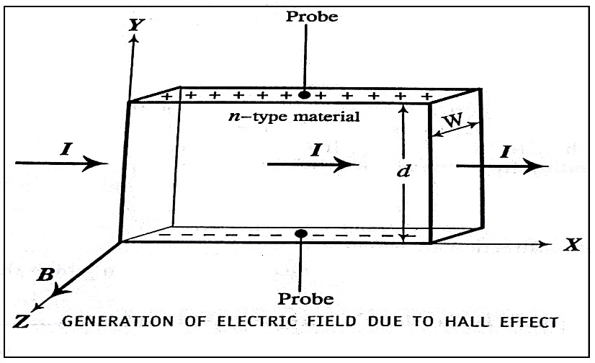

Let a magnetic field B is applied along the z-direction due to which electron experiences Lorentz force, $F_{L}= -Bev$ ----- (1)
Where, $v$is drift velocity
Applying Flemings LHR, we see that the force is exerted on the electrons in the negative y-direction due to which face1 becomes negatively charged and face2 positively charged. Hence a potential appears between the upper and lower surface of the slab which establishes an electric field (Hall field) along negative y-direction.
The force acting on the electrons in the upward direction is given by,
$F_{H}= -eE_{H}$ ----- (2)
These two opposing forces reach equilibrium at the stage,
$F_{L}= F_{H}$
$∴$ From (1) & (2), the above equation becomes
$$-Bev= -eE_{H}$$
or, $E_{H}= Bv$ ----- (3)
If $d$ is the distance between the upper and lower surfaces of the slab, then,
$$E_{H}= \frac{V_{H}}{d}$$
or, $V_{H}=E_{H}d=Bvd,$[from Eq. (3)] ----- (4)
Let $w$ be the thickness of the material in the z-direction.
$∴$It’s area of cross section $A = wd$
$∴$ The Current density, $J =$ $\frac{I}{wd}$
But, we know that $J = nev =ρ v$ ----- (5)
Where, n is the charge carrier concentration
$ρ$ is the charge density
$$∴ ρ v= \frac{I}{wd}$$
or, $v= \frac{I}{ρwd}$ ---- (6)
Substituting for v, from Eq. (6), Eq. (4) becomes,
$V_{H}=\frac{BI}{ρw}$ ----- (7)
or, $ρ= \frac{BI}{V_{H}w}$ ----- (8)
Thus, by measuring$V_{H}, I and w$, and by knowing$B$, the charge density $ρ$ can be determined.

Hall Coefficient ($R_{H}$):
For a given semiconductor Hall field $E_{H}$ depends upon the current density $J,$ and the applied field $B.$
i.e., $E_{H} ∝$ $JB$
or, ${ E}_{H}=R_{H}JB$
Where, $R_{H}$is called the Hall Coefficient.
Now from the above equation
$R_{H}= \frac{{ E}_{H}}{JB}$ ----- (9)
Substituting for ${ E}_{H}$ and J from Eq. (3) and (5) in Eq. (9),
We have
$$R_{H}= \frac{Bv}{ρvB}$$
Or, $R_{H}= \frac{1}{ρ}$
Thus, the Hall coefficient can be evaluated once $ρ$ is known.

Problems
- The Hall co-efficient of a material is -3.68$×{10}^{-5}{m^{3}}/C$. What is the type of charge carriers? Also calculate the carrier concentration.
Solution: Given, Hall co-efficient of a material, $R_{H}=$-3.68$×{10}^{-5}{m^{3}}/C$.
Carrier concentration, $n =$?
Since the sign of $R_{H}$ is negative as per the data, the charge carriers are electrons.
We have, $R_{H}= \frac{1}{ρ}$
$$R_{H}= \frac{1}{ne}$$
The carrier concentration,
$$n= \frac{1}{R_{H}e}$$
$$n= \frac{1}{\left(3.68×{10}^{-5} ×1.602 ×{10}^{-19} \right)}$$
$$n=1.7 × {10}^{23}/m^{3}$$
The carrier concentration is, $1.7 × {10}^{23}/m^{3}.$
- The Hall co-efficient of a specimen of doped silicon is found to be $3.68×{10}^{-4}{m^{3}}/C$. The resistivity of the specimen is $9.93 ×{10}^{-3} Ωm$. Find the mobility and density of the charge carrier, assuming single carrier conduction.
Solution: Given, Hall co-efficient of a material, $R_{H}=$3.66$×{10}^{-4}{m^{3}}/C$.
Resistivity of the specimen, $ρ_{i}=$ $9.93 ×{10}^{-3} Ωm$.
Mobility of charge carrier, $μ_{h}= ?$
(Since the $R_{H}$ is positive, charge carriers are holes)
Charge carrier density, $N_{h}$ = ?
We have,
$$R_{H}=\frac{1}{ρ}= \frac{1}{ne}$$
$R_{H}$ $= \frac{1}{N_{h}e}$
$N_{H}$ $= \frac{1}{R_{h}e}$
$N_{H}$ $= \frac{1}{\left(3.66×{10}^{-4}×1.602 ×{10}^{-19}\right)}=1.705×{10}^{22} /m^{3}$
We know that the mobility of charge carriers $μ_{h}$ is given by,
$$μ_{h}= σR_{H}$$
Where, $σ$ is the conductivity, $σ= \frac{1}{ρ_{i}}$ & $R_{H}=\frac{1}{ρ}= \frac{1}{ne}$
$∴$ ${ μ}_{h}= \frac{1}{ρ_{i}N_{h}e}$
$${ μ}_{h}= \frac{1}{\left(9.93 ×{10}^{-3}×1.705×{10}^{22}×1.602 ×{10}^{-19}\right)}$$
${ μ}_{h}=0.041$m²V⁻¹s⁻¹ .
$∴$Mobilty and density of the holes in doped silicon are $0.041$m²V⁻¹s⁻¹ & $1.705×{10}^{22} /m^{3}$.

Dielectric Materials
Dielectric materials: polar and non-polar dielectrics, internal fields in a solid, Clausius-Mossotti equation(Derivation), mention of solid, liquid and gaseous dielectrics with one example each. Application of dielectrics in transformers.

Fundamentals of Dielectrics
- Dielectrics are electrically non conducting materials such as glass, porcelain, wood, rubber, waxed paper etc.,
- Dielectrics provide electrical insulation between two medium and also serves as an electrical storage devices.
- Dielectrics basic electric property is the ability to be polarized and in which an electrostatic force can exist and electric field can persist for a long time.
- They possess high resistivity in the range of ${10}^{6}- {10}^{16} Ωm.$

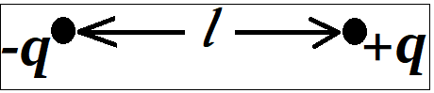
Electric dipole and dipole moment:

“A pair of equal and opposite charges whose distance of separation is very small is called an Electric dipole”.
“The product of the magnitude of the one of the charges and the distance of their separation is called “the dipole moment”.
If $+q and –q$ are the two charges separated with a distance $‘l’$ which is very small then the dipole moment (µ) is given by,
$$µ=ql$$

Dielectric materials:
“Dielectric materials are those which have the ability to get electrically polarized and in which electric field can exist. Also, they do not allow an electric current to flow through when subjected to ordinary voltages.”
They are classified as Polar and Non-polar dielectrics.
- Polar Dielectrics:
In some dielectric materials like water, the effective centers of the negative and positive charges in the molecules do not coincides with each other, even in the absence of any external field, it consists of a pair of negative and positive charges separated by a small distance, such pair is called Permanent dipoles and such materials are called Polar dielectrics.

- Non-polar Dielectrics:
In the atoms (or molecules) of some of the materials the effective centers of the negative charge distribution coincides with the effective center of the positive charges, thus neutralizes each other’s effect and does not possess dipole moment, such materials are called Non-polar Dielectrics.
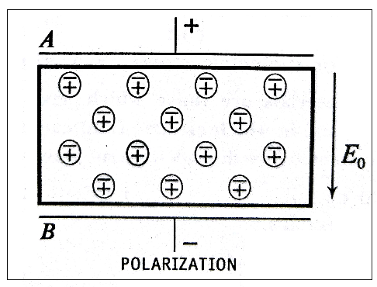
Dielectric Constant:

“The capacitance of a parallel plate capacitor increases if the gap between the plates is filled with a dielectric. This increase in capacity of a capacitor is measured in terms of a quantity known as relative permittivity or relative dielectric constant ($ϵ_{r}$)of the material.”
For isotropic materials the applied electric field strength $E$ and the flux density $D$ are related by,
$$D= ϵ_{0}ϵ_{r}E$$
Where, $ϵ_{0}=8.854 ×{10}^{-12}F/m$is dielectric constant of vacuum
$ϵ_{r}$ is the relative dielectric constant for the material
- $ϵ_{r}$ is a dimensionless quantity and has a value of 1 for vacuum
- $ϵ_{r}$ is frequency dependent, It becomes complex with applied alternating field.
- It varies widely from material to material. For Ex. $ϵ_{r}$ value for glass is 5.6 and water it is 80 & 233 for strontium titanate.

Polarization:
“The displacement of charge s in the atoms (or molecules) of a dielectric under the action of an applied field leading to the development of dipole moment, is called Polarization of dielectric or Electric Polarization.”

Types of polarization:
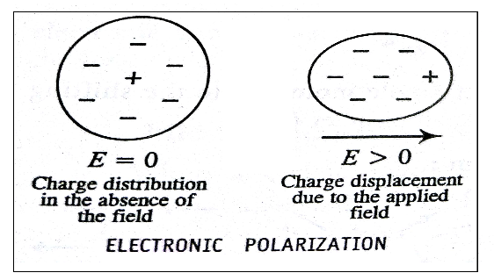
- Electronic Polarization:

- It occurs due the displacement of the $+ve$ and $–ve$ charges in a dielectric material owing to the application of an external electric field (Fig 1).
- The separation between the charges leads to the development of a dipole moment.
- It is Independent of temperature.
- The electronic polarizability, $α_{e}$ for a rare gas atom is given by,
$$α_{e}= \frac{ϵ_{0}\left(ϵ_{r}-1\right)}{N}$$
Where, $ϵ_{0}=8.854 ×{10}^{-12}F/m$is dielectric constant of vacuum
$ϵ_{r}$ is the relative permittivity for the material
$N$ is number of atoms/unit volume.
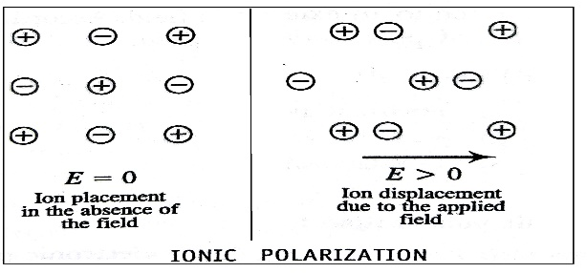
- Ionic Polarization:

- It occurs in Ionic compounds such as NaCl.
- When ionic compounds are kept in an electric field, displacement of positive and negative ions occurs developing a dipole moment (Fig 2).
- The Ionic polarizability, $α_{i}$ is given by,
$$α_{i}= \frac{ϵ_{0}\left(ϵ_{r}-1\right)}{N_{i}}$$

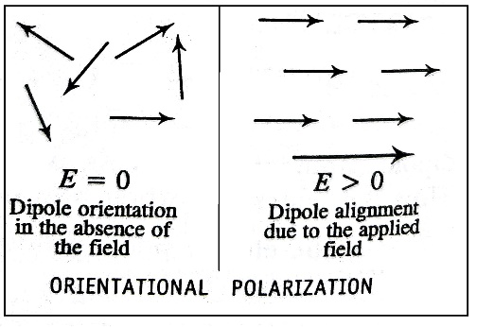
- Orientation Polarization:

- Polar dielectric molecules exhibit Orientation Polarization.
- The Orientation of these molecules will be random normally due the thermal agitation.
- When polar molecules are kept in an electric field, already existing dipoles tend to align in the direction of applied electric field. This increases the dipole moment as shown in the figure.
- The orientation polarizability, $α_{0}$ is given by,
$$α_{0}= \frac{μ^{2}}{3kT}$$
Where, $μ$ is the permanent dipole moment
$k$ is the Boltzmann constant
$T$ is the temperature
The total polarization $α$ of a material is thus given by the sum of electric, ionic and orientation polarizations,
i.e., $α= α_{e}+ α_{i}+ α_{0}$

Relation between Polarization and Dialectic Constant:
The relation between Polarization $\vec{P}$ and Dielectric Constant $ϵ_{r}$ is given by,
$$\vec{P}= ϵ_{0}\left(ϵ_{r}-1\right)\vec{E}$$
Where, $ϵ_{0}=8.854 ×{10}^{-12}F/m$is dielectric constant of vacuum
$\vec{E}$ is the applied field
Also the above equation can be expressed as,
$$\vec{P}= ϵ_{0}χ\vec{E}$$
Where, $χ=\left(ϵ_{r}-1\right)$ is the dielectric susceptibility of the material

Internal Fields in Solids and Liquids:
“The internal field, or the local field, is the electric field that acts at the site of any given atom of a solid or liquid dielectric subjected to an external electric field, and is the resultant of the applied field and the field due to all surrounding dipoles”.

Expression for the Internal field in the case of Solids and Liquids(1D)
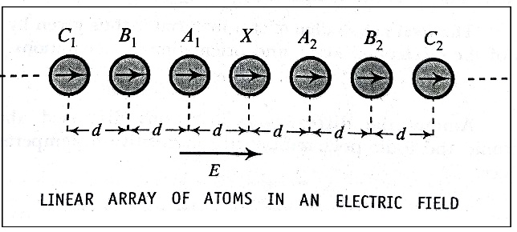
Consider a dielectric material (Solid or Liquid), kept in an uniform electric field of strength $E$. In the material let us consider an array of equidistant atomic dipoles arranged parallel to the direction of the field as shown in the fig.

Let the interatomic distance be$d$, and the electronic polarizability of the dipoles be $α_{e}$.
The expression for internal field $E_{i}$ is then given as,
$$E_{i}= \frac{E}{1- \frac{1.2 α_{e}}{πϵ_{0}d^{3}}}$$
This is the Internal field in case of One-dimensional array of atoms in dielectric Solids or liquids.
$$E_{i}= E+\frac{1.2 α_{e}E}{πϵ_{0}d^{3}}$$
For three dimensional cases, the above equation can be generalized by replacing $\frac{1}{d^{3}}$ by $N$, where $N$ is the number of atoms/unit volume and $\frac{1.2}{π}$ by $γ$ & $γ$ is called the internal field constant.
$E_{i}= E+\frac{γα_{e}EN}{ϵ_{0}}$ But polarization, $P = μN= α_{e}E N$
$$∴ E_{i}= E+ \frac{γ P}{ϵ_{0}}$$
This is the Internal field in case of three-dimensional array of atoms in dielectric Solids or liquids.

Lorentz Field:
The expression for internal field in case of three- dimensional array of solids is given by,
$$E_{i}= E+ \frac{γ P}{ϵ_{0}}$$
Since $γ, P and ϵ_{0}$ are positive quantities,
$$E_{i} >E$$
In the three dimensional case, if it is a Cubic lattice, then it can be shown that $γ= \frac{1}{3}$ and the internal field is named Lorentz field given by,
$$E_{Lorentz}=E+ \frac{P}{3ϵ_{0}}$$
Above equation is known as Lorentz relation.
____________________________________
Clausius – Mossotti Equation:
Consider an elemental solid dielectric material of dielectric constant $ϵ_{r}$.
If $N$ is the number of atoms/unit volume of the material, $μ$ is the atomic dipole moment, then we have,
Dipole moment/unit volume = N$μ$ ----- (1)
Here the field experienced by the atoms is the internal field $E_{i}$. Hence, if $α_{e}$ is the electronic polarizability of the atoms, we can write the equation for $μ$ as,
$μ= α_{e}E_{i}$ ----- (2)
$∴$ Eq. (1) becomes,
Dipole moment/unit volume = $N{ α}_{e}E_{i}$ ------ (3)
In Eq. (3), its left side is same as polarization $P$.
∴ $P$ = $Nα_{e}E_{i}$ ----- (4)
or, $E_{i}= \frac{P}{N{ α}_{e}}$ ----- (5)
But we have the relation for $P$ as,
$P= ϵ_{0} \left(ϵ_{r}-1\right) E$,
Where, E is the applied field.
$∴$ $E= \frac{P}{ϵ_{0} \left(ϵ_{r}-1\right)}$ ----- (6)
Also we have Eq. for internal field as,
$E_{i}= E+ \frac{γ P}{ϵ_{0}}$ ----- (7)
Where, $γ$ is the internal field constant.
Substituting for $E_{i}$ and $E$ from Eq. (5) and (6) in Eq. (7), we have,
$$\frac{P}{N{ α}_{e}}= \frac{P}{ϵ_{0} \left(ϵ_{r}-1\right)}+ \frac{γ P}{ϵ_{0}}$$
or,
$$\frac{1}{N{ α}_{e}}=\frac{1}{ϵ_{0}} \left[\frac{1}{ \left(ϵ_{r}-1\right)}+ γ\right]$$
Considering the internal field in the material to be Lorentz filed, we have $= \frac{1}{3}$ . Substituting the same in the above equation, we get,
$$\frac{1}{N{ α}_{e}} = \frac{1}{ϵ_{0}} \left[\frac{1}{ \left(ϵ_{r}-1\right)}+ \frac{1}{3}\right] = \frac{1}{ϵ_{0}} \left[\frac{3+ ϵ_{r}-1}{ 3\left(ϵ_{r}-1\right)}\right]$$

$$\frac{ϵ_{0}}{N{ α}_{e}} = \left[\frac{ ϵ_{r}+2}{ 3\left(ϵ_{r}-1\right)}\right]$$
By rearranging the above Eq. we have,
$$\frac{\left(ϵ_{r}-1\right)}{\left(ϵ_{r}+2\right)} = \frac{ N{ α}_{e} }{ 3 ϵ_{0}} ----(8)$$
Eq. (8) is called Clausius – Mossotti equation.

Solid, Liquid and Gaseous Dielectrics
Solid Dielectrics:
- Solid dielectrics available in extremely diverse variety. Mica, porcelain, glass, plastic etc., are inorganic whereas, cloth, rubber or paper etc., are organic.
- Solid dielectrics are used as Jacketing materials (rubber), Molding materials (glass), Filling materials (Mica).
- Paper is hygroscopic. High density papers are preferred in energy storage capacitors.
Liquid Dielectrics:
- Mainly, liquid dielectrics are used in transformers, switches, circuit breakers etc.,
- During the working conditions, the windings in an electrical device gets heated, liquid dielectrics allow the winding to cool faster.
- Examples of liquid dielectrics are, transformer oil, silicon fluids, viscous Vaseline, fluoro-organic fluids etc.,
Gaseous Dielectrics:
- Gases are good insulators and work well as heat transferring media
- Air, nitrogen, inert gases, hydrogen, CO₂, etc., are example for gaseous dielectrics.
- Pressure has a decided effect on the dielectric strength of all gases. Higher pressure reduces its ability to insulate.
- It is used in Transformer, Radar waveguides, Circuit Breakers, Switchgears, High Voltage Switching, Coolants. They are usually used in high voltage application.

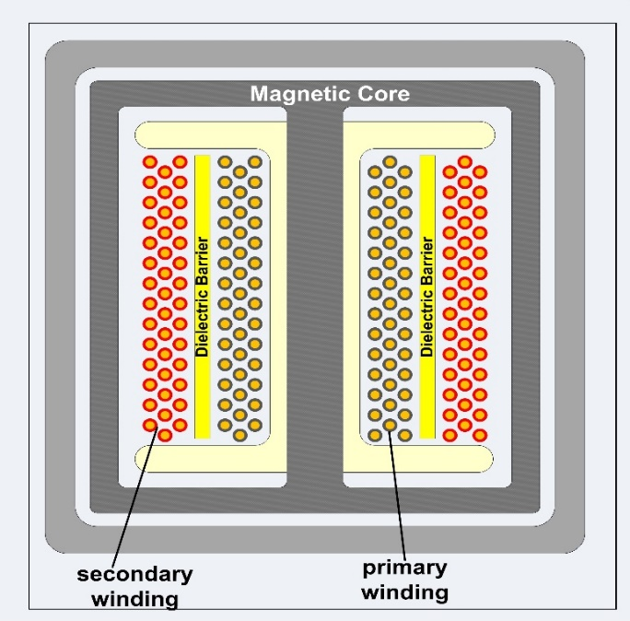
Application of dielectrics in transformers

- A transformer consists of two insulated conducting coils wound on a core. The core is also insulated. In case of high voltage transformers, further insulation is required to be provided between individual windings in the coils and also between the core and the coils. Hence their size grows.
- The size of the transformer increases also with operational ac frequency. The insulation is provided by using paper, mica or cloth. The paper is impregnated with varnish or wax to fill the air gaps.
- If there are air gaps, then, since the permittivity of air is less, ionization of air occurs at high voltage leading to excessive heating which damages the insulation. This effect is called corona. Mica is used to guard against corona.
- However, when the operating voltage crosses 3KV and up, a kind of oil called transformer oil is used. It is based on mineral oil.
- Apart from guarding against corona up to about 100 KV, the oil helps to keep the transformer cool. It remains stable at high temperatures.
- However, for large size transformers that are used in high voltage transmission lines, cooling by water circulation round the body of the transformer is provided.
Important formulas:
- Polarization
$$P= ϵ_{0}\left(ϵ_{r}-1\right) E$$
2. Electrical polarizability
$$α_{e}= \frac{ϵ_{0}\left(ϵ_{r}-1\right)}{N}$$
3. Charge of a capacitor
$$Q= \frac{ϵ_{0}ϵ_{r}sV}{d}$$
$4.$Clausius-Mossotti equation,
$$\frac{\left(ϵ_{r}-1\right)}{\left(ϵ_{r}+2\right)} = \frac{ N{ α}_{e} }{ 3 ϵ_{0}}$$

Problems
- Find the polarization produced in a crystal by an electric field of strength 500 V/mm if it has a dielectric constant of 6?
Solution, Given, Applied electric field, $E = 500 V/mm = 500 × {10}^{3} V/m$
Dielectric constant of the crystal, $ϵ_{r}=6$
Polarization produced, P =?
We have, $P= ϵ_{0}\left(ϵ_{r}-1\right) E$
$P=8.854 ×{10}^{-12}×\left(6-1\right)×$ $500 × {10}^{3}$
$P=$ 2.21$× {10}^{-5} C/m^{2}$
Polarization produced in sodium chloride is 2.21$× {10}^{-5} C/m^{2}.$
- If a NaCl crystal is subjected to an electric field of $1000 V/m$ and the resulting polarization is $4.3 × {10}^{-8} C/m^{2}$, Calculate the dielectric constant of NaCl.
Solution: Given, Applied electric field, $E = 1000 V/m$
Resulting polarization produced, P =$4.3 × {10}^{-8} C/m^{2}$
Dielectric constant of NaCl, $ϵ_{r}=?$
We Have,
$$P= ϵ_{0}\left(ϵ_{r}-1\right) E$$
$$ϵ_{r}-1= \frac{P}{ϵ_{0 }E}= \frac{\left(4.3 × {10}^{-8}\right)}{\left(8.854 ×{10}^{-12} ×1000\right)}$$
$$ϵ_{r}-1=4.855$$
$$ϵ_{r}=4.855+1$$
$$ϵ_{r}=5.855$$
Dielectric constant of NaCl = 5.855.
- The dielectric constant of Helium at 0⁰ C is 1.000074. The density of atom is 2.7 $× {10}^{25}/m^{3}.$ Calculate the dipole moment induced in each atom when the gas is in an electric field of $3×{10}^{4} V/m$.
Solution, Given, Dielectric constant of Helium at 0⁰ C, $ϵ_{r}=1.000074$.
Number density of He atoms, $N= 2.7 × {10}^{25}/m^{3}.$
Applied electric field, $E = 3 × {10}^{4} V/m$.
Dipole moment induced in each atom =?
Dipole moment induced in each atom is given by,
Dipole moment = $α_{e} E$,
Where the electric polarizability $α_{e}$ is,
$$α_{e}= \frac{ϵ_{0}\left(ϵ_{r}-1\right)}{N}$$
$$α_{e}= \frac{\left(8.854 ×{10}^{-12}×0.000074\right)}{\left(2.7 × {10}^{25}\right)}$$
$$α_{e}=2.4255 ×{10}^{-41}$$
Dipole moment = $α_{e} E= 2.4255 ×{10}^{-41}$ $× 3 × {10}^{4}$
$$=7.2767 ×{10}^{-37} Cm.$$
Dipole moment induced in each atom is $7.2767 ×{10}^{-37} Cm$.
- A parallel plate capacitor consists of 2 plates each of area $5 × {10}^{-4} m^{2}$. They are separated by a distance $1.5 × {10}^{-3}m$ & filled with a dielectric of relative permittivity 6. Calculate the charge on the capacitor if it is connected to a 100 V D.C. supply.
Solution: Given, Area of the capacitor plates, $s = 5 × {10}^{-4} m^{2}$
Separating distance between the plates, $d =1.5 × {10}^{-3}m$
Relative permittivity of the dielectric, $ϵ_{r}=6$
Applied voltage, $V = 100 V$
Charge of the capacitor, $Q = ?$
We have the relation for $Q$ as,
$Q = CV$,
Where, C is the capacitance of the capacitor
Also, we have the relation,
$$C= \frac{ϵ_{0}ϵ_{r}s}{d}$$
$∴$ $Q= \frac{ϵ_{0}ϵ_{r}sV}{d}$
$$Q= \frac{\left(8.854×{10}^{-12}×6×5 × {10}^{-4} \right)}{\left(1.5 × {10}^{-3}\right)}$$
$Q=1.77 ×{10}^{-9}C$
The charge on the capacitor is $1.77 ×{10}^{-9}C$.
- The electronic polarization of krypton gas is$3.54 ×{10}^{-40} Fm^{2}$ . If the gas contains $2.7 × {10}^{25}/m^{3}$ at NTP, calculate its dielectric constant.
Solution: Given, Electronic polarization, $α_{e}= 3.54 ×{10}^{-40} Fm^{2}$
Number density of krypton atoms, $N= 2.7 × {10}^{25}/m^{3}$
Dielectric constant at NTP, $ϵ_{r}=?$
We have,
$$ϵ_{0}\left(ϵ_{r}-1\right)= Nα_{e}$$
$$ϵ_{r}-1= \frac{Nα_{e}}{ϵ_{0}}= \frac{\left(2.7 × {10}^{25}×3.54 ×{10}^{-40}\right)}{\left(8.854×{10}^{-12}\right)}$$
$$ϵ_{r}-1=0.00108$$
$$ϵ_{r}=1.00108$$
The dielectric constant of krypton at NTP is $1.00108$.
- The dielectric constant of sulphur is 3.4. Assuming a cubic lattice for its structure, calculate the electronic polarizability of sulphur.
Given: for sulphur, density $= 2.07 gm/cc,$
Atomic weight = 32.07.
Solution: Given, Dielectric constant, $ϵ_{r}=3.4$
Density for Sulphur, $D = 2.07 gm/$cc = 2.07$× {10}^{3} Kg/m^{3}$
Atomic weight = 32.07
Crystal structure of sulphur is cubic.
Electronic polarizability of sulphur, $α_{e}= ?$
Since the crystal structure of sulphur is cubic we can apply Clausius-Mossotti equation,
$$\frac{\left(ϵ_{r}-1\right)}{\left(ϵ_{r}+2\right)} = \frac{ N{ α}_{e} }{ 3 ϵ_{0}}$$
$${ α}_{e}= \frac{ 3 ϵ_{0} }{N }\left[\frac{ϵ_{r}+2}{ϵ_{r}-1}\right]$$
Now, the number of atoms/unit volume can be written as,
$$N= \frac{N_{A}×{10}^{3}×D}{atomic weight}$$
$$N= \frac{\left(6.025×{10}^{26}×2.07× {10}^{3}\right)}{32.07}$$
$$N=3.89×{10}^{28}/m^{3}$$
$$∴{ α}_{e}= \frac{\left(3×8.854×{10}^{-12}\right)}{\left(3.89×{10}^{28}\right)}\left[\frac{3.4-1}{3.4+2}\right]$$
$${ α}_{e}=3.035 ×{10}^{-40} Fm^{2}$$
Electronic polarizability of Sulphur is $3.035 ×{10}^{-40} Fm^{2}.$
- An elemental solid dielectric material has polarizability $7×{10}^{-40} Fm^{2}.$ Assuming the internal field to be Lorentz field, calculate the dielectric constant for the material if the material has $3×{10}^{28} atoms/m^{3}$.
Solution: Given, Polarizability, ${ α}_{e}= 7×{10}^{-40} Fm^{2}$
No of $atoms/m^{3}$, $N = 3×{10}^{28}$
The internal field is Lorentz field.
Dielectric constant of the material, $ϵ_{r}=?$
Since the internal field is Lorentz field, and material is elemental solid dielectric type, we can apply Clausius-Mossotti equation,
$$\frac{\left(ϵ_{r}-1\right)}{\left(ϵ_{r}+2\right)} = \frac{ N{ α}_{e} }{ 3 ϵ_{0}}$$
$$\frac{\left(ϵ_{r}-1\right)}{\left(ϵ_{r}+2\right)}= \frac{\left(3×{10}^{28}×7×{10}^{-40}\right)}{\left(3×8.854×{10}^{-12}\right)}$$
$=$ 0.7906.
$∴ \left(ϵ_{r}-1\right)= \left(ϵ_{r}+2\right) ×$0.7906
$ϵ_{r}-1=$0.7906$ϵ_{r}+1.5812$
$ϵ_{r}\left(1- 0.7906\right)$ = $2.5812$
$$ϵ_{r}= \frac{2.5812}{0.2094}$$
$$ϵ_{r}=12.33$$
The dielectric constant of the material is 12.33.
Question Bank
Module 5: Dielectric materials

Q. No. | Question Bank
1 | Explain the salient features of Drude – Lorentz theory (Free electron Concept)
2 | Explain the failure of classical free electron theory.
3 | Mention the assumptions of quantum free electron theory.
4 | Explain Fermi energy and Fermi factor.
5 | Discuss the probability of occupation of various energy states by electron at T=0K and T>0K on the basis of Fermi energy.
6 | Write a note on density of states.
7 | Explain the merits of quantum free electron.
8 | Derive an expression for the electrical conductivity of an intrinsic semiconductor.
9 | Derive an expression for the Fermi energy of an intrinsic semiconductor.  Or  Derive the relation between Fermi energy and energy gap of a semiconductor.
10 | Write a note on a) Valence band, b) Conduction band, c) Energy gap, d) Fermi energy and e) conductivity of semiconductor.
11 | Derive the expression for Hall effect and Hall coefficient.
12 | Explain different types of polarization.
13 | Give the relation between Polarization and Dialectic Constant
14 | Derive Clausius – Mossotti Equation

Engineering Physics Lab(18PHYL16/26)
Sl. No. | Calendar of Events | No. of Labs
Cycle 1
1 | Series and Parallel LCR Circuits | 01
2 | Dielectric Constant | 01
3 | Torsional Pendulum | 01
4 | Young's Modulus by Single Cantilever | 01
5 | - Spring Constants | 01
 | - Laser Diffraction
6 | Internal Lab Test - 1 | 01
Cycle 2
7 | Transistor Characteristics | 01
8 | Photo Diode Characteristics | 01
9 | Fermi Energy | 01
10 | Newton’s Rings | 01
11 | - Magnetic Field Intensity | 01
 | - Acceptance Angle & Numerical Aperture
12 | Internal Lab Test - 2 | 01
13 | Open Ended Expt. | 01
14 | Reddy Shock Tube (Demo) | 01
15 | Repetition | 01

Viva voce questions
- LCR Resonance
- Define resonance.
When the natural frequency of the system matches with the applied frequency, the system is said to be under resonance.
- What is meant by sharpness of resonance?
Sharpness of resonance gives a measure of the rate of fail of current amplitude from its maximum frequency value either side of it. Sharpness of a resonance is function of a parameter called quality factor which is defined as: Q = $\frac{f_{0}}{f_{2-f_{1}}}$ and
sharpness of resonance $α$ Q
Where f₀ = resonance frequency, f₂-f₁ = bandwidth.
Greater the value of Q sharper is the resonance.
- How the resonance happens in LC circuit?
The capacitive reactance X_{c} = 1/2πfC and The inductive reactance X_{L} = 2πfL
At resonance, the capacitive reactance is equal to inductive reactance and the circuit is said to be resonating.
- How do we identify the resonance in LC circuit?
When LC is in series with power supply, the current attains maximum value at resonance frequency. Whereas LC is in parallel with power supply, the current will be minimum value at resonance frequency.
- Why the series resonance circuit is called an acceptor circuit and the parallel resonance circuit is called rejecter circuit?
In LCR series, the circuit accepts only one frequency component out of the range of input signals and attains maximum current at that frequency known as resonance frequency and hence the LCR series is called an acceptor circuit. Similarly, in parallel resonance, the circuit rejects the signal of the same frequency as its own resonance frequency and thus LCR parallel circuit is called rejecter circuit.
- What is the potential difference across L and C at resonance?
Since both L and C are at the same potential at resonance p.d = 0
- What is self-inductance of an inductor?
The emf induced in an inductor = L dI/dt
L = coefficient of self-inductance and is often referred as self-inductance. dl/dt = 1 amp/sec.
- Define henry.
Henry is the SI unit of inductance, equal to an emf of one volt in a closed circuit with a uniform rate of change of current of one ampere per second.
- What is capacitance of capacitor?
Capacitance of a capacitor is defined as quantity of charge required to raise its potential by 1 volt. The unit of capacitance is Farad.
- Define a Farad?
Farad is the SI unit of capacitance. The capacitance of a capacitor is said to be 1 farad if the addition of 1 coulomb of charge raises its potential by 1 volt in the given environment.
- Along with the frequency of ac signals from the frequency oscillator, the current of the LCR circuit will also vary. Why?
The impedance offered by the circuits is given by
Z² = R²+(X_{L} – X_{C})²
Where X_{L} = 2πfL, X_{C} = 1/2πfC
Since X_{L} and X_{C} vary with f, Z also varies with f
- What happens when the resistance R in the circuit is varied?
If the resistance increases/decreases, the value of maximum/minimum current at resonance in LCR series/parallel will decrease/increase. However, the value of resonance frequency remains unaltered. The resistance R plays role of damping factor. Lesser the resistance, greater will be the maximum current.
- How to change the resonance frequency in LCR circuit?
Changing the value of R cannot change the resonance frequency but either changing L or C one can changes it because they are related by a factor
f₀ = $\frac{1}{2π\sqrt{LC}}$
- Define inductive reactance X_{L}
Inductive reactance of a coil is its effective opposition offered by the inductor to the flow of ac current and is defined as the ratio of rms value of voltage across the coil to rms value of current through the coil. It is given by X_{L} = 1/ώL = 2πfL
- Define capacitive reactance X_{C}
Capacitive reactance is the effective opposition offered by the capacitor to the flow of current and is defined as the ratio of rms value of voltage across the capacitor to the rms value of the current though the capacitor XL = 1/ώC= 1/2πfC .
- Define power factor.
Power factor is defined as the ratio of the resistance to the impedance.
Power factor = resistance/impedance = R/Z = cosθ
- How are their behaviors with frequency?
Inductive reactance X_{L} increases with f linearly where X_{C} decreases with increase of f as shown in this figure. At particular value of f₀ = resonance frequency X_{L} = X_{C}
- What is meant by impedance in LCR circuit?
Impedance Z plays the same role as resistance R of dc circuit. It is the effective opposition offered by the circuit to the flow of ac current and is defined as the ratio of rms value of voltage across the circuit to rms value of current through the circuit. For LCR circuit
Z² = {R² + (X_{L}-X_{C})²} at resonance Z =R
2. DIELECTRIC CONSTANT
- What is capacitor?
A capacitor is a passive component used to store energy in the form of an Electrostatic field.
- What are passive element?
The circuit elements which cannot deliver any electrical power and do not perform the operations like amplification, rectification etc are called passive elements.
- What are active elements?
The circuit elements which can deliver electrical power to the system and can perform the operations like amplification, rectification etc ae called active elements.
- What is meant by capacitance of a capacitor?
It is defined as the ratio of charge on either of the conductors to the potential difference between the conductors forming the capacitor.
- How can the capacitance of a capacitor be increased?
Capacitance of capacitor can be increased by introducing a dielectric material between the two parallel plates of the capacitor.
- What is the charge on the capacitor when the voltage across it is V ?
Q = CV coulomb, when C is expressed in farad and V in volt.
- Define Dielectric constant?
It is defined as the ratio of absolute permittivity of a given medium to the absolute permittivity of free space.
- Are the time constants for charging and discharging of a capacitor the same in your experiment?
No, the time constant for discharging the capacitor is larger than for its charging.
- What are the factors on which dielectric constant depends?
Dielectric constant mainly depends on the nature of the material and does not depend on the size of shape of a capacitor or the dielectric material.
- What is polarization of dielectrics?
The process of acquiring charges by a dielectric when placed in a dielectric medium is called polarization.
- Give examples of dielectric material?
Paper, wax, mica, ceramics and some electrolytes etc.
- What is dielectric strength?
The limiting electric field above which the dielectric breakdown occurs is called dielectric strength.
- Give applications of dielectrics?
Dielectrics can be used as a dielectric medium in capacitors, as an insulator in power transmission, as a heating material in microwave oven.
- Mention the types of capacitors?
Ceramic, electrolytic and tantalum capacitors.
- What are dielectrics?
Dielectric is an insulator which is used to increase the capacitance of the capacitor.
- The dielectric constant depends on what factors?
It depends on frequency, material and temperature.
- Define one farad?
It is the amount of charge required to raise the potential by 1 volt.
- What is charging and discharging?
Charging is the process of storing the energy in the capacitor. Discharging is the process of releasing the energy from the capacitor.
- Define T_{1/2}?
It is the time required for increasing the voltage of the capacitor to half of its maximum value during charging or It is the time required for decreasing the voltage of the capacitor to half of its maximum value during discharging

3. TRANSISTOR CHARACTERISTICS

- What is transistor? How many types of transistor are there?
A transistor is a three-terminal semiconductor device. There are two types of transistors p-n-p and n-p-n.
- What are the three terminals of transistors called? How do you identify them?
The three terminals of transistors are called emitter, base and collector. A transistor will have a tab a small projecting flap at their bottom edge. The lead nearest to this tab is the emitter lead and the farthest one is the collector lead. The lead in between these two is base lead.
- What are the comparative difference in doping concentration between the emitter, base and collector?
In comparison to the doping level the collector, the emitter is always heavily doped in order to provide a large supply of charge carriers and the base is very lightly doped to minimize the recombination current.
- Define current amplification factor of a transistor.
It is defined as the ratio of change in collector current to change in base current. For CE configuration is denoted by β = $\frac{∆Ic}{∆IE}$
- What does the arrow in the transistor symbol represent and what does the direction of the arrow indicate the transistor symbol?
The arrow indicates emitter. The direction of the arrow indicates the flow of current.
- What are three basic transistor connection modes?
Common emitter, Common base and Common collector.
- Explain the biasing of transistor.
The emitter base junction should be forwarded biased and the base-collector junction should be reverse biased.
- Why should the base be very thin and lightly doped?
When the base is made very thin, the electrons leaving the emitter almost all of them, pass right through the base section and flow into the collector where they constitute the collector current. If the base is very lightly doped, the recombination current becomes negligible.
- What is the meaning of saying a=0.99 for a transistor?
It implies that 99% of the electron emitted by the emitter can reach the collector.
- What happens if both the junctions of a transistor are reverse biased?
If the emitter base junction is reverse biased no electron reach the base form the emitter. Thus a reverse biased emitter with a reverse biased collector results in a transistor circuit with no current passing in it.
- What is Knee voltage?
Knee voltage is that value of the emitter base voltage at which the transistor starts to conduct.
- Briefly explain the working of a transistor.
A forward biased transistor consists of two batteries in series. Ignoring the base, one can see that the collector is at a positive potential with respect to the emitter and since the reverse biasing voltage is normally many more times higher than the forward biasing. The collector is at a far greater potential than the base with respect to the emitter.
Under these conditions a base section acts no better than a thin screen through which almost all electrons pass through under powerful influence of the collector potential.
A few electrons do undergo recombination with the holes in the base and return to the batter as base current but the fraction will be very less (2%), this is because of the fact that the base ills very thin and also lightly doped. Thus, above 98% of the electrons surge ahead to reach the collector.
- If the emitter and collector are forward biased, what kind of action does the transistor exhibit?
Then the transistor can be considered to be made of two forward biased diodes, joined back to back and the currents in the two circulate practically independent of each other.
The emitter electrons cannot get into the collector region, because there is no positive potential on the collector to attract the electrons. Thus, the transistor cannot exhibit the amplification property.
- State at least two fundamental differences between a diode and a transistor.
(a) A diode is a two electrode device, whereas a transistor is three electrode devices
(b) A diode can act as only a rectifier whereas; a transistor can act as both rectifier and
amplifier.
- Why CE more is preferred compared to CB and CC?
Because the CE mode gives the highest voltage gain
- Explain why the input resistance of a transistor is low while the output resistance is high.
The emitter of the transistor is always forward biased and the collector is always reverse biased. Therefore, a smaller emitter voltage produces a large emitter current. This also means that a small signal voltage variation at a input of the transistor produces a large emitter current variation. In other words, the input resistance to a small signal voltage impressed on the emitter is very low.
The reverse biased collector collects all the charge carriers that diffuse into it through the base. Therefore, a very large change in collector voltage produces only a small change in the collector current. This means that the output resistance of the transistor is very high.
- A transistor is a current operated device while a triode valve is a voltage operated device, explain this.
Superficially the working of triode valve and transistor are similar. In a triode, the cathode electrons which pass through the grid and reach the collecting plate. In a transistor, the emitter is the source of electrons for (or holes) which pass mostly through the base and reach the collector. The physical properties or process involved in the working of the two devices are however different in the triode the current is controlled by the electric field between the grid and the cathode. The current therefore depends on the grid voltage (relative to cathode) and changes in current are approximately proportional to the change in the grid voltage over a sufficient range. The triode is thus a voltage operated device.
In a transistor, on the other hand, the collector is controlled by the base current which is extracted from the emitter current and the changes in the collector are proportional to the changes in base current (not to the changes in base voltage). Hence, the transistor is a current operated device.
4. FERMI ENERGY
- Mention the materials belonging to conductors of metals.
Metals are good conductors include iron, copper, aluminum, nickel, gold, silver etc….
- What is meant by Fermi energy of a metal?
At ‘0’k there is an energy level above which all levels are empty and below which all levels are completely occupied and is called Fermi energy of metal.
- What is the unit of Fermi energy?
Its unit is eV. 1eV = 1.6x10⁻¹⁹ C.
- What is the effect of temperature on E_{F}?
At T = 0K Fermi level will be at the center of the energy gap, but as the temperature increases EF moves towards the conduction band.
- What are the factors on which E_{F} depends?
E_{F} depends on the material and the temperature.
- Are the energy levels lying above E_{F} are empty at 0K?
Yes, they are empty but below E_{F} are filled.
- How many electrons are there in each energy level?
According to Pauli’s exclusion principle, there are 2 electrons are there in each energy level.
- State Pauli’s exclusion principle?
It states that no two electrons having same quantum number can occupy the same energy level at the same time.
- If the dimension of the wire is changed will it affect the value of E_{F}?
No, E_{F} depends on the material and the temperature but not on the dimension.
- What is Fermi level?
It is used to describe the top of the collection of energy levels at the absolute zero temperature.
- From where does the Fermi level concept comes from?
It comes from Fermi Dirac statistics.
- What are fermions?
Photons, electrons, pions etc which have ½ spin are called fermions. They obey Pauli’s principle exclusion.
- How fermions differ from Bosons?
Fermions which have a spin of ½ are different from bosons that have a spin of 0,1,2…..
- What are bosons?
the particles which obey Bose-Einstein statistics are called bosons.
- How does Fermi energy varies in semiconductors?
Fermi energy is at lower level in case of impurity semiconductor and is at highest level at intrinsic semiconductor.
- What is the importance of Fermi energy?
It helps to understand electrical and thermal properties of solids. It explains why electrons do not contribute significantly to the specific heat of solids at room temperature T. It gives information about the velocity of electrons which participate in ordinary electrical conduction.

5. NEWTONS RINGS
- What is the basic principle of Newton’s rings experiment?
The basic principle of Newton’s rings experiment is Interference phenomenon.
- What are coherent sources?
Sources which emit waves of same wave length, amplitude and zero.
- What is Interference?
Modification in the redistribution of light energy when waves from two sources super impose on each other.
- What are Newton’s Rings?
Alternate dark and bright rings with central dark spot are called Newton’s rings.
- Why it is necessary for the light to fall normally on Plano convex lens?
For interference.
- What is constructive interference and destructive interference?
When two light waves interfere at each other such that the resultant intensity at a point increase due to the interference of two waves is called Constructive interference. If the resultant intensity is minimum, then that is called Destructive Interference.
- What is the purpose of glass plate incline at 45⁰ in this experiment?
For normal incidence of light wave.
- Why the center of the rings is dark?
Because the Plano convex lens and the plane lens both are in contact and at that particular place the centre dark ring will appear.
- Which light do you use in this experiment?
Monochromatic light. Ex. Sodium Light.
- What will happen if we use White light in this experiment?
Colored fringes will form.
- If you replace yellow light with green light, Is there any difference in the formation of rings?
No, because both are Monochromatic lights only.
- What are Newton’s rings?
The alternately bright and dark concentric rings formed due to interference at an air film enclosed between a convex surface (lens) and plane surface (optical flat) are called Newton’s rings.
- What do you mean by radius of curvature?
Radius of curvature is the radius of the sphere of which the lens forms a part.
- What will happen if a liquid is introduced between the lens and plate?
The rings will contract because its diameter will decrease.
- Why is the central spot dark in the ring system?
At the point of contact the path difference between the two interfering beam is equal to ½ . Since this is the condition of minimum intensity the central spot will appear dark.
- Mention some applications of the Newton’s rings?
a. Wavelength of monochromatic light
b. Radius of curvature of a spherical surface.
c. Refractive index of a liquid.

6. PHOTO DIODE CHARACTERISTICS
1. What is photo diode?
A photo diode is a light sensitive electronic device capable of converting light into a voltage or current signal. It works on the principle of photoelectric effect.
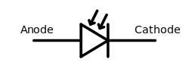

Photo diode has two terminals anode and cathode with the arrows indicating that the light rays falling on photo diode reflecting its significance as a photo detector.
2. What are the types of photo diodes?
There are mainly three types of photo diodes
- PN junction photo diode
- Avalanche photo diode
- PIN photo diode
Normal PN junction photo diode is used in low frequency and low sensitive applications. When high frequency of operation and high sensitivity is needed avalanche photo diode or PIN photo diodes are used.

3. Mention the physical structure of photo diode
A normal PN junction photo diode is made by sandwiching a P type semiconductor into N type semiconductor. All the sides of PN junction diode is enclosed in metallic case or painted black except for one side on which radiation is allowed to fall.
4. Modes of operation of Photo diode
A photo sensitive diode can be operated mainly in two modes
Photo conductive mode
Photo voltaic mode
The photo diodes used as photo detectors are optimized (in the physical construction of the device itself) to have fast response times whereas the photo diodes used in electrical energy generation are optimized to have high efficiency of energy conversion. The photo detectors are operated in photo conductive mode. Solar cells are operated in Photo voltaic mode.
5. What is luminance?
The intensity of light emitted from a surface per unit area in a given direction.
6. V-I characteristics of photo diode
A photo diode is always operated in reverse bias mode. From the photo diode characteristics, it is seen clearly that the photo current is almost independent of applied reverse bias voltage. For zero luminance, the photo current is almost zero except for small dark current. It is of the order of nano amperes.
As optical power increases the photo current also increases linearly. The maximum photo current is limited by the power dissipation of the photo diode.
7. Applications of photo diodes
  - Photo diodes are used as photo detectors
  - Photo diodes are used in providing electric isolation using a special circuitry called as Optocouplers. Optocoupler is an electronic component which is used in coupling optically the two isolated circuits by using light. The two circuits are optically coupled but electrically isolated. It is a combination of light emitting diode and photo diode (or) avalanche diode (or) photo transistor. Optocouplers are faster than the conventional devices.
  - They are used in consumer electronics
  - They are used in cameras as photo sensors, Slotted optical switch, in scintillators etc.

8. Why photo-diode works in the reverse bias?
The current in the forward bias is primarily due to major carriers but in reverse bias it is due to the minor carriers. As the fractional change in the reverse current due to the photo effects is more easily measurable than in the forward bias current. So photodiodes are operated in the reverse bias.
7. LASERS
- What is LASER?
LASER is the Acronym for Light Amplification by Stimulated Emission of Radiation.
- What are the important Characteristics of LASER?
High intensity, high monochromaticity, high coherence, unidirectional, high focussability.
- What is the basic principle involved in LASER action?
An emission that is caused by an external stimulus known as “stimulated emission” is the basic principle in LASER action.
- What is stimulated emission?
Stimulated emission is the emission of a photon by a system, under the influence of a passing photon of suitable energy, due to which the system transits from a higher energy state to a lower energy state. The photons thus emitted is called stimulated photon and will have same phase, energy and direction of movement as that of the passing photon is called stimulating photon.
- What are the requirements of LASER system?
a. The excitation source for pumping action.
b. An active medium which supports population inversion.
c. A laser cavity.
- What are the conditions required for the LASER action?
Population inversion and metastable state
- What is population inversion?
It is a stage at which number of atoms in the excited state exceeds the number of atoms in the ground state (N2>N1)
- What is diffraction?
The phenomenon of bending of light around the edges of obstacles or narrow slits and hence its encroachment into the region of geometrical shadow is known as diffraction.
- What is the condition for diffraction?
The dimension of the object or the size of the slit must be comparable to the wavelength of the light used.
- What is diffraction grating?
It is a system consisting of large number of equidistant slits separated by opaque spaces.
- How gratings are prepared?
Gratings are prepared by ruling parallel and equidistant lines on a well-polished glass plate using sharp diamond edge.
- What is grating constant?
The distance between two consecutive opaque rulings.
8. TORSIONAL PENDULUM
- What is torsional pendulum?
A body suspended from a rigid by means of a long and thin elastic wire is called torsional pendulum.
- What is the type of oscillation executing in torsional pendulum?
This is of simple harmonic oscillation type.
- On what factors does the time of oscillation depend?
It depends upon
1) Moment of inertia of the body
2) Rigidity of wire i.e. length, radius and material of the wire.
- What is a rigid body?
A rigid body is defined as a body on which the distance between two points never changes whatever be the force applied on it nor you may say the body which does not deform under the influence of forces is known as rigid body.

- Define Moment of Inertia?
A quantity expressing a body’s tendency to resist angular accelerations, which is the sum of the products of the mass of each particle in the body with the square of its distance from the axis of rotation. Its unit is Kgm ²
- What is oscillation?
it is a repetitive motion over time.
- What is damping?
Reduction of oscillation due to the influence within the system.
- What is the Q-factor in torsional pendulum?
It is a quality factor which is a dimensionless parameter. It basically describes the bandwidth of the damped oscillator.
- Distinguish between inertia and moment of inertia?
Inertia is a slow-motion acceleration in a linear path. Moment of inertia is a slow-motion acceleration in a rotational path.
- What is torsion?
A twisting deformation produced by a torque.
- What is torque?
Torque is a cross product of displacement and momentum.
- State one fundamental differences between a simple pendulum and torsional pendulum?
Simple pendulum executes simple harmonic oscillations about a vertical plane. The torsional pendulum on other hand executes simple harmonic oscillations about a horizontal plane.
- About what axis will the moment of inertia of a body is maximum?
The moment of inertia of a body will be maximum about an axis normal to the plane of a body.
14. Moment of inertia of a disc
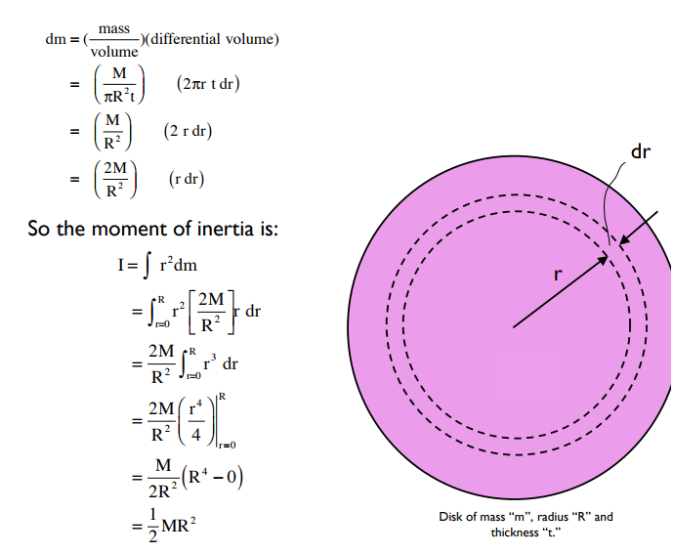

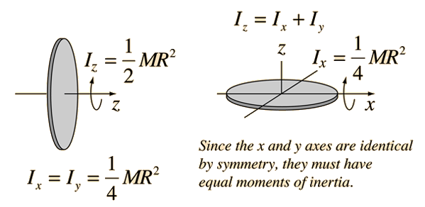

9. Acceptance angle and Numerical Aperture
- What is Angle of Acceptance?
It is the maximum angle which can be sent into the optical fiber such that it suffers Total Internal reflection and reaches other end of the fiber.
- What is Numerical Aperture?
It is light gathering capacity of an optical fiber and it is given by
$N.A=\sin{θ_{0}}$
- What is Optical fiber?
Optical fibers are essentially light guides used in optical communication as wave guides. They are transparent dielectrics and able to guide visible and IR rays over long distances.
4. What is attenuation and mention the types.
“Attenuation is the loss of power suffered by the optical signal as it propagates through the fiber”. It is also called fiber loss.
There are three types of attenuation
- Absorption loss
- Scattering loss
- Radiation loss
5. What are the advantages if Optical fiber.
- It carries very large amount of information in either digital or analog form due to its large bandwidth.
- Since it is made by using dielectrics, it doesn’t produce or receive any electromagnetic interference.
- It is easily compatible with electronic system
- Can operate in high temperature range
- Not affected by corrosion and moisture

10. Spring constant
1. Explain the formula of spring constant.
According to Hooke’s law, the force required to compress or extend a spring is directly proportional to the distance it is stretched. It can be represented in an equation as F = kx, where F is the force applied, k is the spring constant and x is the extension of the object usually in meters.
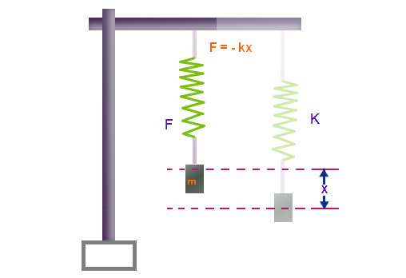

The Spring Constant Formula is given as,
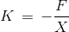
Where,
F = Force applied,
x = displacement by the spring
It is expressed in Newton per meter (N/m).
2. Write a note on Hookes law.
Hooke’s Law
According to Hooke’s law for a small deformation, the stress in a body is proportional to the corresponding strain.” i.e.,
$$Stress α Strain$$
$$Stress=E Strain$$
There are three types of modulus,

1. Young’s Modulus of Elasticity (Y)
When a wire is acted upon by two equal and opposite forces in the direction of its length, the length of the body is changed. The change in length per unit length (Δl/l) is called the longitudinal strain and the restoring force (which is equal to the applied force in equilibrium) per unit area of cross-section of wire is called the longitudinal stress.
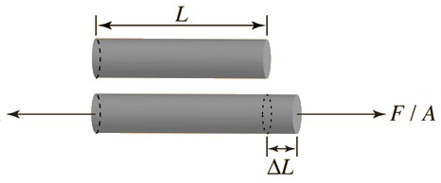
For small change in the length of the wire, the ratio of the longitudinal stress to the corresponding strain is called the Young’s modulus of elasticity (Y) of the wire. Thus,
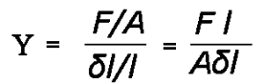
Let there be a wire of length ‘l’ and radius ‘r’. Its one end is clamped to a rigid support and a mass M is attached at the other end. Then
F = Mg and A = πr²
Substituting in above equation, we have
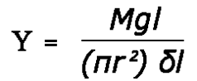

2. Bulk Modulus of Elasticity (B)
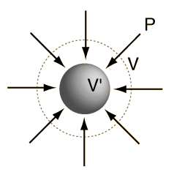
When a uniform pressure (normal force) is applied all over the surface of a body, the volume of the body changes. The change in volume per unit volume of the body is called the ‘volume strain’ and the normal force acting per unit area of the surface (pressure) is called the normal stress or volume stress. For small strains, the ratio of the volume stress to the volume strain is called the ‘Bulk modulus’ of the material of the body. It is denoted by B. Then
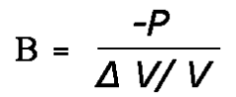
Here, the negative sign in formula implies that when the pressure increases volume decreases and vice-versa.

3. Modulus of Rigidity (η)
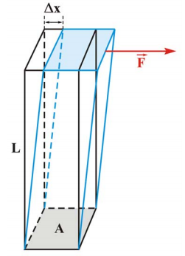
When a body is acted upon by an external force tangential to a surface of the body, the opposite surfaces being kept fixed, it suffers a change in shape of the body, its volume remains unchanged. Then the body is said to be sheared.
The ratio of the displacement of a layer in the direction of the tangential force and the distance of the layer from the fixed surface is called the shearing strain and the tangential force acting per unit area of the surface is called the ‘shearing stress’.
For small strain in the ratio of the shearing stress to the shearing strain is called the ‘modulus of rigidity‘ of the material of the body. It is denoted by ‘η’.
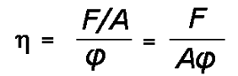

11. YOUNG’S MODULUS BY SINGLE CANTILEVER
- What is stress? Give its unit.
The force applied on a body per unit area is known as stress. its unit is N/m²
- What is strain? Give its unit.
The ratio of change in dimension to original dimension is called strain. It is a ratio of same quantities; hence it has no unit.
- What is elasticity?
The property of the body to regain its original shape and size, after the removal of the applied stress.
- What are the factors affecting the elasticity of a material?
Effect of stress Effect of change in temperature Effect of Impurities Effect of hammering, rolling and annealing Effect of crystalline nature.
- What are the elastic bodies?
The bodies which regain its original shape or size after removal of the deforming force are called elastic bodies.
- Define the term Young’s modulus.
Young’s modulus is defined as the ratio of longitudinal stress to the longitudinal strain.
- State Hooke’s law?
It states that within the elastic limit, the stress generated within the body is proportional to the strains. Stress/strain = constant.
- What is modulus of elasticity?
The ratio of stress to strain is a constant and is known as modulus of elasticity.
- What is Young’s modulus?
Young’s modulus is defined as the ratio of the longitudinal stress to the longitudinal stress.
- What is a beam?
When the length of the rod of uniform cross-section is very large compared to its breadth such that the shearing stress over any section of the rod can be neglected, the rod is called a beam.
- How the longitudinal strain and stress is produces?
Due to depression, the upper or concave side of the beam becomes smaller than the lower or convex side of the beam, As a result longitudinal strain is produced. The change in length will be more to the force acting along the length of the beams. These forces will give rises to longitudinal stress.
- How do you ensure that in your experimental your elastic limit is not exceeded?
The consistency in the readings of depression both for increasing and decreasing the loads indicates that in the elastic limit is not exceeded.
13. What is Single cantilever?
A cantilever is a rigid structural element, such as a beam or a plate, anchored at one end to a (usually vertical) support from which it protrudes; this connection could also be perpendicular to a flat, vertical surface such as a wall. Cantilevers can also be constructed with trusses or slabs.

12. Magnetic Field Intensity
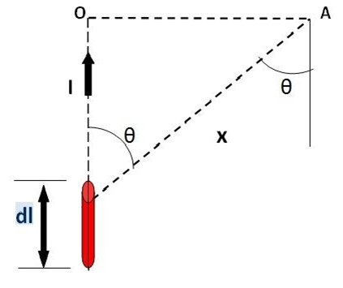
1. State Biot-Savart’s law

Biot Savart Law states that The magnetic intensity dH at a point A due to current I flowing through a small element dl is
- Directly proportional to current (I)
- Directly proportional to the length of the element (dl)
- Directly proportional to the sine of angle θ between the direction of current and the line joining the element dl from point A.
- Inversely proportional to the square of the distance (x) of point A from the element dl.
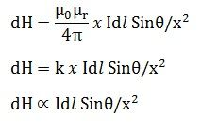
where k is constant and depends on the magnetic properties of the medium.
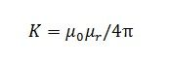
µ₀ = absolute permeability of air or vacuum and its value is 4 x 10⁻⁷ Wb/A-m
µ_{r}= relative permeability of the medium.
2. What is magnetization?
Magnetization is the polarization is the vector field that expresses the density of permanent or induced magnetic dipole moments in a magnetic material.
The magnetization field or M-field can be defined according to the following equation
$$M=\frac{dM}{dV}$$
$$dM is the Elementray Magnetic moment and dV is the Volume element.$$

$3$. Mention the classes of Magnetic materials
The magnetic behavior of materials can be classified into the following five major groups:
1. Diamagnetism
2. Paramagnetism
3. Ferromagnetism
4. Ferrimagnetism
5. Antiferromagnetism
4. What is Diamagnetism?
Diamagnetic substances are composed of atoms which have no net magnetic moments (ie., all the orbital shells are filled and there are no unpaired electrons). However, when exposed to a field, a negative magnetization is produced and thus the susceptibility is negative

5. What is paramagnetism?
This class of materials, some of the atoms or ions in the material have a net magnetic moment due to unpaired electrons in partially filled orbitals. One of the most important atoms with unpaired electrons is iron. However, the individual magnetic moments do not interact magnetically, and like diamagnetism, the magnetization is zero when the field is removed. In the presence of a field, there is now a partial alignment of the atomic magnetic moments in the direction of the field, resulting in a net positive magnetization and positive susceptibility.
6. What is Ferromagnetism?
The atomic moments in these materials exhibit very strong interactions. These interactions are produced by electronic exchange forces and result in a parallel or antiparallel alignment of atomic moments. Exchange forces are very large, equivalent to a field on the order of 1000 Tesla, or approximately a 100 million times the strength of the earth's field. These materials shows Spontaneous magnetization.
7. What is Ferrimagnetism?
Ferrimagnetic material is one that has populations of atoms with opposing magnetic moments.
8. What is Antiferromagnetism?
The spins of electrons, align in a regular pattern with neighboring spins pointing in opposite directions.




